# Unit 1: Introduction and Motivation

## Videos:

Introduction

1. Intro
2. Big Data
3. Modern-day DS
4. Seven steps in data modelling pipeline
5. Large scale machine learning
6. Tricks of the trade
7. MR using the command line

Readings

1. Doing Data Science Chapter 1 and 2: on Safari
2. An introduction to information retrieval: Chapter 13, downloaded; Info on Naïve Bayes and Text Classification
3. Elements of Statistical Learning, Chapter 7: downloaded and read

Big Data Definitions

1. ML at Scale
   1. 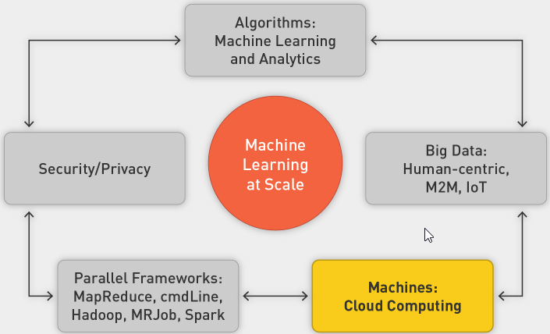
2. Big Data Definition
   1. Big data is broad term for data sets so large or complex that traditional data-processing applications are inadequate:
   2. Processing
   3. Laptop (8–16 GB of memory, 1 TB hard drive) overwhelmed with 4–5 GB
   4. Storage
   5. Laptop only 1 TB
   6. Throughput
   7. Three hours to read 1 TB on laptop
   8. Other Challenges
      1. Analysis
      2. Capture
      3. Data curation
      4. Search
      5. Sharing
      6. Storage
      7. Transfer
      8. Visualization
      9. Security
      10. Information privacy
   9. Three Vs
      1. 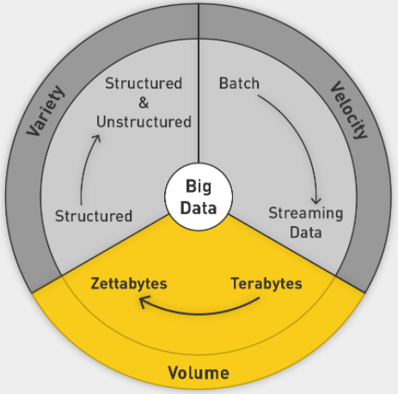
      2. Add Veracity: uncertainty of data
3. Sources Driving Big Data
   1. Everything is recorded online
   2. User-generated world, social media
   3. IoT
   4. Scientific Computing
4. Areas of Application
   1. NYSE
   2. FB
   3. CERN
5. Data in Zettabytes (ZB)
   1. 1ZB is 10^21
   2. 2020: 40 ZB

Sources of Big Data

1. Applications of Big Data
2. Societal and Personal Sources of Data
3. Online Society
4. Advertising
   1. Represents 2% of GDP in United States since 1900s
   2. Increased spending online as opposed to on traditional channels
   3. Mobile advertising surpasses others
5. Dating
6. Life Logging
7. Health Care and how tech can help
8. Genomics

IoT

1. IoT
   1. More data coming from machines than from humans
   2. Machine to machine communication
   3. Attach sensors to all the things
   4. 2020: 26b things on network
   5. Everyone has a unique identifier and data is automatically sent across the internet
2. Japan Earthquake
   1. 14 seconds before, all trains and plants shut down
   2. Mesh of sensors from connected computers to form an early warning system
3. Tracking Nature in the Wild
   1. Sea lions with GPS tracking system
   2. Underwater hub picks up signals from devices
   3. Serengeti
4. Challenges
   1. Battery life
   2. Storage
   3. Network connectivity
   4. Privacy and security
5. Smart homes
6. Smart Cities
   1. 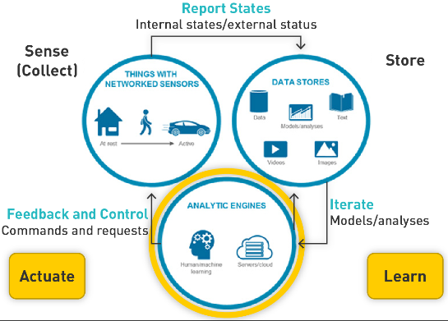
7. Autonomous Vehicles

Data Modelling Pipeline

1. Intro
   1. Massive challenge for machine learning
   2. ML is not in a vacuum
   3. ML in real world
2. Modelling
   1. 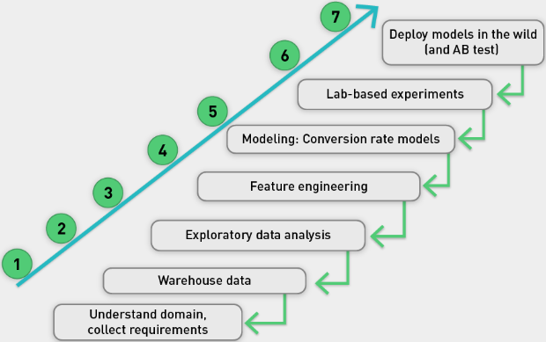
   2. Very iterative, might go back at every step
   3. 80% of work is spent in getting, prepping and engineering data
3. Example US insurance
   1. Half of it is property and casualty (auto, home, commercial)
   2. Highly competitive rates
      1. Special rates for good drivers
      2. Score computed through accident history over five years
      3. Static, annual, batch process, easy
4. Progressive’s Snapshot product
   1. Bad driver surveillance through telematics
   2. Small box plugged into steering wheel that records, sends information
   3. Features:
   4. How many miles driven
   5. How many miles driven between midnight and 4 a.m.
   6. Use of sharp or gentle braking
   7. Data used to analyze driving patterns, risk to insurance company
   8. Potential reduced premiums for user
5. Privacy
   1. Huge data generated
   2. Data not transitory
   3. Caution needed with who can access and how is it stored
   4. Who owns the data?

Data Scientist: Post This Class

1. Three skill sets
   1. 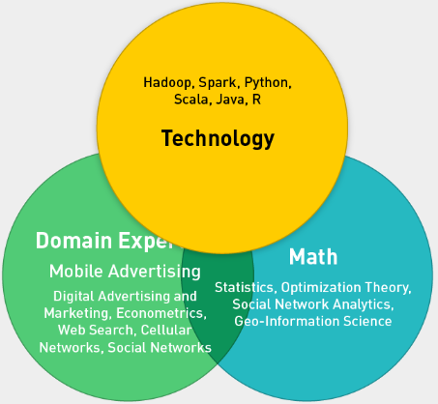
2. Understand Models
3. Understand Security and Privacy
4. ML at scale
   1. 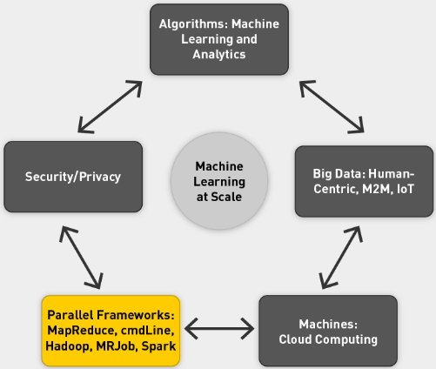
5. DS Team with different experts in the three fields
6. DS improves KPIs dramatically
   1. 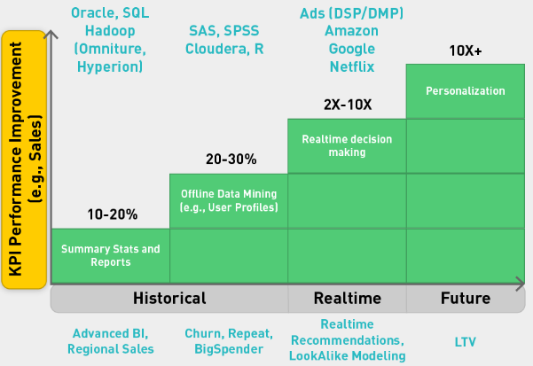

Goals of Class

1. ML at Scale
2. Large-Scale ML
   1. Needs supporting infrastructure
   2. Parallel computing frameworks
3. MapReduce Framework
   1. Allows us to divide and conquer huge data problems
   2. Four frameworks
      1. Cmd
      2. Hadoop
      3. MRJob
      4. Spark
4. Embarrassingly Parallel Problems
   1. Most ML problems
   2. Divide into tasks that can easily be distributed and parallelized
   3. Divided into subproblems
   4. Require little or no communication
   5. Are easily distributed
   6. Have linear computational flow and scale
5. Framework Requirements
   1. Scalable
   2. Fault tolerant
   3. Iterative
   4. Interactive
   5. 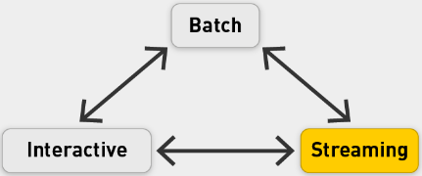
   6. Frameworks that empower us to do above
   7. OS ecosystem
6. Four MR frameworks
   1. CMD based
   2. Hadoop: Storing and manipulating data
   3. MRJob: Convenient Python application programming interface (API) for writing MapReduce programs
   4. Spark: memory backed with integrated framework; Specialized libraries for many things
7. Data analytics stack
   1. 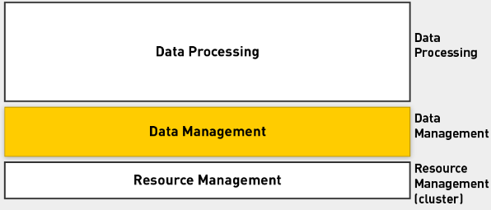
   2. Populating the stack
   3. 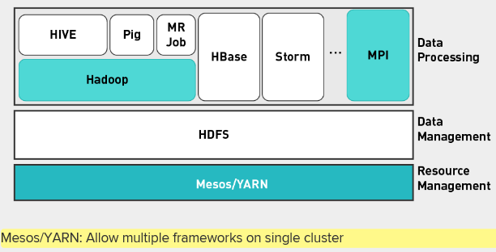
   4. Add Spark
   5. 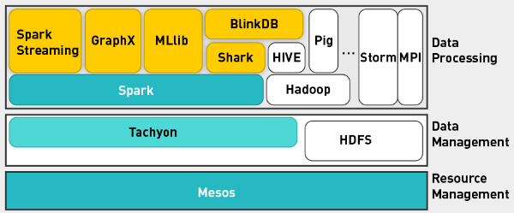
8. Class Phases
   1. Phase 0: CMD
   2. Phase 1: Hadoop/HDFS
   3. Phase 2: MRJob
   4. Phase 3: Spark
9. ML Algorithms
   1. Adopt them for parallel framework
   2. Supervised machine learning (convex optimization, gradient descent, linear regression, decision trees, ensembles of models, support vector machines)
   3. Unsupervised (expectation maximization, matrix multiplication, alternating least squares)
   4. Graphs (random walks, PageRank, graph search algorithms such as breadth-first search, shortest path)
   5. Hybrid algorithms (supervised machine learning and random walks)
   6. Applications (digital advertising, social media, health care, e-commerce, entertainment, metrics, statistics)

Logistics and Performance Evaluation

1. The more you put in, the more you get back
2. Structure
   1. 13 lectures over 14 weeks
   2. Two exam weeks
   3. Week 8 midterm
   4. Week 15 final project
   5. Performance evaluation
   6. 

Large Scale ML

1. Do you need more data scientists or do you need more data?
2. ML and Data Study
   1. Filling in confusable words in sentences
   2. Use ML
   3. Vary size of training data
   4. 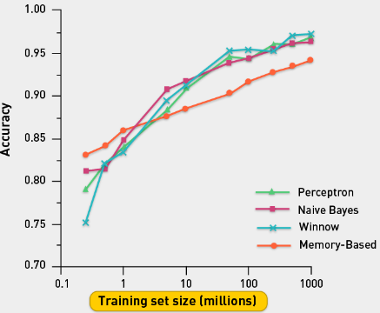
   5. Different algorithms perform differently if they have small number of training examples, but similarly with large number of examples
   6. Conclusion: more data leads to 10-20% boost in performance
3. Supervised Classification in a nutshell
   1. 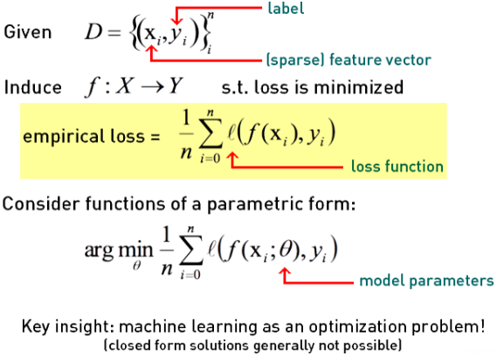
   2. 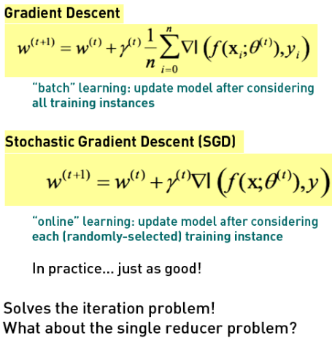
4. Complexity of models
   1. 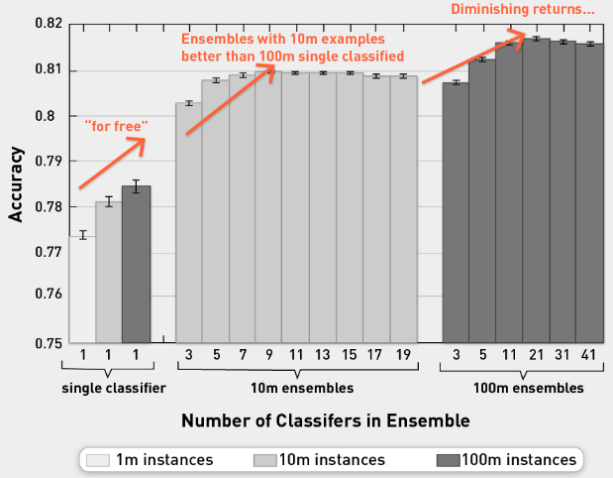
   2. Moving from single to ensemble, you get huge boost in performance
   3. However, if you use 100m examples, you get further boost of 1-2%.
   4. Using more data we get amazing improvements, but we hit diminishing returns
5. More data or more DS?
   1. Trade-off between bias and variance
   2. Bias from data scientists
   3. Variance from more data
   4. With more data can reduce variance

Bias-Variance Background

1. B-V
   1. Empirical studies: more data leads to big improvements
   2. More data or more DS?
   3. Bias-variance trade-off
2. ML objectives
   1. Minimize error term
   2. Minimize loss function
   3. Reduce model complexity
   4. Better generalization
   5. For linear regression, we use mean squared error
3. Loss: Irreducible and reducible error
   1. Irreducible:
      1. Has inherent uncertainty
      2. Associated with natural variability in system
      3. Noisy sensors
   2. Reducible:
      1. Can and should be minimized further to max accuracy
4. Reducible error
   1. Includes both "error due to squared bias" and "error due to variance"
   2. Goal: Simultaneously reduce bias and variance as much as possible in order to obtain as accurate a model as is feasible
   3. Trade-offs in selecting models:
      1. Flexibility and complexity
      2. Selecting appropriate training sets
5. Complexity of model
   1. 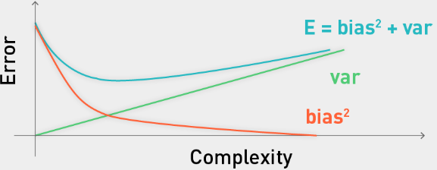
   2. Try to minimize error
   3. E is from two components: bias^2 and variance (noise factor as well)
   4. Bias decreasing as complexity increased
   5. Usually, bias is a decreasing function of complexity, while variance is an increasing function of complexity.
6. BV tradeoff in model selection
   1. 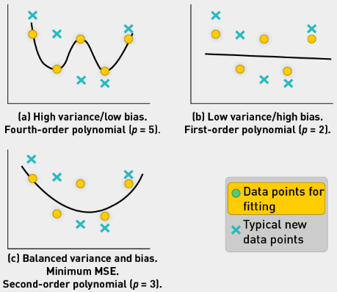
   2. First plot shows high variance as we fit the data too well.
   3. Second plot shows **high bias as we cannot fit the training data well**.
7. Error due to squared bias
   1. Definition: Amount by which expected model prediction differs from the true value, **over the training data**
   2. Bias is introduced at model selection
   3. Repeat model-building process (through resampling) to obtain average of prediction values
   4. If average prediction values are substantially different than true value, bias will be high
8. Error due to variance
   1. Definition: Amount by which prediction **over one training set differs from expected predicted value over all training sets**
   2. Repeat modeling, measure inconsistency over different training data sets
   3. Variance measures how inconsistent predictions are from one another, over different training sets, not whether or not they are accurate (Manning et al., 2008)
9. BV Analysis in Regression
   1. 
   2. 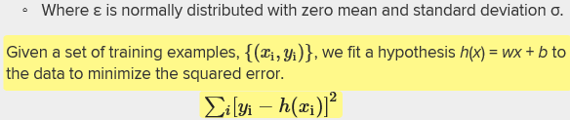
10. Example
    1. 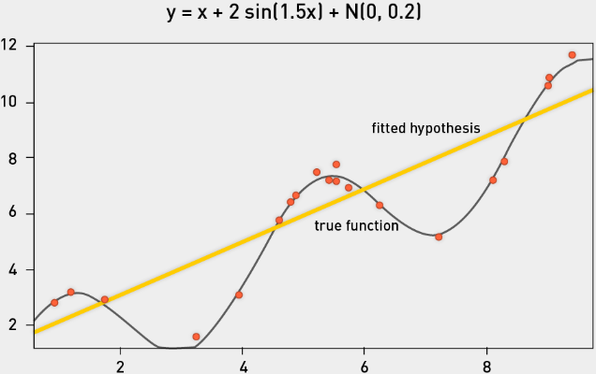
    2. We fit linear model
    3. If we resample 50 times and fit 50 linear models and plot them, we get:
    4. 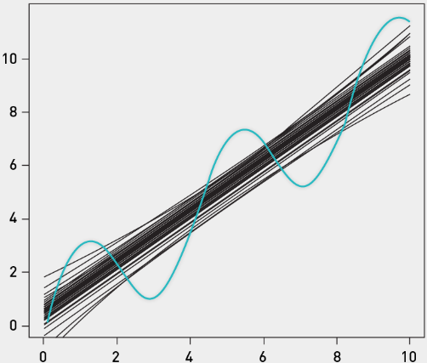
    5. Use bootstrap sampling, see average model
    6. 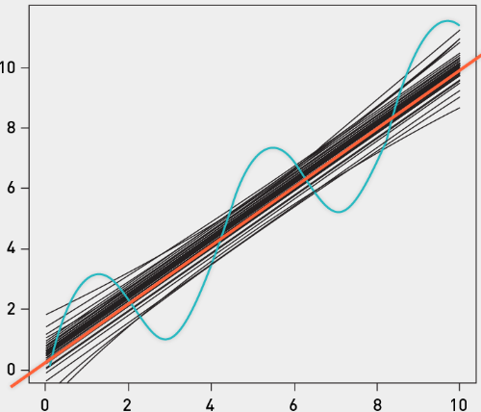
    7. Avg model introduces a bias. Prediction for x=3 is way above actual value for 3.
    8. From variance perspective, models are variable from training set to training set
    9. Noise: low since artificial
    10. 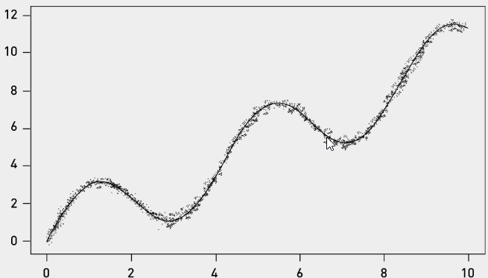
11. Variance, Bias and Noise
    1. Variance: 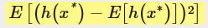
    2. Model prediction minus average model prediction
    3. Bias: 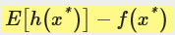
    4. Average model prediction vs true function value
    5. Noise: 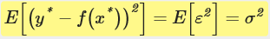
    6. Observed target value and true function value
12. Distribution of Predictions at x=2.0
    1. 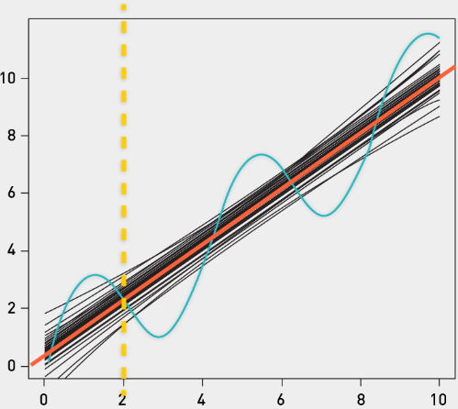
    2. High variance between 50 models in this case, but true and mean prediction aren’t very different.
    3. X=5 has big difference between true prediction and mean prediction.
13. Measuring Bias and Variance
    1. Simulate multiple training sets by bootstrap replicates.
    2. Construct B bootstrap replicates of S (e.g., B = 200).
    3. 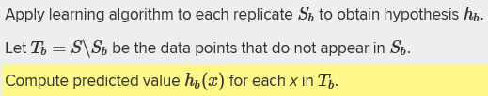
    4. Use to est bias and variance
14. Model Complexity
    1. 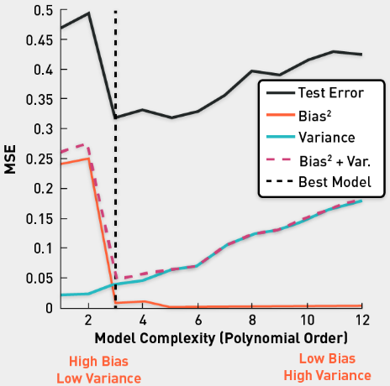
    2. Experiment where you take training data and use different models: from linear to polynomial regression (go from 1 to 12 polynomial order)
    3. Linear models have very high bias (don’t fit data well)
    4. High polynomial models fit data precisely, lowering bias, but they increase variance (the green line)
    5. Polynomial regression model of order 3 is the best here
15. BV Decomposition
    1. Can be extended to classification problems
    2. Pedro Domingos (2000a; 2000b): Developed unified decomposition that covers both regression and classification
16. BV Tradeoff code:
    1. [Model Selection: Underfitting, Overfitting, and the Bias-Variance Tradeoff](https://theclevermachine.wordpress.com/2013/04/21/model-selection-underfitting-overfitting-and-the-bias-variance-tradeoff/)
    2. [Ask a Data Scientist: The Bias vs. Variance Tradeoff](http://insidebigdata.com/2014/10/22/ask-data-scientist-bias-vs-variance-tradeoff/)
    3. [polyfit: Polynomial curve fitting](http://www.mathworks.com/help/matlab/ref/polyfit.html)
17. Model Selection
    1. Trade off between b and v
    2. Practical method for selecting model
       1. Minimize error
       2. Function of model complexity
18. Effect of algorithm parameters
    1. K-Nearest Neighbor: Increasing k typically increases bias, reduces variance
    2. Decision trees of depth D: Increasing D typically increases variance, reduces bias
    3. Radial basis function (RBF) support vector machines (SVM) with parameter σ: Increasing σ increases bias, reduces variance
    4. Bagging tends to reduce variance without increasing bias
19. Wrap-up
    1. Bias and variance of an estimator are related to squared prediction error.
    2. These concepts can be applied to classification problems.
    3. An optimal estimator will have both low variance and low bias.

MR with CMD

1. Overview
   1. Aim for ML on billions of examples
   2. Use parallel computational framework based on cmd
   3. Divide and conquer strategy
2. Goal
   1. Large scale problem
   2. Decompose into nonoverlapping subproblems
   3. Non-ML problem
   4. Related to NB
3. Task
   1. Find all occurrences of the word apple (by date) in Facebook posts log file.
   2. Parallel grep for FB posts available in a log file
4. Back-of-the-Envelope Calculations
   1. 10^9 active FB users on a daily basis
   2. One post per day = 10^9 posts per day
   3. 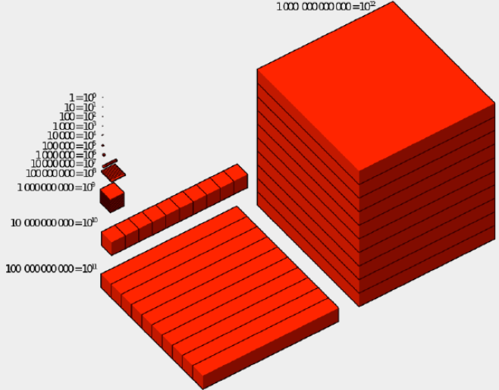
   4. Each post = 1000 bytes (text and metadata)
   5. 1TB of data (1000 * 10^9 = 10^12 bytes)
5. Processing Times
   1. On one node:
      1. if you scan at 100 MB/s (10^8), it will take you
      2. 
      3. This is way too long
   2. On a 96 multicore machine
      1. Scanning at 100MB/s, assume 100 cores has no latency
      2. 
      3. How do you write code to leverage this power?
6. Strategy: Calculate Term Popularity
   1. Unix-based divide and conquer strategy
   2. Poor man’s distributed computational perspective
7. Ground Rules
   1. Use only below commands
   2. split, grep, wc, merge, cat, for, echo
   3. cut, paste, bc
   4. |, &, wait
8. GREP command
   1. "grep <string> <filename>" returns all lines in file that contain string
   2. Each line corresponds to one record (Facebook post)
   3. Date, time, body of post
   4. 
9. Pipe command: |
   1. Chain together various commands
   2. 
   3. Find lines that contain all three words
10. Split command
    1. Split by number of lines: "split -l 30" splits file into chunks of 30 lines or less
    2. Split by number of MB: ◦"split -b 24m" splits file into chunks of 24MB or less
    3. Example Split command:
       1. 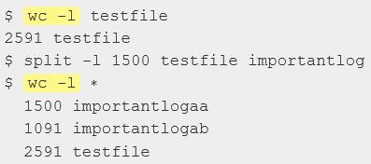
       2. Wc counts number of lines in this case
       3. 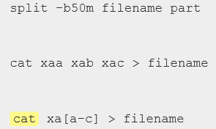
       4. Cat displays the data or feeds it into another file
11. For loop and Echo
    1. 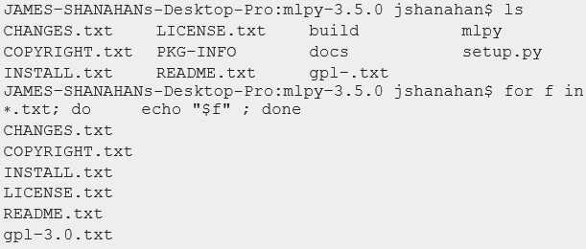
12. Cut, Paste, bc
    1. Seq just generates list of numbers
    2. 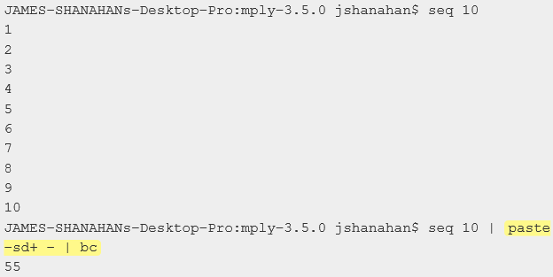
    3. Paste takes the numbers produced by the sequence and creates a string with a plus sign between each of the numbers.
    4. Bc then takes that string and executes it as a calculator, summing up the count
13. Parallel Computing with & and Wait
    1. "&" causes parent process to spawn off parallel processes
    2. "wait" will cause parent process to wait until child processes have finished
    3. 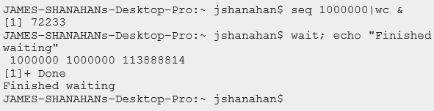
    4. "seq 1000000|wc &" causes the parent terminal process to spawn line-count task off as child process
    5. "wait" causes the shell to freeze until child process finishes
    6. It will print Finished waiting when wait is over
    7. Once child command finishes, shell can continue and run echo command
14. Schematic of Parallel Processing
    1. Split file in chunks of 10G each
    2. Take grep function and grep each chunk | wc to count how many matches the grep generated in each chunk. Output is number of matches per chunk
    3. Merge these counts together
    4. 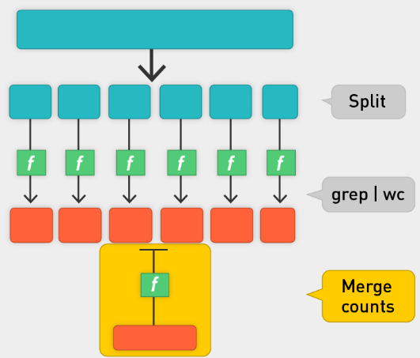
    5. Unix Commands
    6. 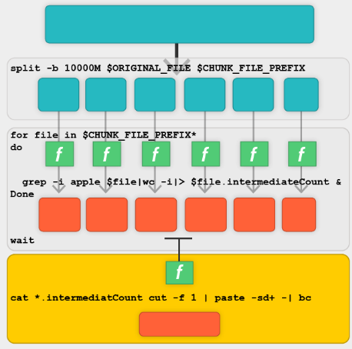
    7. MapReduce Pattern
    8. 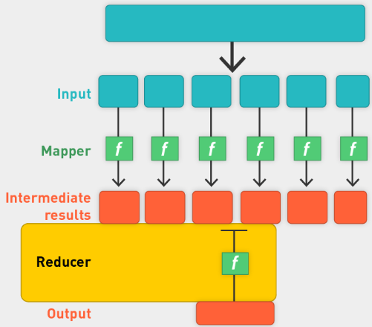
15. MapReduce Framework
    1. 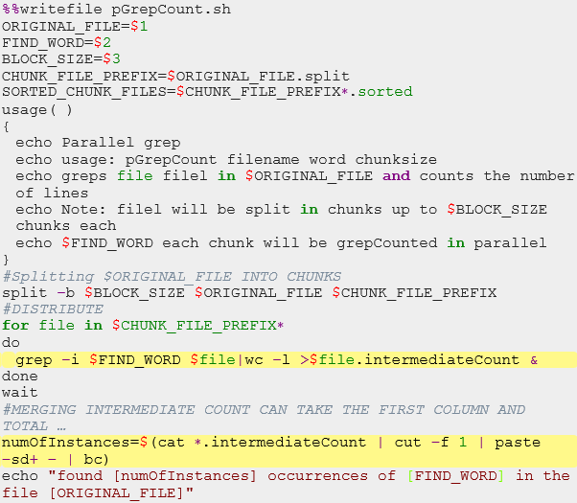
    2. How about using python?
    3. 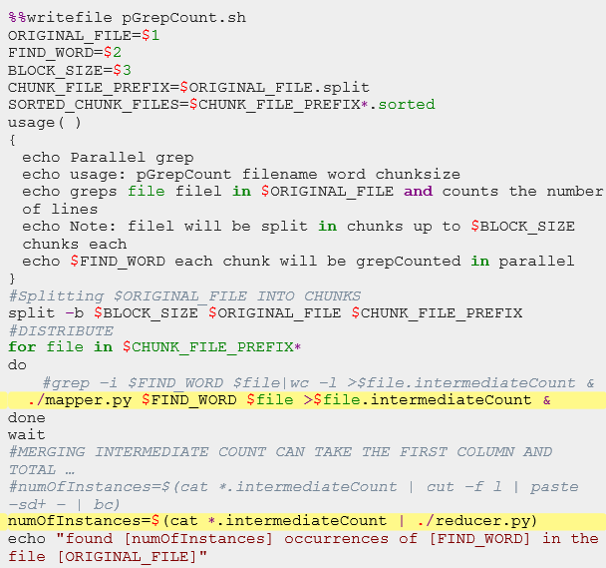
    4. Write mapper.py and reducer.py
    5. Change execution privileges
16. Python: Mapper for Grep
    1. 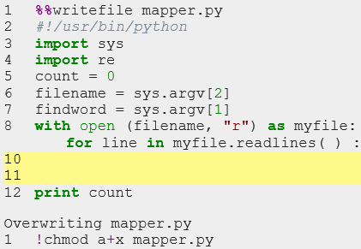
    2. If findword in line
    3. Count = count + 1
17. Python Reducer for Grep
    1. Barrier pattern: we cannot start reduce function until all mapper processes are done
    2. 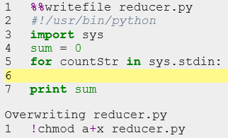
    3. Sum = sum + int(countStr)

Summary

1. Keep Unix MR framework, swap out map and reduce files for other frameworks
   1. 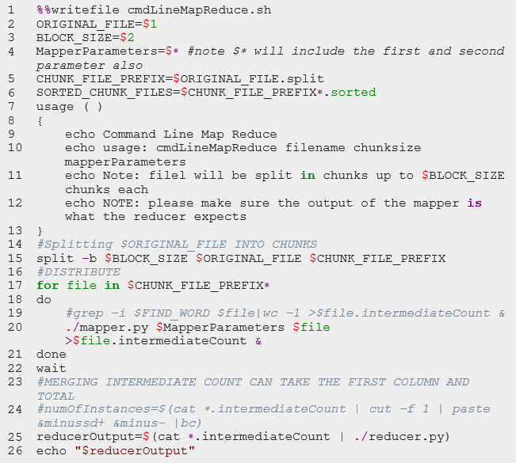
   2. Parallel Sort
   3. 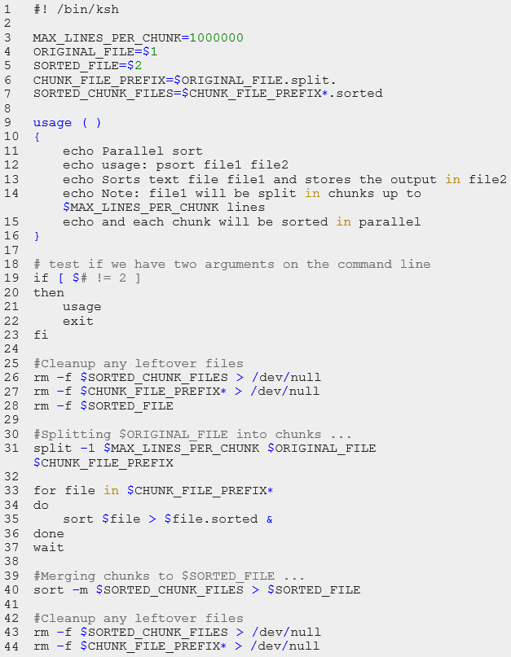
2. Course Overview
   1. How to quantify Data
   2. How to estimate Time
   3. Powers of 10
   4. Parallelism
   5. Scale mundane tasks like grep, sort
3. Challenges in MR Framework
   1. Data management
   2. Task management
   3. Fault tolerance
   4. Lack of interactivity
4. A better framework
   1. Scale Out, not up
   2. Fault tolerance
   3. Minimise data movement
   4. Move processing of the data
   5. Hide file system details from application developer
   6. Seamless scalability
5. Class Phases
   1. Phase 0: Command line
   2. Phase 1: Hadoop/HDFS
   3. Phase 2: MRJob
   4. Phase 3: Spark
6. Summary
   1. Big data (what, why, where, who, how)
   2. Role of data scientist
   3. Data modeling pipeline
   4. Bias variance as a means of understanding more data
   5. MapReduce framework using command-line utility

## Lecture:

* Long/Short slides, follow short
* Lecturer: Mike Bowles
* Homework, normally due Thursday after next class; HW1 should be done before the class however.
* 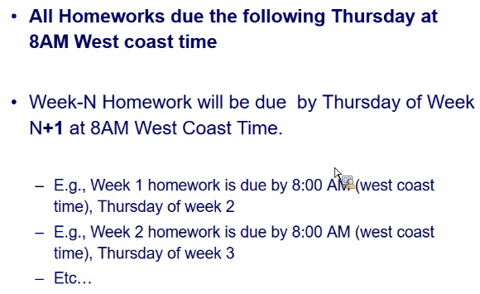
* HW1:
* Saturday: OH for setting up Docker container; check on slack when it is.
* Docker and HW: look at UCB-w261
* Slides:
* Data science is everywhere
* Steps:
  + Raw data
  + Feature extraction
  + Classifier is run
  + Result
* What can make use of MR format, what cannot?
* Optimization
* 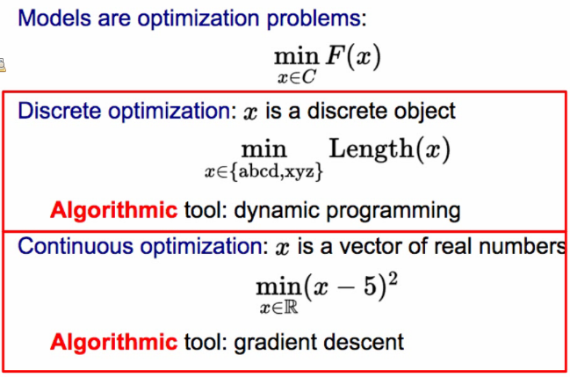
* ML allows us to shift the complexity from the program to the data.
* Deep learning
* Data Analytics Stack
* 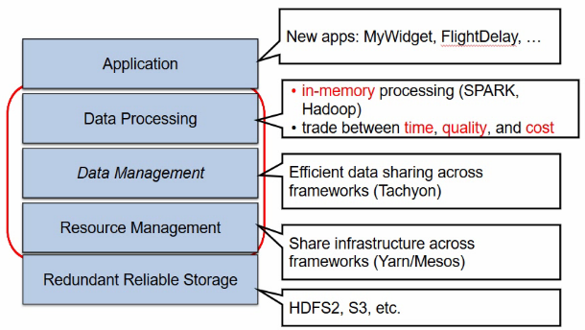
* Class Phases
* 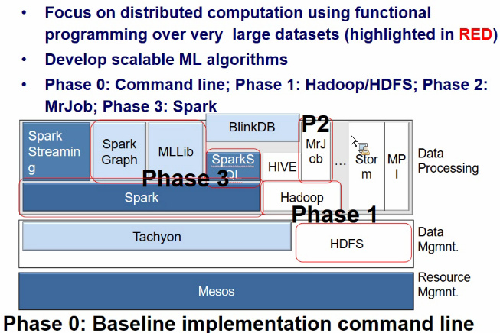
* Scaling solutions
* 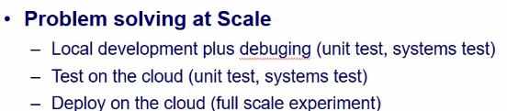

# Unit 2: Parallel Computing, MapReduce, and Hadoop (Data Storage and Algorithms)

## Videos:

Introduction

1. Gigabytes of data? Can fit on PC memory
2. Petabytes? Need cluster of server
3. MapReduce
4. Embarrassingly Parallel
5. Hadoop

Motivation for Parallel Computing

1. Assume 100b web pages
   1. How to store them?
   2. 10,000 characters per page x10^11 = 10^15 (1 petabyte of raw data)
   3. How can we scan them?
   4. How to do sth useful with them?
   5. Document frequency of term
   6. Extract out-links and count in-links for page
2. Why Parallelism?
   1. Data size is increasing
   2. Scan 1000 TB on one node at 100 MB/s = 120 days
   3. Store that amount of data?
   4. Growing demand
   5. Parallelism: Divide and Conquer
   6. Standard or commodity and affordable architecture emerging
   7. Clusters of commodity linux nodes (CPU, memory, disk)
   8. Gigabit internet interconnectivity
3. Design Goals for Parallelism
   1. Scalability to large data volumes
   2. Scan 1,000 TB (1PB) on one node at 50 MB/s = 120 days
   3. Scan on 10,000-node cluster = 16 minutes!
   4. Cost efficiency: commodity nodes and network
   5. Fault tolerance is automatic
   6. Easy to use framework
4. D&C Is common: Packet switching
   1. Packet switching is a digital networking communications method that transmits messages in chunks or blocks, called packets.
   2. Packets are transmitted via a medium that may be shared by multiple simultaneous communication sessions.
   3. Packet switching increases network efficiency and robustness and enables technological convergence of many applications operating on the same network.
   4. 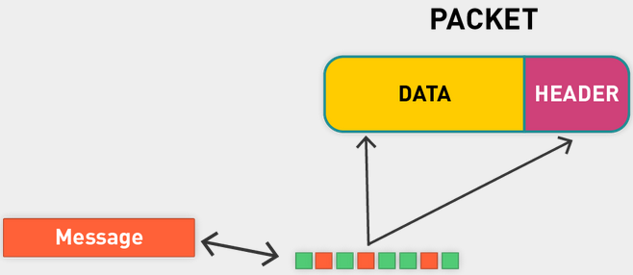
   5. Split message into packets, each packet has data (payload) and a header that tells where it goes, where it comes from, etc.
   6. Sender sends chunks across network. Each packet may take different path through the network.
   7. Barrier sync in receiver says: hold until all packages have been received and combined
   8. Individual packets get transmitted in isolation. There is no communication between the packets, and they synchronize only at the destination node; this is known as barrier-based synchronization in parallel computing.
   9. Handle process synchronization through devices such as barriers.
5. Conclusion
   1. The key to success here was divide and conquer
   2. Decompose a large task into smaller ones
   3. We came up with a very nice framework for parallelizing tasks on the command line!
      1. But it is limited
      2. Granularity of task is somewhat coarse
      3. No fault tolerance
      4. No control over file space
   4. Divide and conquer does not come for free; there are obligations in terms of communication, synchronization, and fault tolerance

Definition and Communication Synchronization Types of PC Tasks

1. Serial vs Parallel Computation
   1. Traditionally, computer software has been written for serial computation.
   2. To solve a problem, an algorithm is constructed and implemented as a serial stream or list of instructions.
   3. These instructions are executed on a central processing unit on one computer. Only one instruction may execute at a time—after that instruction is finished, the next is executed.
   4. Parallel computing, in contrast, uses multiple processing elements simultaneously to solve a problem.
   5. This is accomplished by breaking the problem into independent parts so that each processing element can execute its part of the algorithm simultaneously with the others.
   6. The processing elements can be diverse and include resources such as a single computer with multiple processors, several networked computers, specialized hardware, or a combination of the above.
2. Parallel computing
   1. Parallel computing is a form of computation in which many calculations are carried out simultaneously.
   2. It operates on the principle that large problems can often be divided into smaller ones, which are then solved concurrently ("in parallel").
3. Parallel computers
   1. How much does HW support parallelism?
   2. Single computer: Multicore or multiprocessor
   3. Clusters: multiple computers
   4. Specialized HW: GPUs
4. Challenges of Group Work
   1. Division of work
   2. Coordination costs (partition problem, communication)
   3. Coordination costs represent time and energy that group work consumes that individual work does not
   4. They include the time it takes to coordinate schedules, arrange meetings, meet, correspond, make decisions collectively
   5. Integrate the contributions of group members, etc.
   6. The time spent on each of these tasks may be small, but together they are significant
   7. Coordination costs cannot be eliminated
5. Parallel programs are challenging
   1. Single node:
      1. Parallel computer programs are more difficult to write than sequential ones, because concurrency introduces several new classes of potential software bugs, of which **race conditions** are the most common
      2. Communication and synchronization between the different subtasks are typically some of the greatest obstacles to getting good parallel program performance
   2. Clusters: similar issues, amplified
6. Dev responsibilities
   1. Explicitly address above issues
   2. Shared-memory programming: Explicitly coordinate access to shared data structures through synchronization primitives such as mutexes. Also, explicitly handle process synchronization through devices such as barriers. Be vigilant against deadlocks and race conditions
7. Without Sync
   1. Thread A
      1. Read variable X
      2. Compute X + 1
      3. Assign to X
   2. Thread B
      1. Read variable X
      2. Compute X + 1
      3. Assign to X
   3. We don’t know which thread will run first. Depending on order, final value might be different.
   4. Case 1: X = X + 1
      1. A and B could both read the initial value of X and then overwrite each other
      2. Final result: X = X + 1
   5. Case 2: X = X + 2
      1. A reads and writes, then B reads and writes
      2. Final result: X = X + 2
   6. Don’t know whether the right one (second will occur)
   7. Case 1 is a race condition
8. Use Sync to avoid Race condition
   1. There are several ways to synchronize and avoid race conditions
   2. Depending on the level of parallelism possible for the problem at hand
   3. Mutex:
      1. In computer science, mutual exclusion refers to the requirement of ensuring that no two concurrent processes are in their critical section at the same time; it is a basic requirement in concurrency control, to prevent race conditions
      2. In computer programming, a mutex is a program object that allows multiple program threads to share the same resource, such as file access, but not simultaneously
      3. When a program is started, a mutex is created with a unique name
      4. Usually a mutex is associated with a variable or code block
      5. 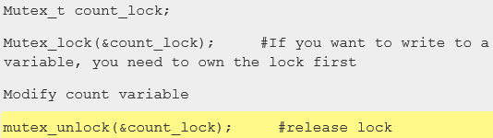
   4. Barrier
9. Deadlock from Mutex
   1. Next issue: Mutex base syncing can cause deadlocks.
   2. Threads A and B both need locks for variables X and Y.
   3. A acquires mutex_X.
   4. B acquires mutex_Y.
   5. A waits for mutex_Y to be free.
   6. B waits for mutex_X to be free.
10. Join Pattern for Sync
    1. Those problems that can be decomposed into independent subtasks, requiring no communication or synchronization between the subtasks except a join or barrier at the end
    2. 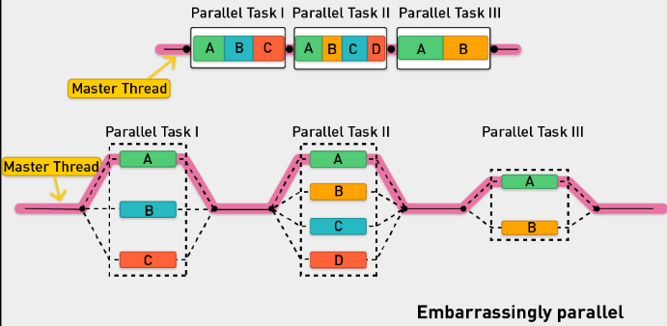
    3. Master thread with multiple zones, each with multiple tasks (A,B,C). Tasks don’t need to communicate with each other, can be done in parallel, need to be joined together
11. Barrier
    1. Another popular way of syncing is the barrier method
    2. In parallel computing, a barrier is a type of synchronization method
    3. Explicitly handle process synchronization through devices such as barriers
    4. It is pretty effective and very coarse grained and can be great in certain types of problems
    5. A barrier for a group of threads or processes in the source code means any thread or process must stop at this point and cannot proceed until all other threads or processes reach this barrier
12. Summary
    1. Those problems that can be decomposed into independent subtasks, requiring no communication or synchronization between the subtasks except a join or barrier at the end, are very parallelizable ("embarrassingly parallel")
    2. Mutex, Join, Barrier patterns can be used to sync
13. Categories of Computational Tasks
    1. Applications are often classified according to how often their subtasks need to synchronize or communicate with each other
    2. Fine-grained parallelism: An application exhibits fine-grained parallelism if its subtasks must communicate many times per second (share memory programming)
    3. Coarse-grained parallelism: It exhibits coarse-grained parallelism if they do not communicate many times per second
    4. Embarrassingly parallel: An application is embarrassingly parallel if it rarely or never has to communicate: divide and conquer; summing a list of numbers
    5. Such applications are considered the easiest to parallelize
    6. Can be realized on a shared nothing architecture (see this shortly)
14. Examples of Embarrassingly Parallel problems
    1. An application is embarrassingly parallel if it rarely or never has to communicate
    2. Summing a list of numbers
    3. Matrix multiplication
    4. Lots of machine learning algorithms
    5. Tree growth step of the random forest machine learning technique
    6. Genetic algorithms and other evolutionary computation metaheuristics
    7. Serving static files on a Web server to multiple users at once
    8. Computer simulations comparing many independent scenarios, such as climate models
    9. Ensemble of numerical weather predictions
    10. Discrete Fourier transform, where each harmonic is independently calculated

Architectures for Parallel computing

1. CPUs: Multiprocessor vs Multicore
   1. We think about computation in terms of CPU, memory, and hard disks (and possibly network bandwidth)
   2. A computer (motherboard) has multiple components for computation
   3. A CPU, or simply "processor," contains many discrete parts, such as one or more memory caches for instructions and data, instruction decoders, and various types of execution units for performing arithmetic or logical operations
   4. GPU (graphics processor unit)
   5. Multicore CPU: The CPU is not always busy; e.g., it may be idle while the GPU is performing a task. A CPU can be better utilized by sharing with many tasks. In 2000, IBM first introduced a dual-core CPU. A multicore CPU has multiple execution cores on one CPU; also shares memory; may have its LX caches
   6. 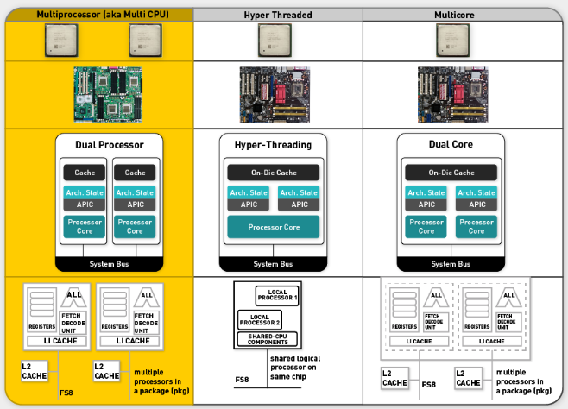
2. iPhone 6 Single CPU with Dual Cores
   1. iPhone has single CPU with dual cores
   2. And a quad-core GPU
   3. iPad: three-core CPU; eight-core GPU
3. Parallel Systems
   1. Resources: CPU, Memory, Disk, Network
   2. Many parallel architectures
      1. Shared Nothing
      2. Shared disk
      3. Shared All
   3. 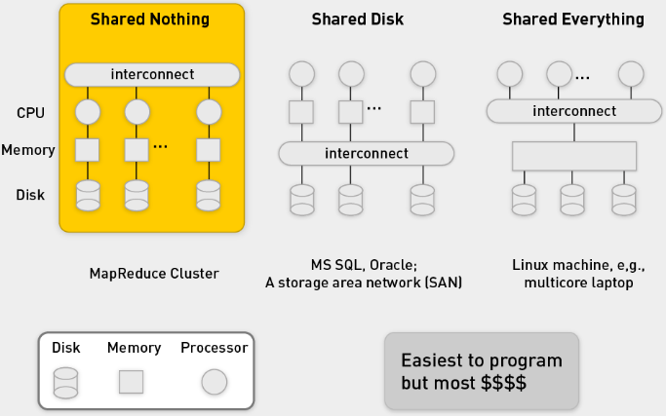
4. Shared Memory Programming
   1. Onus on the programmer
   2. In shared memory programming, the developer needs:
   3. To explicitly coordinate access to shared data structures through synchronization primitives such as mutexes
   4. To explicitly handle process synchronization through devices such as barriers
   5. To remain ever vigilant for common problems such as deadlocks and race conditions
5. Shared Nothing
   1. Shared nothing: The machines are connected only by the network (scale out).
   2. A shared nothing architecture (SN) is a distributed computing architecture in which each node is independent and self-sufficient, and there is no single point of contention across the system.
   3. A "shared nothing" architecture means that each computer system has its own private memory and private disk.
   4. The "shared nothing" architecture shares network bandwidth because it must transfer data from machines doing the map tasks to machines doing the reduce tasks over the network.
   5. In order to achieve a good workload distribution, MPP systems have to use a hash algorithm to distribute (partition) data evenly across available CPU cores.
   6. It is very popular because it is highly scalable
   7. Shared nothing is popular for Web development because of its scalability
   8. As Google has demonstrated, a pure SN system can scale almost infinitely simply by adding nodes in the form of inexpensive computers, since there is no single bottleneck to slow the system down
   9. Shard or partitioned data (e.g., distribute documents)
   10. Google calls this sharding
   11. An SN system typically partitions its data among many nodes on different databases (assigning different computers to deal with different users or queries) or may require every node to maintain its own copy of the application's data, using some kind of coordination protocol
   12. This is often referred to as database sharing
6. Shared Everything
   1. Only way to scale is to scale up
   2. Very expensive to add more memory and disk
   3. Oracle RAC does not run on a shared nothing system. It was built many years ago to run on a "shared disk" architecture.
   4. In this world, a computer system has private memory but shares a disk system with other computer systems.
   5. Such a "disk cluster" was popularized in the 1990s by Sun and HP, among others. In the 2000s, this architecture has been replaced by "grid computing," which uses shared nothing.
   6. Shared disk has well-known scalability problems when applied to database management systems (DBMSs) and is super-expensive.
   7. A storage area network (SAN) can cost $500,000 and still struggle with terabytes of data.
7. Web Search:
   1. 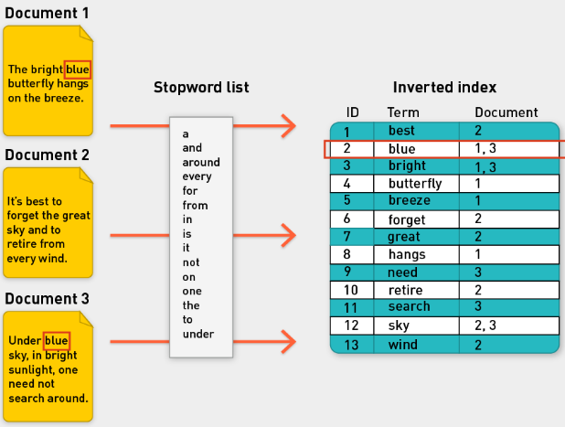
   2. Sharding: partition data
   3. Google web search in the past
   4. 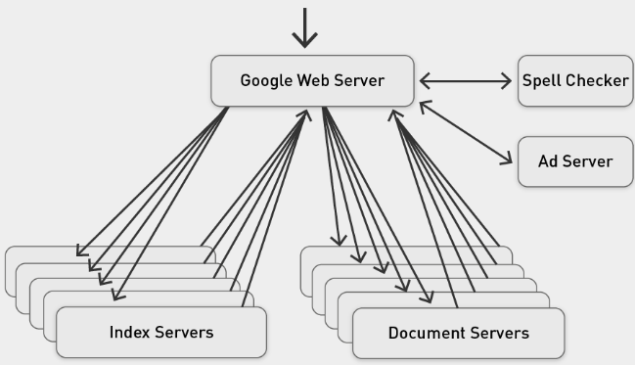
   5. Index servers have index of the documents
   6. Doc servers have contents of document
   7. Process query locally on each index server to figure out what is relevant for a query.
   8. Web server takes those results from each server, merge them, create final ranking
8. Shared Nothing Architecture
   1. 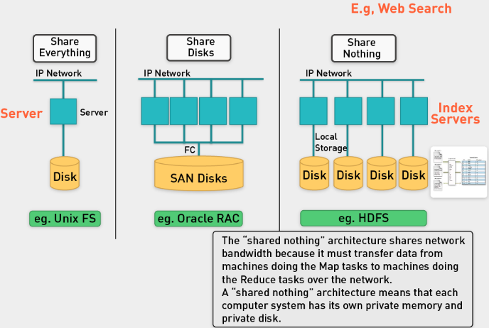

Dev frameworks for Parallel Computation

1. Frameworks for Parallel Computation
   1. Onus is on the programmer, they can do it themselves if they want
   2. Language extensions such as OpenMP (Open Multi-Processing) can be used for shared-memory parallelism
   3. OpenMP has predefined locking paradigms
      1. Reduce the chance of deadlock
      2. Not foolproof (though possibly fool resistant)
   4. Cluster and grid computing
      1. Provide logical abstractions that hide details of operating system synchronization and communications primitives
      2. MPI: Libraries implementing the Message Passing Interface (MPI) for cluster-level parallelism (same local network)
      3. MapReduce: MapReduce is a framework processing parallelizable problem across huge data sets, using a large number of computers (nodes); cluster or grid (nodes are shared across geographically or heterogeneous hardware)
2. MPI
   1. Message Passing Interface (MPI) provides a powerful, efficient, and portable way to express parallel programs.
   2. MPI is a specification for an API that allows many computers to communicate with one another.
   3. It is used in computer clusters and supercomputers.
   4. MPI was created by William Gropp, Ewing Lusk, and others.
   5. MPI, in short:
      1. Hides the details of architecture.
      2. Hides the details of message passing and buffering.
      3. Provides message management services:
      4. Packaging
      5. Send, receive
      6. Broadcast, reduce, scatter, gather message modes
   6. MPI defines an environment where programs can run in parallel and communicate with each other by passing messages to each other. There are two major parts to MPI:
      1. The environment programs run in.
      2. The library calls programs use to communicate.
   7. MPI is so preferred by users because it is so simple to use. Programs just use messages to communicate with each other. Can you think of another successful system that functions using message passing? (The Internet!)
      1. Each program has a mailbox (called a queue).
      2. Any program can put a message into another program's mailbox.
      3. When a program is ready to process a message, it receives a message from its own mailbox and does something with it.
3. MPI: Master Divides and sends data to workers
   1. 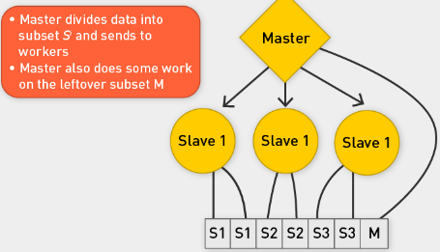
   2. Example task: Sum an array of numbers.
   3. In this program, the master divides the array into subarrays Si and sends these to each slave.
   4. Each slave will then calculate the sum of its subarray. In the case where the size of the array is not an even multiple of the number of slaves, the master will finish the remaining work by calculating the sum of the last clause of the array.
   5. 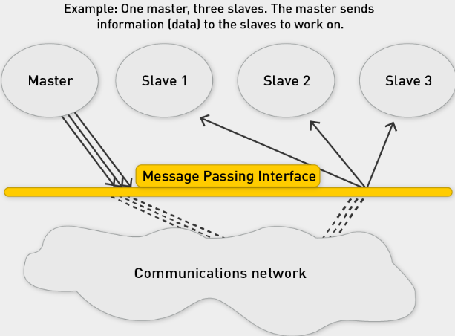
4. MPI for Big Data?
   1. Data transfer is huge problem: transmit array of numbers to slaves
   2. Requires cooperation of sender and receiver
   3. Cooperation not always apparent in code
   4. Hard for programming
   5. Explicitly communicate between nodes via message passing
   6. Synchronization is hard and error prone
   7. Not designed for fault tolerance
   8. Not designed for data locality
   9. Move data to computation nodes
   10. Network bandwidth is limited
5. Data Locality and Isolation
   1. Various patterns for parallel computation have been proposed over the years.
   2. These patterns, when composed, can be used to express computations in a wide variety of domains.
   3. Scalable approaches to parallel computation have to take two things into account: Tasks and data.
   4. Many approaches to parallel computation overemphasize the former (task) at the expense of the latter (e.g., MPI).
   5. However, in order to achieve scalable parallel performance, algorithms need to be designed in a way that emphasizes data locality and isolation.
6. MapReduce
   1. The MapReduce pattern provides a simple way for the software developer to express both data and locality in isolation.
7. Extending for Loops to Maps
   1. A set of numbers
   2. A common pattern in sequential programming is iteration
   3. If we disallow dependencies between loop iterations, we do get a type of computation that can be parallelized easily: The map pattern
   4. In the map pattern, a set of loop indices are generated, and independent computations are performed for every unique index
   5. Map is a Design pattern
   6. Map is a design pattern in parallel computing where a simple operation is applied to all elements of a sequence, potentially in parallel.
   7. It is used to solve embarrassingly parallel problems:
   8. Those problems that can be decomposed into independent subtasks, requiring no communication or synchronization between the subtasks except a join or barrier at the end
   9. The map pattern is typically combined with other parallel design patterns. E.g., map combined with category reduction gives the MapReduce pattern:
   10. A straightforward way to express both data locality and isolation.
8. MR frameworks
   1. Some parallel programming systems, such as OpenMP and Cilk, have language support for the map pattern in the form of a parallel for loop; languages such as OpenCL (Open Computing Language) and CUDA (Complete Unified Device Architecture) support elemental functions (as "kernels") at the language level
   2. Limitations of these frameworks:
      1. Developers are still burdened to keep track of how resources are made available to workers
      2. Additionally, these frameworks are mostly designed to tackle processor-intensive problems and have only rudimentary support for dealing with very large amounts of input data
   3. MapReduce-Hadoop-Spark to the rescue!
   4. Distributed data handling, and distributed computation, framework that hides system-level details
9. MR: Move code to the data
   1. Distributed data handling and storage
      1. Terabytes and petabytes in size
      2. Large-data processing by definition requires bringing data and code together for computation to occur; no small feat for huge data sets
      3. MapReduce addresses this challenge by providing a simple abstraction for the developer, transparently handling most of the details behind the scenes in a scalable, robust, and efficient manner
   2. Distributed computation: Move the code to the data
      1. Like OpenMP and MPI, MapReduce provides a means to distribute computation without burdening the programmer with the details of distributed computing (but at a different level of granularity)
      2. But instead of moving large amounts of data around, it is far more efficient, if possible, to move the code to the data
      3. This is operationally realized by spreading data across the local disks of nodes in a cluster and running processes on nodes that hold the data
10. MR + Scalability and Fault Tolerance
    1. Inspired by functional programming: The model is inspired by the map and reduce functions commonly used in functional programming, although their purpose in the MapReduce framework is not the same as in their original forms
    2. Scalability and fault tolerance: The key contributions of the MapReduce framework are not the actual map and reduce functions but the scalability and fault tolerance achieved for a variety of applications by optimizing the execution engine once
    3. Optimizing the communication: Optimizing the communication cost is essential to a good MapReduce algorithm
    4. The use of this model is beneficial only when the optimized distributed shuffle operation (which reduces network communication cost) and fault-tolerance features of the MapReduce framework come into play
11. Why use MR?
    1. Increase computational power: linear scalability
    2. Must be able to split up the data in chunks for processing, which are then recombined later
    3. Requires a constant flow of data from one simple state to another
    4. The Hadoop framework handles the processing details, leaving developers free to focus on application logic
    5. Within the Hadoop Core framework, MapReduce is often referred to as mapred, and HDFS is often referred to as dfs
    6. MRs ideal for "embarrassingly parallel" problems
    7. Very little communication
    8. Easily distributed
    9. Linear computational flow

Hadoop Background and History

1. MR
   1. MapReduce is a programming model for processing and generating large data sets with a parallel, distributed algorithm on a cluster
   2. Pioneered by Google
   3. Processes 20 PB of data per day
   4. Popularized by open-source Hadoop project
   5. Used by Yahoo!, Facebook, Amazon, NativeX, …
   6. Distributed file system (HDFS)
      1. Single namespace for entire cluster
      2. Replicates data three times for fault tolerance
   7. MapReduce implementation
      1. Executes user jobs specified as "map" and "reduce" functions
      2. Manages work distribution and fault tolerance
2. What is it used for?
   1. 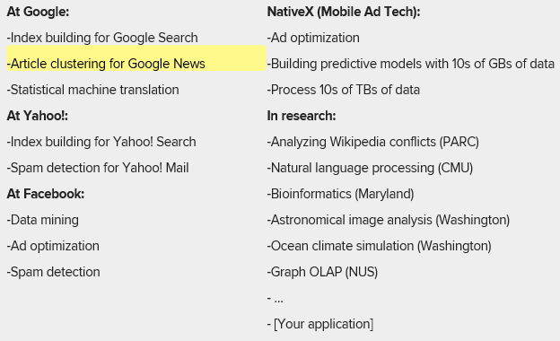
   2. And for ML
3. Hadoop Ecosystem
   1. 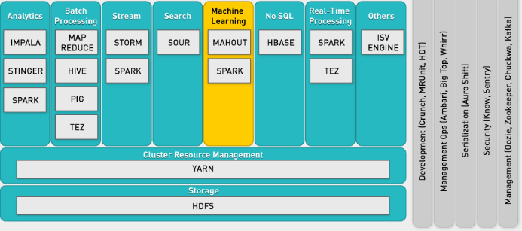
4. What is Hadoop?
   1. The Apache Hadoop project develops open-source software for reliable, scalable, distributed computing. Hadoop includes:
   2. Hadoop Common utilities.
      1. Avro, a data serialization system with scripting languages.
      2. HDFS, a distributed file system.
      3. Hive, data summarization and ad hoc querying.
      4. MapReduce, distributed processing on compute clusters.
5. Master slave architecture
   1. Hadoop follows the master-slave architecture described in the original MapReduce paper.
   2. Since Hadoop consists of two parts—data storage (HDFS) and processing engine (MapReduce)—there are two types of master node.
   3. Types of node:
   4. For HDFS, the master node is namenode, and slave is datanode.
   5. For MapReduce in Hadoop, the master node is jobtracker, slave node is task tracker
   6. 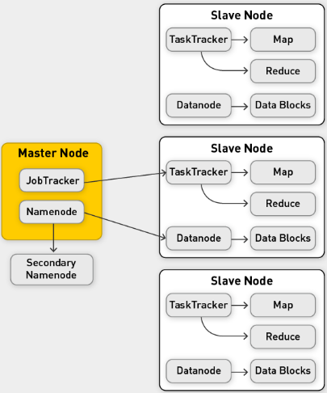

HDFS

1. HDFS
   1. Big files (Petabytes)
   2. Typical usage patterns
      1. Append only
      2. Rarely update in place
      3. Reads common
   3. Optimized for large files, sequential reads
   4. 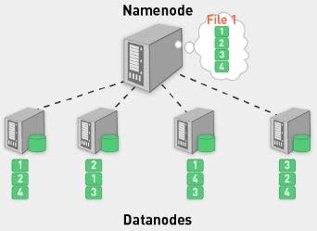
   5. Files split into blocks (chunks): 64-128MB, today 1-2GB recommended
   6. Blocks are replicated (usually three times) across several datanodes (called chunk or slave nodes)
   7. Computation is done at chunk node (close to data)
   8. Single namenode (master node) stores metadata (file names, block locations, etc.)
   9. May be replicated also
   10. Datanodes provide redundant store for the data blocks
   11. Client library provides file access
   12. Talks to master to find chunk servers
   13. Connects directly to chunk servers to access data
   14. Master nodes not a bottleneck
2. Hadoop Cluster
   1. 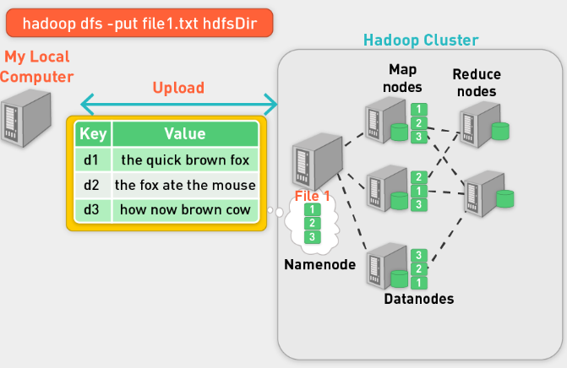
   2. Take data from local computer, put it in HDFS
   3. We upload three files, they are distributed by namenode to datanodes
   4. 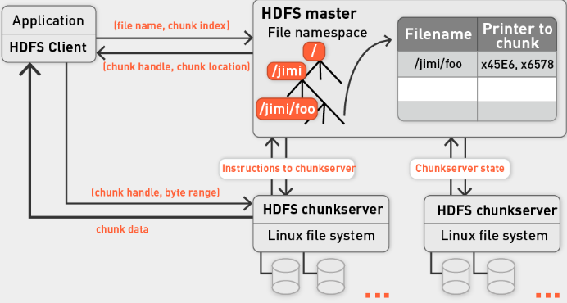
   5. Default: 3x replication
   6. HDFS is Rack-aware when placing blocks
   7. Dynamic control for replication factor
   8. Balancer application to rebalance cluster in background
3. HDFS commands
   1. 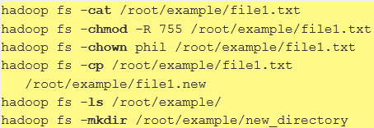
4. Write file in HDFS
   1. 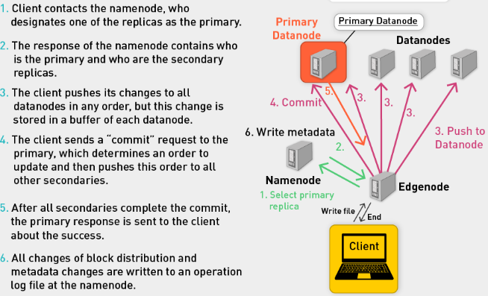
5. Summary:
   1. Hadoop file system
   2. Master-slave architecture
   3. Organized data
   4. How to get data in
   5. How to get data out
   6. HDFS goals
   7. Store large data sets
   8. Deal with hardware failures
   9. Emphasize streaming data access

MR: Functional Programming

1. Functional Programming: M and R
   1. Key feature: higher-order functions that accept other functions as arguments
   2. Map and reduce are such functions
2. Map: A higher order function
   1. 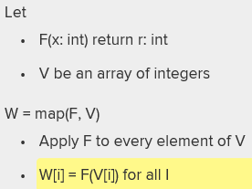
   2. Example in Haskell
   3. 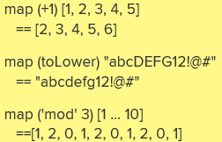
3. Reduce
   1. 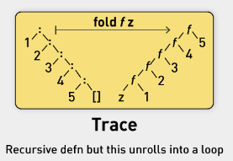
   2. 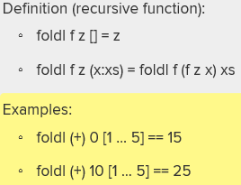
   3. You need to pass a starting point, an operator and the array
   4. Fold left type of reduce functions can be defined recursively
4. MR from FP
   1. 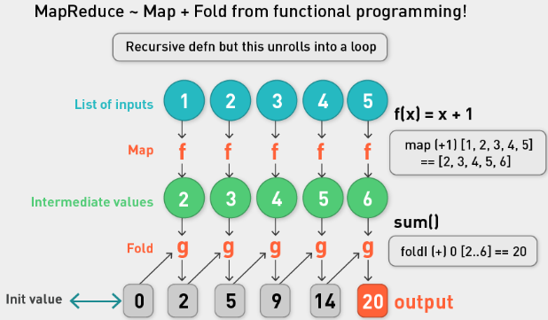
5. FP
   1. FP is all about the evaluation of mathematical functions and avoids changing state and mutable data.
   2. It is a declarative programming paradigm, which means programming is done with expressions.
   3. In functional code, the output value of a function depends only on the arguments that are input to the function, so calling a function f twice with the same value for an argument x will produce the same result f(x) each time.
   4. This is an abstract diagram; despite this, you can see the potential for parallelism, especially in the map phase.
   5. It is lazy: only works when it requires an answer. Hadoop isn’t lazy.

Hadoop: MapReduce

1. From FP to MR
   1. Map corresponds and reduce corresponds approximately.
   2. The map phase in MapReduce roughly corresponds to the map operation in functional programming, whereas the reduce phase in MapReduce roughly corresponds to the fold operation in functional programming.
   3. MR framework takes care of the execution, data processing, storage (HDFS). MR does the rest.
2. Data
   1. 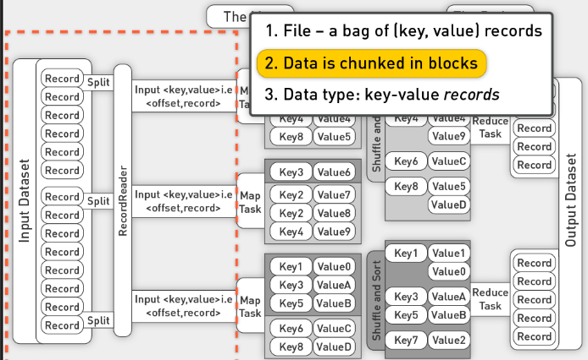
   2. Decompose large file into records
   3. Delimited by carriage return
   4. Split into records that are fed into a map task
   5. The map task creates a key and value pair
   6. Mapper operates on each record, produces output that is shipped off to reducers
   7. Reducer accepts a key and a list of values with the same key
   8. Process list of values and key, stores result on disk
   9. What is restriction of key/val pair: Each pair must be small enough to fit into one single machine; e.g., a document should be fine, an image should be fine, but 1PB value is probably not.
3. Mapper
   1. takes key-value pair
   2. produces key-value pair
   3. framework uses protocol to move data from mapper to reducer: each record with same key value is routed to same reducer
   4. divide and conquer in both mapper and reducer
4. Reducer
   1. Gets list of values associated with a key
   2. Produces output as result.
5. MR Example Sum (X^2)
   1. 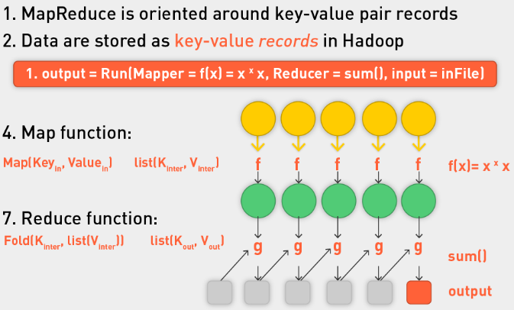
   2. We can reduce to multiple key values, not just one
6. MR
   1. Framework for big data
   2. Codify generic recipe for processing large data sets that consist of two stages
   3. Programmer and execution framework synergy
   4. Just provide the mapper and reducer functions
   5. The programmer defines these two types of computations, and the execution framework coordinates the actual processing (very loosely, MapReduce provides a functional abstraction)
   6. Very powerful: Many interesting algorithms can be expressed quite concisely
   7. Although such a two-stage processing structure may appear to be very restrictive, many interesting algorithms can be expressed quite concisely, especially if one decomposes complex algorithms into a sequence of MapReduce jobs
7. Summary
   1. MR cluster of machines
   2. Each machine is storage node and computational node
   3. The framework will convert each record of input into a key-value pair.
   4. The framework will convert each record of input into a key-value pair, and each pair will be input to the map function once.
   5. The map output pairs are grouped and sorted by key.
   6. The map output is a set of key-value pairs—nominally, one pair that is the transformed input pair, but it is perfectly acceptable to output multiple pairs.
   7. The reduce function is called one time for each key, in sort sequence, with the key and the set of values that share that key.
   8. Reduce outputs to file:
   9. The reduce method may output an arbitrary number of key-value pairs, which are written to the output files in the job output directory.
   10. If the reduce output keys are unchanged from the reduce input keys, the final output will be sorted.

Animated Examples

1. Count example
   1. Count words in each example
   2. We have three documents
   3. 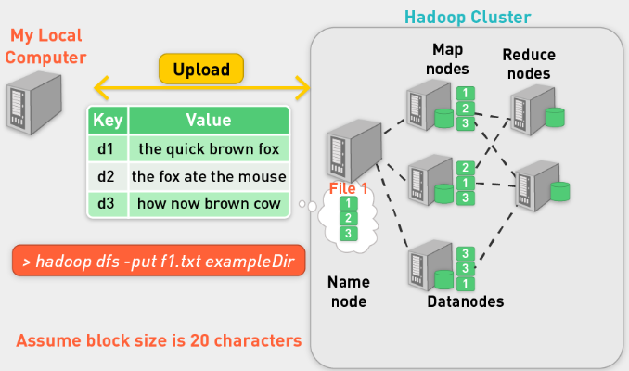
   4. Use hdfs put to upload data, each file gets its own node in this case
   5. 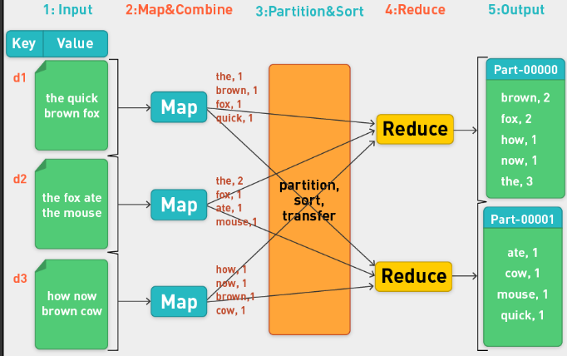
   6. Key is d1, d2, d3 identifiers
   7. Map produces (key,val) as (word,intermediateCount)
   8. Framework partitions data so that records with the same key routed to the same reducer.
   9. Take key (brown) and sum up individual values for that word.
   10. Two parts of the output file, one for each reducer.
   11. There is a record for each word
2. High Level
   1. Specify
   2. Mapper
   3. Reducer
   4. Where data is
   5. Where output should be
   6. 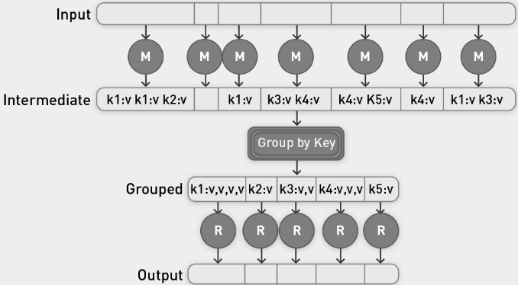
   7. Group by the key of the key,value pairs.
3. MR: Word Count from a Word Stream
   1. 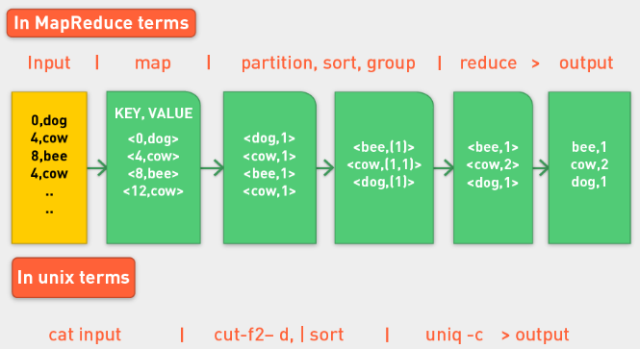
   2. Unix commands replicate functionality of MR world
4. Word Count Pseudo Code
   1. 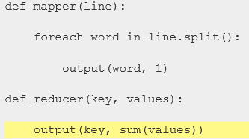
   2. Python:
   3. 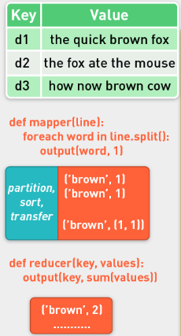
   4. Java:
   5. 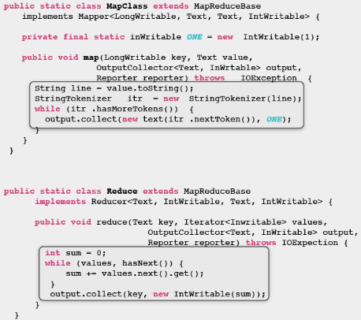
5. Contract with the programmer
   1. The frozen part of the MapReduce framework is a large distributed sort. The hot spots, which the application defines, are:
      1. An input reader
      2. A map function*
      3. A partition function
      4. A compare function
      5. A reduce function*
      6. An output writer
      7. *Required from programmer (generally)
6. Character count
   1. 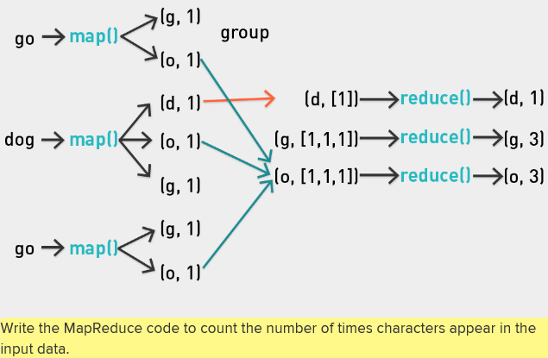
7. Hadoop: Native Java or Streaming
   1. Although the Hadoop framework is implemented in Java, MapReduce applications need not be written in Java.
   2. Hadoop provides an API to MapReduce that allows you to write your map and reduce functions in languages other than Java (e.g., Python, Ruby, Perl, etc.).
   3. **Hadoop Streaming** uses Unix standard streams as the interface between Hadoop and your program, so you can use any language that can read standard input and write to standard output to write your MapReduce program.
   4. Hadoop Streaming is a utility that allows users to create and run jobs with any executables (e.g., shell utilities) as the mapper or the reducer.
8. Python example with Hadoop Streaming
   1. 
   2. 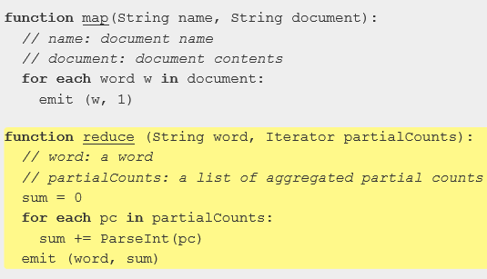
   3. Hadoop Streaming is a utility that comes with the Hadoop distribution.
   4. The utility allows you to create and run MapReduce jobs with any executable or script as the mapper or reducer.
   5. 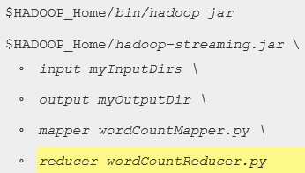
9. Word count stream
   1. 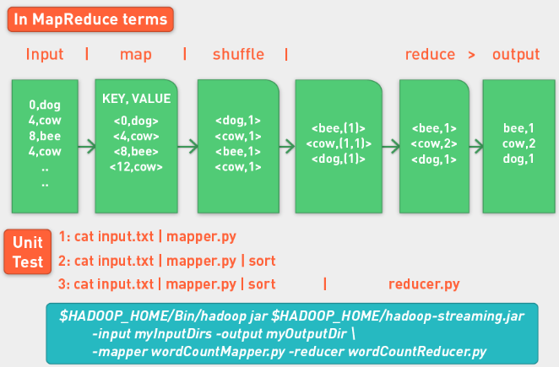
   2. Unit test mapper and reducer

Summary

1. Parallel Computing
   1. Motivation for parallel computing
   2. Parallel computing (PC)
   3. Definition, communication and synchronization, types of PC tasks
   4. Architectures for parallel computation
   5. Developer frameworks for parallel computation
2. Hadoop
   1. Background and history
   2. Hadoop Distributed File System (HDFS)
   3. MapReduce
   4. Functional programming
   5. MapReduce
   6. Animated examples
   7. Hadoop in practice
   8. Full-code examples
   9. Word count example on local machine
   10. Word count example on cluster
   11. MapReduce: Runtime environment

## Lecture:

* Treat function like a parameter or variable, input to another function
* Proximity function: like Euclidean distance, for example; you can pass in different proximity functions to other functions
* Substitute in different functions for the mapper and the reducer.
* Map applies same function to each element that is iterated
* Reducer: iterates over fixed values for a single key
* Python apply(func, args) applies a function to any number of args
* Python filter() function takes function and iterable and returns a list. Function must return true or false for each element of the iterable. If true, element enters list that will be returned
* Reduce(function, iterable[,initializer]): initializer can sit as the first argument in the sum, function application. We get a single output
* Shortly after Google MR paper, a lot of people release paper for MR and ML.
* Classifying spam
  + We have email that’s classified as spam or ham
  + Divide them in two piles
  + Count frequency of words in spam pile and frequency of words in ham pile and compare
* Hadoop Streaming
  + Comes from Hadoop distribution
  + 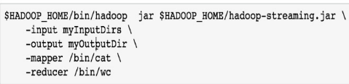
  + We need to define mapper and reducer (python functions)
  + Shuffle phase sends data to reducer in right order. Hadoop really good at sorting, let it do it.
* Bayes Rule
* 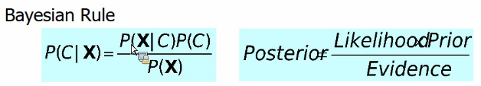
* 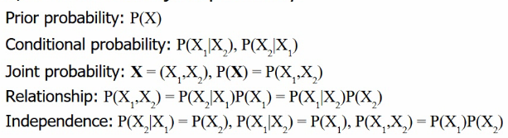
* Interested in classification, so probability of C=spam or ham given the example.
* Easier to count probability of seeing these words, given the classification, we know this because we have labelled data. P© just count examples with this classification. P(X) count occurrence of these words. To get it for a list of words, we make bayes assumption of independence. Therefore P(X|C)=P(word1|C)*P(word2|C)
* 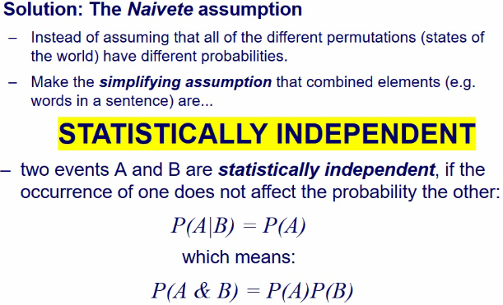
* Learning classifiers based on Bayes Rule
* 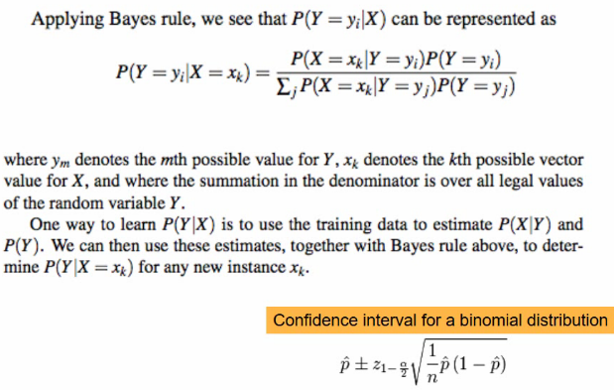
* To get P(X=x1|Y=y1), count number of time the word x1 appears in emails classified as y1 and divide by the total number of words in emails classified as y1
* 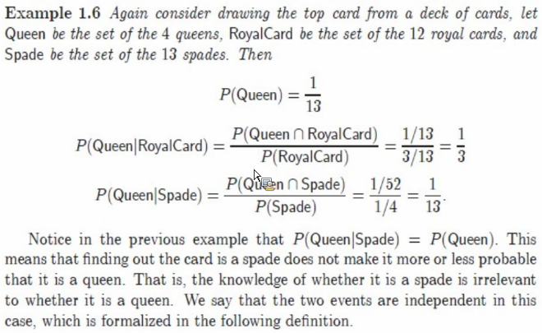
* 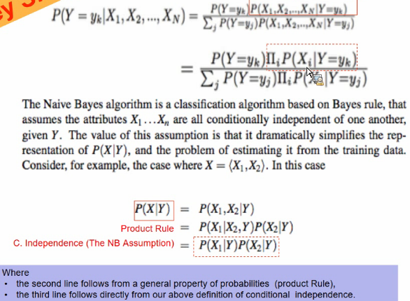
* 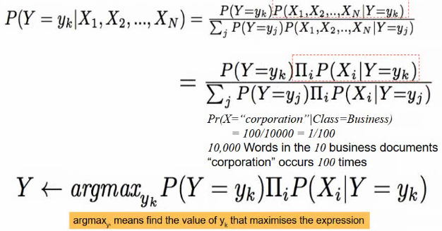
* After you do counts but before doing multiplications, take log of values.
* 
* Will this normalizer work the right way?
* This stops you multiplying by zero for words that don’t appear often. This also stops overtraining.
* 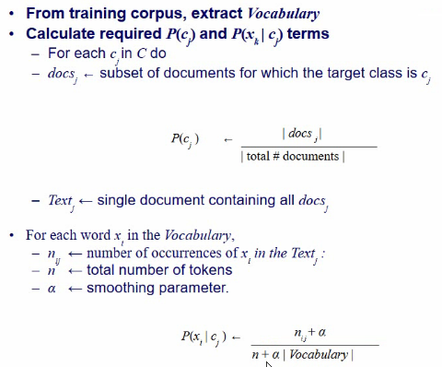
* Alpha equal to one, we get previous slide
* 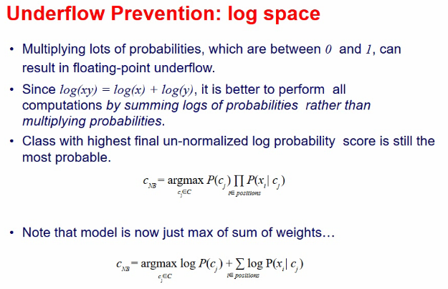
* Best to sum logs of probabilities than multiplying probabilities.
* See rest of slides for more details on NB and HW2.

# Unit 3: MapReduce Algorithm Design

## Videos:

Introduction

1. Contract with programmer
   1. Data
   2. Mapper
   3. Reducer
   4. Optional: combiner, partitioner
2. All else is handled transparently by framework
3. Design Patterns for MapReduce
   1. Design mappers
   2. Design reducers
   3. Combiners if we need
4. When and how to partition data
5. Useful for ML
6. Relationship between
   1. Memory
   2. Disk
   3. Bandwidth
7. Data structures
8. Hadoop Shuffle
9. Local aggregation
10. Pairs and stripes
11. Secondary sorting
12. Scaling tricks

Background: RAM vs Disk vs Bandwidth

1. Hadoop Workflow
2. Divide and conquer
   1. 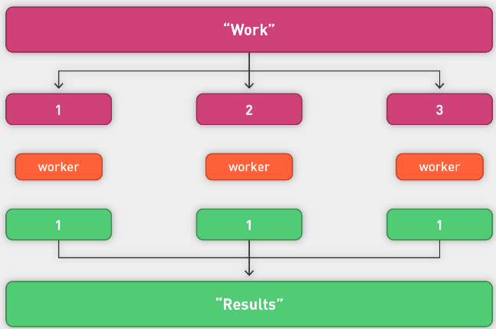
   2. Adds burden to sync and communicate results
   3. Hadoop takes care of a lot of this sync and communication, as well as fault tolerance
   4. Other systems are compute-centric, but don’t cater for big data
3. Sync and coordinate
   1. Modeled after Lisp primitives:
   2. Map (apply function to all items in a collection)
   3. Reduce (apply function to set of items with a common key)
   4. Synchronization and coordination in distributed tasks is key
   5. E.g., reducer is a big target of communication and synchronization (barrier between map and reduce)
   6. Need to get all data for a particular key to the same location
   7. How to achieve sync?
      1. Keys
      2. Sorting and secondary sorting
      3. Partitioning
      4. Framework or in-memory mappers or reducers
4. Communicate through files and streams
   1. Abstraction: Instead of sending messages, different pieces of code communicate through files
   2. Code is going to take a very "stylized" form; at each stage each machine will get input from files, send output to files
   3. Files are generally persistent, nameable (in contrast to distributed hash table messages, which are transient)
   4. Files consist of blocks, which are the basic unit of partitioning (in contrast to object or data item IDs)
   5. Server is stateless, so clients must send all context (including position to read from) in each request
5. Reading data from Disk
   1. Also transfer data over network
   2. Sometimes quickly read from memory (100x faster)
   3. 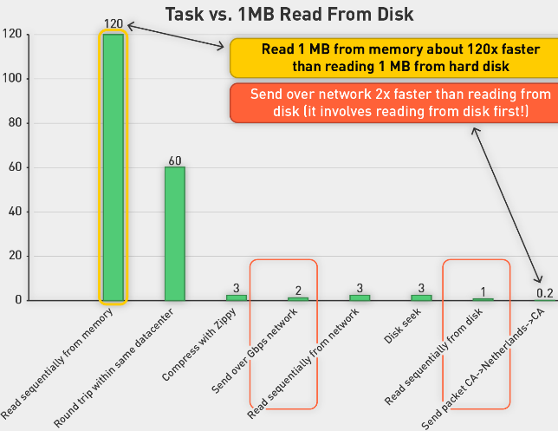
   4. Transferring is faster than disk, but usually followed by write to disk.
   5. Try to put in memory

Background: Priority Queues and Merge Sort

1. Priority queue
   1. Queue: list of elements to be consumed by a thread
   2. LIFO, FIFO
   3. Each element has priority in priority queue
   4. 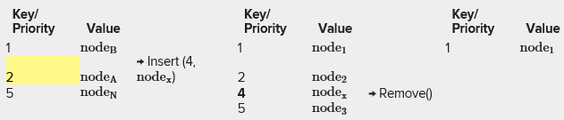
   5. First element of queue has highest priority
   6. Main methods of the priority queue abstract data type:
   7. insert(k, x): Inserts an entry with key k and value x
   8. removeMin(): Removes and returns the entry with smallest key
   9. Maintained priority queue always sorted
   10. A priority queue stores a collection of entries, where each entry is a pair (key, value), where the key is priority; these entries are sorted in order of decreasing priority
   11. Priority queues used throughout Hadoop
2. Merge Two Sorted Lists or Arrays
   1. We have three pointers:
      1. Start of first sorted list
      2. Start of second sorted list
      3. Start of merged list
   2. Keep picking the smallest element and move it to a temp array, incrementing corresponding indices.
   3. 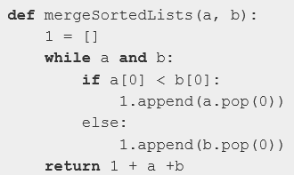
3. Merge algorithms
   1. Complexity of O(mlogn)
   2. Given n sorted lists, let m= sum of lengths of the lists
   3. Merge can use a heap-based priority queue : Merge algorithms that operate on large numbers of lists at once will multiply the sum of the lengths of the lists by the time to figure out which of the pointers points to the lowest item, which can be accomplished with a heap-based priority queue in O(log n) time, for O(m log n) time, where n is the number of lists being merged and m is the sum of the lengths of the lists. When merging two lists of length m, there is a lower bound of 2m − 1 comparisons required in the worst case.

Background: Internals of Hadoop Shuffle

1. Recap of MR
   1. Specify map, reduce, partition and combine function
   2. Partition (k', number of partitions) → partition for k'
      1. Often a simple hash of the key, e.g., hash(k') mod n
      2. Divides up key space for parallel reduce operations
   3. Combine (k', v') → <k', v'>*
      1. Mini-reducers that run in memory after the map phase
      2. Used as an optimization to reduce network traffic
   4. Framework deals with
      1. Scheduling: Assigns workers to map and reduce tasks
      2. "Data distribution": Moves processes to data
      3. Synchronization: Gathers, sorts, and shuffles intermediate data
      4. Errors and faults: Detects worker failures and restarts
      5. Limited control over data and execution flow
      6. All algorithms must be expressed in m, r, c, p
   5. You don't know:
      1. Where mappers and reducers run
      2. When a mapper or reducer begins or finishes
      3. Which input a particular mapper is processing
      4. Which intermediate key a particular reducer is processing
   6. A lot going on under the covers
2. Communication Hot spot: transferring between M and R
   1. 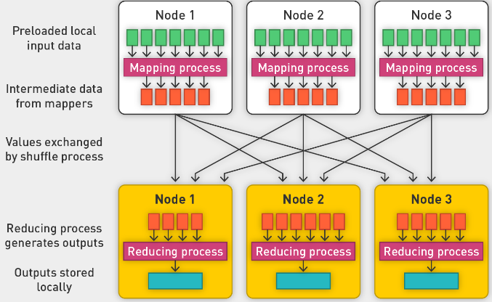
   2. Records with same key must be processed by same reducer
   3. Incur a lot of communication traffic.
3. In-Mapper combiner
   1. A mapper-side function allows us to combine records with the same key
   2. 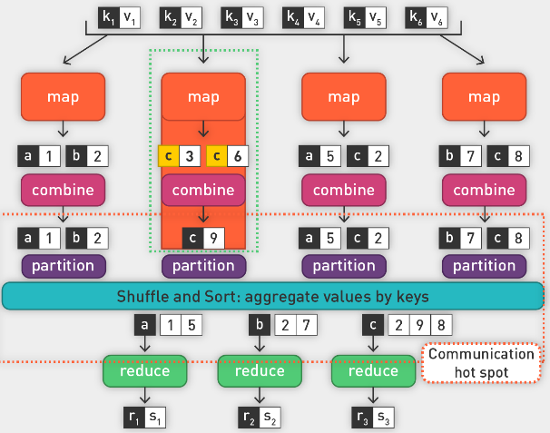
   3. Reducing the number of tuples to be processed by shuffle and reducers.
4. Shuffle: Heart of MR
   1. Makes sure input of every reducer is sorted by key
   2. We can take control of picking the key
   3. Performing the sort and transferring the data is know as the shuffle
   4. Partition, sort, combine: do in memory if possible, otherwise on disk
   5. 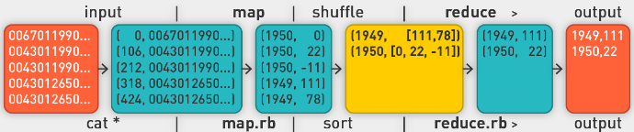
5. Partition, sort and combine
   1. 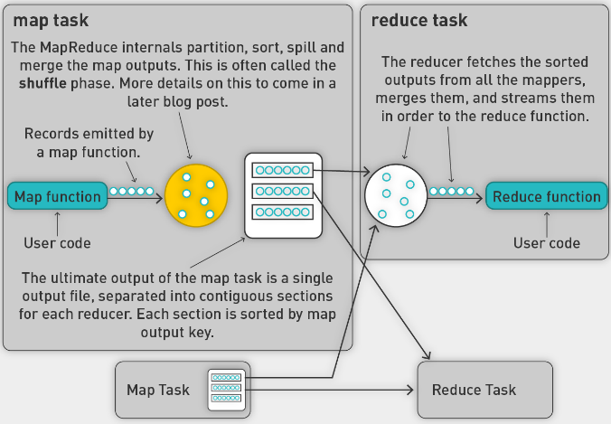
   2. In memory:
      1. Partition output of mapper into separate files (one for each reducer)
      2. Can look at first letter of key and put in its own bucket: 26 buckets.
      3. MR has internal partition functions based on hashing
6. Shuffle on disk
   1. Map side: Map outputs are buffered in memory in a circular buffer (in-memory shuffle, i.e., partition, sort, combine). First task is to assign output record to partition. Records in same partition are sorted. We use combine function to combine records of the same key. Then pass to reducer.
   2. When buffer reaches threshold, sorted contents are spilled to disk
   3. Spills (sorted) are merged in a single, partitioned file (sorted within each partition)
   4. Combiner runs on the sorted partition file
   5. We do this continually.
   6. Make sure all spills are sort-merged.
   7. We can transfer sorted partition file to reducer
   8. Reducer side: receive multiple sorted files from multiple mappers. "Sort" is a multipass merge (merge-sort) of map outputs (happens in memory and on disk); combiner runs here.
   9. Produce stream of values which can be put in the reducer input stream.
7. Things we control
   1. When the contents of the buffer reach a certain threshold size (mapreduce.map.sort.spill.percent, which has the default 0.80, or 80%), a background thread will start to spill the contents to disk.
   2. Map outputs will continue to be written to the buffer while the spill takes place, but if the buffer fills up during this time, the map will block until the spill is complete.
8. Summary
   1. 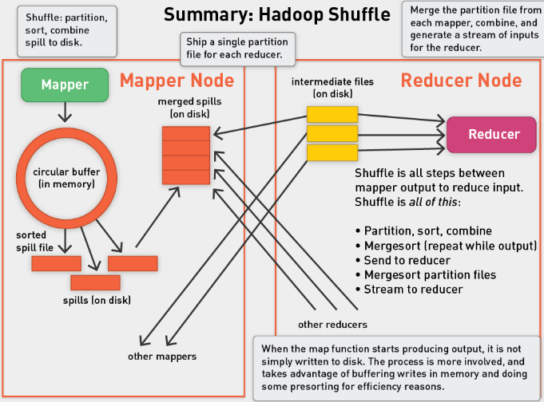

Local Aggregation Combiners and In-Mapper Combining

1. Divide and Conquer
   1. Ideal scaling characteristics (linear scaling):
      1. Twice the data, twice the running time
      2. Twice the resources, half the running time
   2. Why can't we achieve this?
      1. Communication kills performance
      2. Synchronization requires communication
   3. Thus … avoid communication?
      1. Reduce intermediate data via local aggregation
      2. Combiners, in-memory mappers, and reducers can help
2. Individual M and R
   1. All mappers and reducers have a common goal.
   2. To solve a job, they need to work as a team.
   3. Teamwork requires communication and synchronization.
   4. Mappers and reducers run in isolation without any mechanisms for direct communication.
   5. Synchronization or merging of results can be the most tricky aspect of designing MapReduce algorithms (or, for that matter, parallel and distributed algorithms in general).
   6. Within a single MapReduce job, there is only one opportunity for cluster-wide synchronization—during the shuffle and sort stage where intermediate key-value pairs are copied from the mappers to the reducers and grouped by key.
3. Local Aggregation
   1. In the context of data-intensive distributed processing, the single most important aspect of synchronization is the exchange of intermediate results from the processes that produced them to the processes that will ultimately consume them.
4. Tools for Sync
   1. Cleverly constructed data structures for bringing partial results together
   2. Sort order of intermediate keys: control order in which reducer processes keys
   3. Partitioner: control which reducer processes which keys
   4. Preserving state in M and R: captures dependencies across multiple keys and values
5. Word count: Baseline
   1. 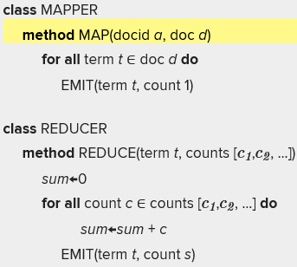
   2. Emit each word … heavy disk storage requirements on mapper side; big sorts; big transfer from mapper to reducer
   3. What's the impact of combiners?
   4. Can reduce storage and transfer requirements by 50%
6. Other forms of local optimization
   1. Data has gravity, heavy to move around network
   2. In-mem mappers and reducers?
7. Mappers are Java Objects with Init and State
   1. In Hadoop, mappers are Java objects with a map method (among others).
   2. A mapper object is instantiated for every map task by the task tracker.
   3. The life cycle of this object begins with instantiation, where a hook is provided in the API to run programmer-specified code.
   4. This means that mappers can read in "side data," providing an opportunity to load state, static data sources, dictionaries, etc.
   5. After initialization, the map method is called (by the execution framework) on all key-value pairs in the input split.
   6. Since these method calls occur in the context of the same Java object, it is possible to preserve state across multiple input key-value pairs within the same map task. This is an important property to exploit in the design of MapReduce algorithms, as we will see in the next chapter.
   7. After all key-value pairs in the input split have been processed, the mapper object provides an opportunity to run programmer-specified termination code. This, too, will be important in the design of MapReduce algorithms.
   8. The actual execution of reducers is similar to that of the mappers.
8. WC V1: Record-level combiner
   1. Keep local tally of values that can be emitted
   2. 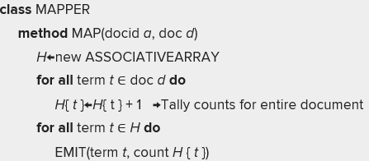
   3. Issues:
      1. Disk
      2. CPU
      3. Memory
   4. We still need combiners to combine instances from different mappers.
9. WC V2: In-memory mapper combiner
   1. 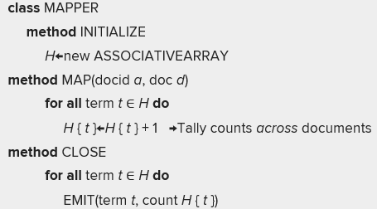
   2. For each mapper, we create an associative array
   3. Each document that is processed increments counts in the hash table
   4. Resolves: Disk, CPU and network issues, but has memory issues as HT may grow to be very big for a huge corpus of words
   5. Combining has small footprint on disk and on network, but memory issues.
   6. You still need combiners on reducer side
   7. Combiners can be run to consolidate results before putting them into the REDUCE stream.
10. Design pattern for local aggregation
    1. "In-mapper combining"
    2. Fold the functionality of the combiner into the mapper by preserving state across multiple map calls
    3. Advantages
    4. Speed
    5. Why is this faster than actual combiners?
    6. Disadvantages
    7. Explicit memory management required
    8. Potential for order-dependent bugs

Local Aggregation: Algorithmic correctness

1. Associative (Grouping) property
   1. Within an expression containing two or more occurrences in a row of the same associative operator, the order in which the operations are performed does not matter as long as the sequence of the operands is not changed.
   2. That is, rearranging the parentheses in such an expression will not change its value.
   3. 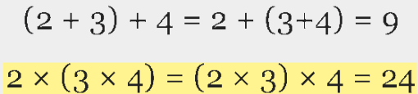
2. Commutative Property
   1. In mathematics, a binary operation is commutative if changing the order of the operands does not change the result. The term commutative is used in several related senses.
   2. 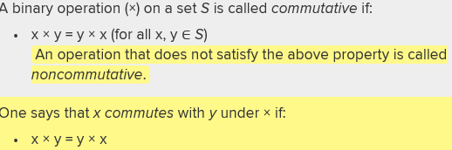
3. Combiner design
   1. Both associative and commutative
   2. Combiners and reducers share the same method signatures
   3. They are optional optimizations, so should not affect algorithm correctness
   4. Hadoop makes no guarantees; could be run 0,1 or multiple times
   5. Combiners need to be associative and commutative
   6. Example: Find average of all integers associated with the same key
4. Simple Problem
   1. We have a large dataset where input keys are strings and input values are numeric, and we wish to compute the mean of all numerics associated with the same key.
   2. Customer log file (e.g., purchase transactions)
   3. A real-world example might be a large user log from a popular website, where keys represent user ids and values represent some measure of activity, such as elapsed time for a particular session. The task would correspond to computing the mean session length on a per-user basis, which would be useful for understanding user demographics.
   4. 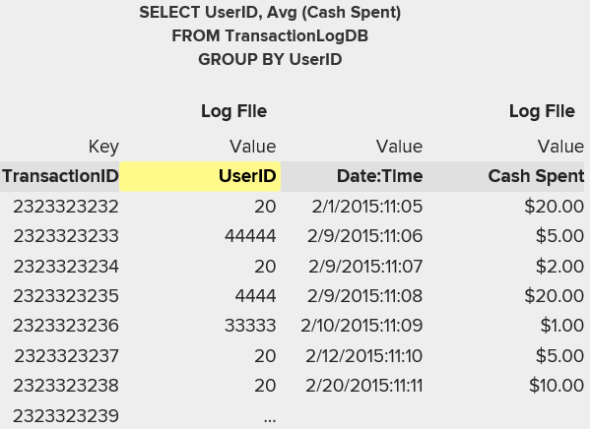
5. Computing the Mean: V1, no combiner
   1. 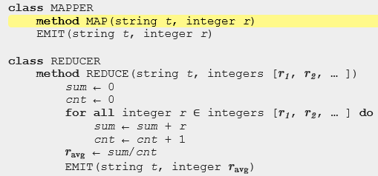
   2. Can we use reducer as combiner? No, mean is not associative operation:
   3. 
   4. Challenge: How can we transform a nonassociative operation (mean of numbers) into an associative operation?
   5. (Element-wise, sum of a pair of numbers, and a count, with an additional division at the very end)
6. Computing the Mean: V1, combiner
   1. 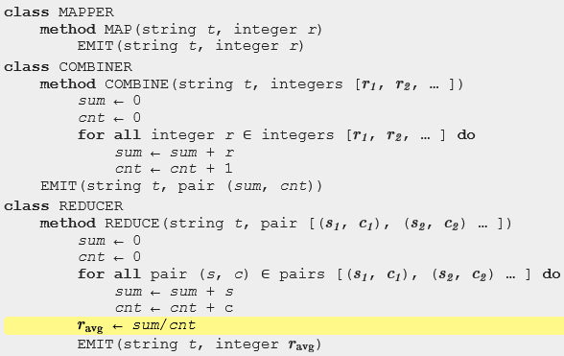
   2. Combiner is mirror image of reducer without the division step. We are doing a local accumulation for transactions for each user ID.
   3. However, there is no guarantee that we get combiner at all. If we don’t call it, there will be a mismatch between mapper output and reducer input.
7. Computing the Mean: Version 3
   1. 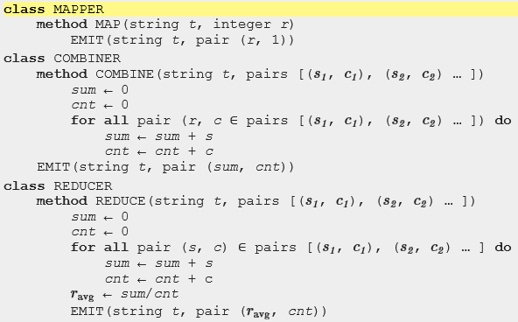
   2. Combiners and reducers share the same method signature.
   3. Remember: Hadoop makes no guarantees; could be run zero, one, or multiple times.
   4. Combiners need to be associative and commutative.
   5. Note that although the output key-value type of the combiner must be the same as the input key-value type of the reducer, the reducer can emit final key-value pairs of a different type.
8. Solution to our challenge
   1. How can we transform a nonaassociative operation (mean of numbers) into an associative operation?
   2. Choose a combiner operation that is commutative and associative (addition/sum is!)
   3. Element-wise sum of a pair of numbers, with an additional division at the very end

How Many Maps and Reduces?

1. Hadoop Wiki: <http://wiki.apache.org/hadoop/HowManyMapsAndReduces>
2. How many Maps and Reduces in cluster?
   1. Picking the appropriate size for the tasks for your job can radically change the performance of Hadoop.
   2. Increasing the number of tasks increases the framework overhead but increases load balancing and lowers the cost of failures.
   3. At one extreme is the one map/one reduce case, where nothing is distributed. The other extreme is to have 1,000,000 maps/1,000,000 reduces, where the framework runs out of resources for the overhead.
   4. The number of reduce tasks can also be increased in the same way as the map tasks, via **JobConf's conf.setNumMapTasks(int num).**
   5. The number of maps is usually driven by the number of DFS blocks in the input files.
   6. Although that causes people to adjust their DFS block size to adjust the number of maps.
   7. The right level of parallelism for maps seems to be around 10–100 maps/node, although we have taken it up to 300 or so for very CPU-light map tasks. Task setup takes a while, so it is best if the maps take at least a minute to execute.
   8. E.g., if you expect 10TB of input data and have 128MB DFS blocks, you'll end up with 82k maps, unless your mapred.map.tasks is even larger.
   9. 128MB block size for 10TB job → 82k maps 10–100 maps per node; each map takes one minute
3. Back-of-the-Envelope Estimates: 10TB
   1. 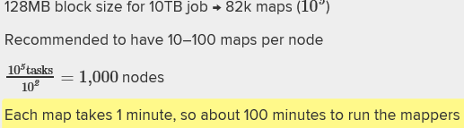
   2. Number of reducers
   3. The ideal reducers should be the optimal value that gets them closest to:
   4. A multiple of the number of blocks
   5. A task time between 5 and 15 minutes
   6. Creating the fewest files possible
   7. The number of reduce tasks can also be increased in the same way as the map tasks, via JobConf's conf.setNumReduceTasks(int num).
4. How many?
   1. Empirical question best solved by taking this guidance and experimenting with some small jobs and establishing the length of map and reduce tasks at different block sizes, etc.
   2. Block sizes of 128MB to 1GB
5. Computing the mean: V4, In-memory mapper
   1. 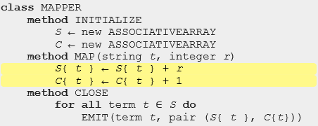
   2. Super-efficient: no shuffling!
   3. Inside the mapper, the partial sums and counts associated with each string are held in memory across input key-value pairs. Intermediate key-value pairs are emitted only after the entire input split has been processed; similar to before, the value is a pair consisting of the sum and count. The reducer is exactly the same as above.
   4. We can run out of memory easily. Do we need a combiner? Yes, I think they are still needed.

Pairs and Stripes

1. Sync in streams!
   1. Change example and change gears here to introduce some more design patterns for communication efficiency and for synchronization
   2. Previous example: Grouping by customer ID to get average amount spent by customer
   3. Next, we want to explore more challenging examples that are combinatorically explosive before synchronizing down to a solution space
   4. One common approach for synchronization in MapReduce is to construct complex keys and values in such a way that data necessary for a computation are naturally brought together by the execution framework
   5. More complex value
   6. We first touched on this technique in the previous section, in the context of packaging partial sums and counts in a complex value (i.e., pair) that is passed from mapper to combiner to reducer
2. Market basket analysis
   1. 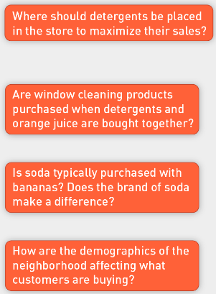
   2. Correlations and patterns are interesting
3. Co-occurrence matrix
   1. 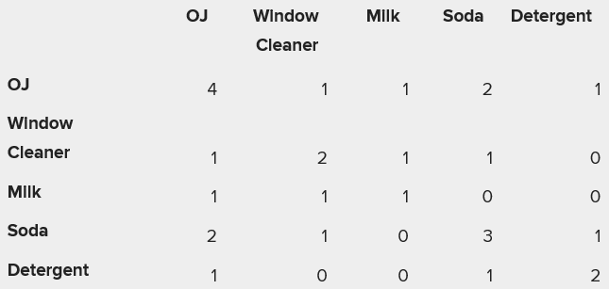
   2. In how many baskets did window cleaner and OJ appear together? Only one.
4. Algorithm design: running example
   1. 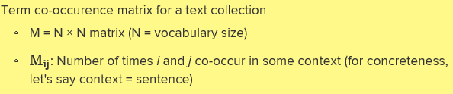
   2. Corpus: A D C E A D F E B A C E D
   3. Window size: 2 (the two words of either side)
   4. 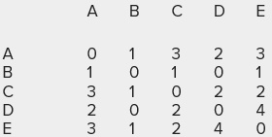
   5. Using context vectors, you can get co-occurrences very easily
   6. Co occurrence of D and E is D[E]=4
   7. Why build it? Distributional profiles as a way of measuring semantic distance, which is useful for many language-processing tasks
5. MR and large counting problems
   1. Term co-occurrence matrix for text collection = specific instance of a large counting problem
   2. A large event space (number of terms)
   3. A large number of observations (the collection itself)
   4. Goal: Keep track of interesting statistics about the events
   5. Basic approach
   6. Mappers generate partial counts
   7. Reducers aggregate partial counts
   8. Combinatorial event space and large number of observations
   9. How do we aggregate partial counts efficiently?
6. CO Matrix: V1 Pairs
   1. Each pair corresponds to a cell in the word co-occurrence matrix. This algorithm illustrates the use of complex keys in order to coordinate distributed computations.
   2. Each mapper takes a sentence:
   3. Generate all co-occurring term pairs
   4. For all pairs, emit (a, b) → count
   5. 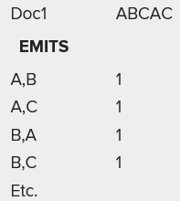
   6. Reducers sum up counts associated with these pairs.
   7. Use combiners!
   8. Each pair corresponds to a cell in the word co-occurrence matrix. This algorithm illustrates the use of complex keys in order to coordinate distributed computations.
   9. 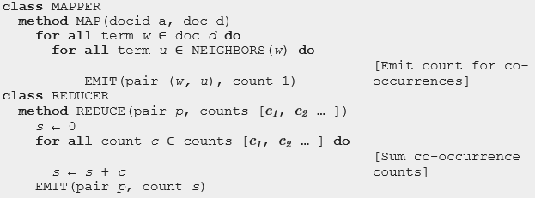
   10. Outer loop iterates over all words, inner loop iterates over neighbours of current word
7. Above is Pairs analysis
   1. Advantages
   2. Easy to implement, easy to understand
   3. Can use reducer as a combiner!
   4. Disadvantages
   5. Lots of pairs to sort and shuffle around (upper bound?)
   6. Not many opportunities for combiners to work
   7. How can we overcome shuffle overhead?
8. Stripes approach
   1. Change mapper
   2. Group together pairs in associative array
   3. 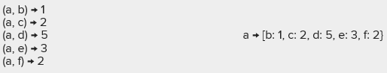
   4. Each mapper takes a sentence:
   5. Generates all co-occurring term pairs
   6. For each term, emits a → { b: ountb , c: countc , d: countd … }
   7. Reducers perform element-wise sum of associative arrays
   8. 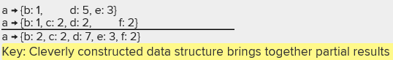
   9. 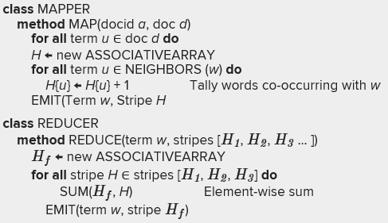
   10. Memory needs to be managed very carefully
9. Performance
   1. Stripes has a bigger value per key.
   2. Pairs has more partition and sort overhead.
   3. Stripes has
      1. Less sorting and shuffling
      2. Better use of combiners
   4. Stripers is limited by
      1. More difficult to implement
      2. Underlying object more heavyweight
      3. Fundamental limitation in terms of size of event space
10. Experimental Data Set
    1. Associated Press Worldstream (APW) of the English Gigaword Corpus (3rd ed.), which contains:
    2. 2.27 million; 1.8 GB compressed; 5.7 GB uncompressed
    3. Would push any laptop to its limits
    4. Preprocessing
    5. All XML markup was removed, followed by tokenization and stop-word removal using standard tools from the Lucene search engine
    6. All tokens were then replaced with unique integers for a more efficient encoding
    7. Goal to generate co-occurrence matrix
11. Performance
    1. 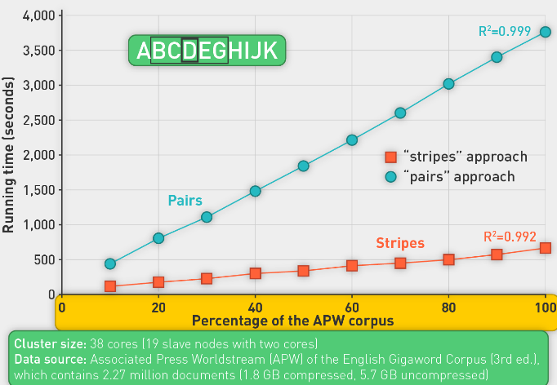
    2. Stripes approach outperformed pairs approach in running time
    3. Six times better
12. Analysis
    1. 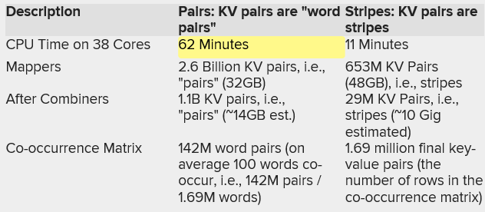
    2. Pairs: The mappers in the pairs approach generated 2.6 billion intermediate key-value pairs totaling 31.2 GB. After the combiners, this was reduced to 1.1 billion key-value pairs, which quantifies the amount of intermediate data transferred across the network. In the end, the reducers emitted a total of 1.42 million final key-value pairs (the number of nonzero cells in the co-occurrence matrix).
    3. Stripes
       1. Mappers emitted 653M KV Pairs (i.e., stripes) (48GB) but after combiners this reduced to 29 Million stripes (extrapolate that the amount of data transferred from mappers to reducers is less 10GB).
       2. As expected, the stripes approach provided more opportunities for combiners to aggregate intermediate results (only a simple key consisting of a single-word (and not two words as is the case in the "pairs" approach), thus greatly reducing network traffic in the shuffle and sort phase.
    4. As expected, the stripes approach provided more opportunities for combiners to aggregate intermediate results, thus greatly reducing network traffic in the shuffle and sort phase.
13. Running time of stripes algorithm
    1. 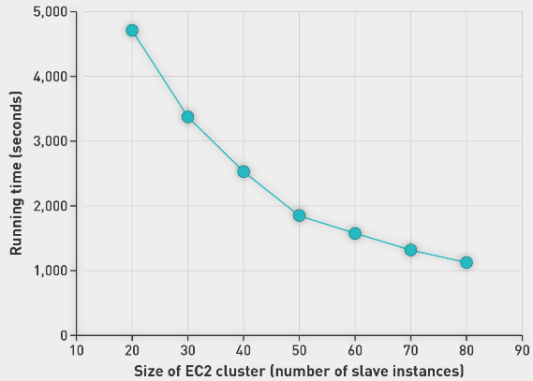
    2. Here we vary size of ec2 cluster (number of slave instances)
    3. We are seeing a linear reduction of time required
    4. 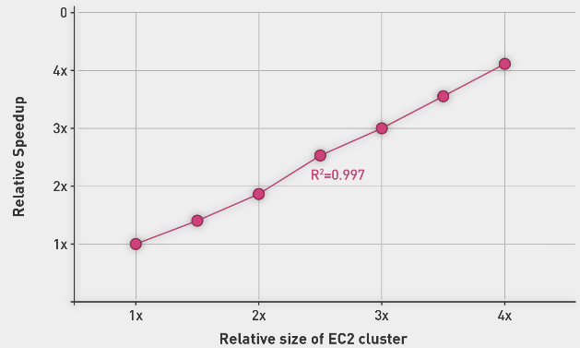
    5. RHS recasts the same results to illustrate scaling characteristics. The circles plot the relative size and speedup of the EC2 experiments, with respect to the 20-instance cluster.
    6. These results show highly desirable linear scaling characteristics (i.e., double the cluster size makes the job twice as fast).
    7. This is confirmed by a linear regression with an R2 value close to 1.
    8. Caution: use it with care

Computing Relative Frequencies

1. Relative frequencies
   1. 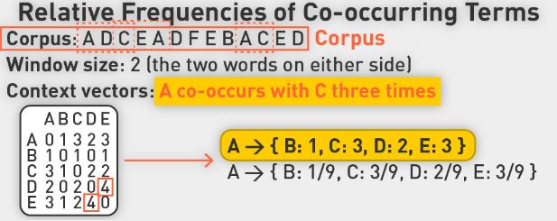
   2. 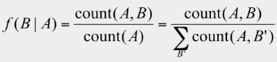
   3. This gets us relative frequencies
2. Stripes
   1. 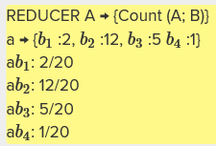
   2. Easy to do apparently
   3. One loop over all value terms (co-occurring words) to compute (a, *). Another pass to directly compute the relative frequency f(B|A)
3. Pairs approach
   1. Note: In the pairs approach, the reducer receives (wi;wj) as the key and the count as the value. From this alone, it is not possible to compute ƒ(wj jwi), since we do not have the marginal.
   2. Synchronization: Need to reconstruct the list of co-occurring terms with the term of interest
   3. Fortunately, as in the mapper, the reducer can preserve state across multiple keys
   4. Inside the reducer, we can buffer in memory all the words that co-occur with wi and their counts, in essence building the associative array in the stripes approach
4. Custom partitioner: sync word counts for word of interest
   1. Repartition data according to primary token (first word) only.
   2. We must ensure that all pairs with the same left word are sent to the same reducer.
   3. This, unfortunately, does not happen automatically. Recall that the default partitioner is based on the hash value of the intermediate key, modulo the number of reducers.
   4. For a complex key, the raw byte representation is used to compute the hash value. As a result, there is no guarantee that, for example, (dog, aardvark) and (dog, zebra) are assigned to the same reducer.
   5. To produce the desired behavior, we must define a custom partitioner that pays attention only to the left word
   6. Must make sure all a's get sent to same reducer (use custom partitioner)
   7. Must make sure (a, *) comes first (define sort order)
   8. Must hold state in reducer across different key-value pairs
   9. 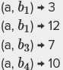
   10. Partition based on primary token, but sort on entire key. This gives us a stream that has same primary token and same co-occurring token appearing together.
   11. 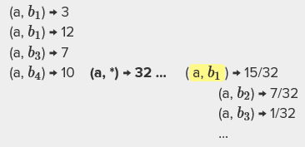
   12. Reducer has co-occurring words and frequencies in memory
   13. How can we avoid the memory issues?
5. Order Inversion pattern
   1. Use framework to count the total occurrences in the primary token. We want it to come first in the reducer stream.
   2. First emit (dog,*), so reducer has the total count for primary token without having to accumulate all records in memory.
   3. 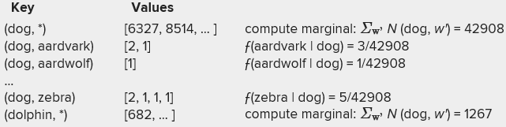
   4. Example of the sequence of key-value pairs presented to the reducer in the pairs algorithm for computing relative frequencies; this illustrates the application of the order inversion design pattern
   5. It is so named because through proper coordination, we can access the result of a computation in the reducer (for example, an aggregate statistic) before processing the data needed for that computation
   6. The key insight is to convert sequencing of computations into a sorting problem.

Summary

1. Ram vs Disk vs bandwidth
2. Back of the envelope calculations
3. Priority queues and merge sorts
4. Internals of Hadoop Shuffle operation
5. Patterns
6. Local aggregation:
   1. Combiners and in-mapper combining
   2. Algorithmic correctness with local aggregation
   3. Number of tasks and in-memory mapper
7. Pairs and stripes
8. Computing relative frequencies
9. Order inversion pattern
10. Secondary Sorts
11. Sync and Communication are key:
    1. Constructing complex keys and values that bring together data necessary for a computation. This is used in all of the above design patterns.
    2. Controlling the partition of the intermediate key space. This is used in order inversion and value-to-key conversion.
    3. Controlling the sort order of intermediate keys. This is used in order inversion and secondary sorting.
12. Patterns apply to Hadoop MR and MRJob and Spark

## Lecture:

* Asdfad
* -D mapred.reduce.tasks=0 for a reducer free map reduce
* These generic options need to be before command options, need to be in the right order
* Counters: lightweight objects in Hadoop that allow you to keep track of system progress in both the map and reduce stages of processing. Similar to global variables with read/write constraints. Keep count across all of the mappers.
* Can use to track occurrences of global events. For example: how many IO operations took place during MapReduce task?
* 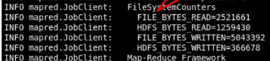
* Reporter:counter:counter_group,counter,increment_by
* Streaming MR program can increment counters by sending a specially formatted line to std error stream.
* 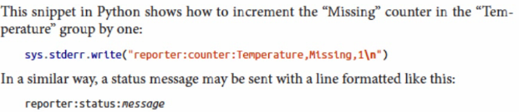
* Counters lifestyle: task periodically sends counter to TaskTracker
* You can have a mapper counter and a reducer counter if you put counters higher up in the code
* 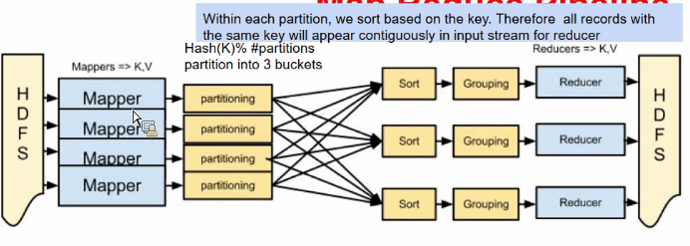
* Partitioners figure out how to send things to the pile for a reducer to deal with. Use a hash function on the key to divide things into piles to cut down on amount of work that needs to be done.
* Shuffle sends data to reducer through a round robin manner and a HashMap (probably)
* 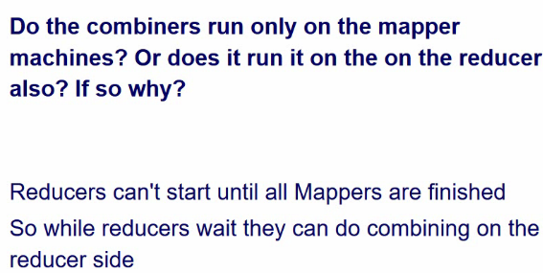
* Not sure if the above is true, since combiners run locally to the data of the mapper
* 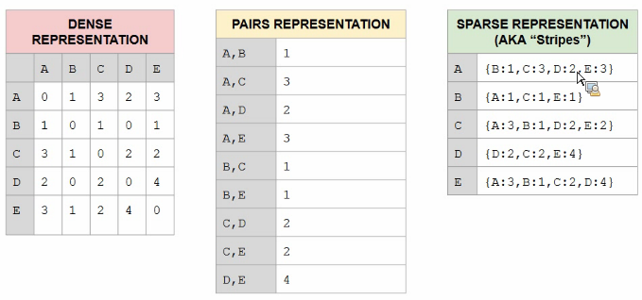

# Unit 4: MRJob, Unsupervised Learning at Scale: Clustering, Canopy-Based K-Means, and Expectation Maximization

## Videos:

Introduction:

1. Hadoop and MR CLI not adequate for ML
2. MRJob:
   1. Python API framework on top of Hadoop
   2. Allows us to easily introduce ML concepts
   3. Install, write hello world
3. Log file processing
4. KMeans in MRJob

Background:

1. Building a Multistep Pipeline
   1. In sequence or iterative steps
   2. Trending queries:
      1. Get counts for various queries
      2. Sort in decreasing order
2. MR job
   1. 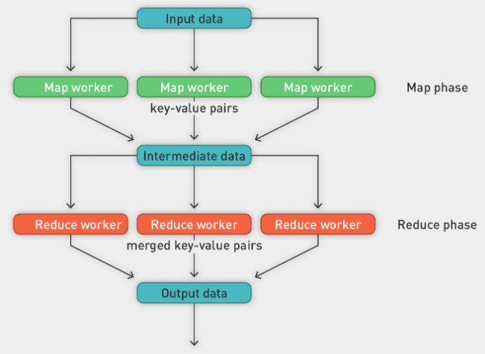
3. Pipeline of jobs:
   1. One MR after another job
   2. Iterative
4. MR frameworks
   1. MR programmed in Java
   2. Hadoop Streaming (python)
   3. MRJob
   4. Dumbo
   5. Luigi
5. Goal:
   1. Simple to use
   2. Pseudo-codiness
   3. Flexibility and generality
   4. Easy installation
   5. Good performance
6. MRJob
   1. Python package for Hadoop streaming jobs
   2. Produce multistep jobs; submitting to Hadoop job tracker
   3. Developed by yelp.com
7. Motivation for MRJob
   1. Processing speed: 10 min/GB
   2. Production: 250 GB/day
   3. Need new solution
8. Features of MRJob
   1. Version 4.5
   2. Abstracted MapReduce interface
   3. Ability to handle complex Python objects
   4. Multistep MapReduce workflows
   5. Tight Amazon Web Service (AWS) integration
   6. Easy to run locally
   7. Community of developers and contributors
9. Example Word Count
   1. 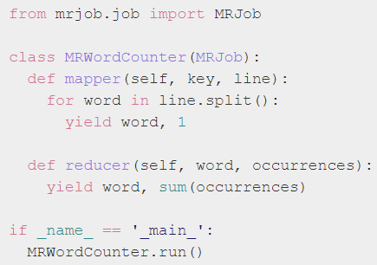
   2. Mapper and reducer method

MRJob Installation

1. Installing
   1. Conda install mrjob
   2. Pip install mrjob
2. Verify
   1. 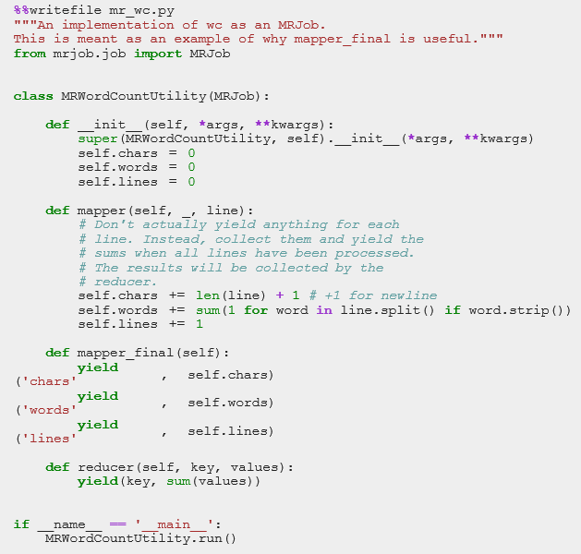
   2. 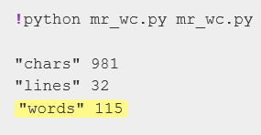
3. Python Driver
   1. 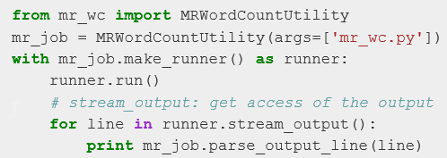
   2. Running mrjob utility from within cell
   3. Stream_output() gives you the output
   4. Mr_job can parse output to mapper and reducer

MRJob Fundamentals

1. MRJob Function Review
   1. Mapper: Takes a single record with key and value as input and returns zero or more (key, value) pairs
   2. Reducer: Takes a key and a subset of the values for that key as input and returns zero or more (key, value) pairs
   3. Combiner: Takes a key and the complete set of values for that key in the current step and returns zero or more arbitrary (key, value) pairs as output
   4. Mapper-side reducer to alleviate network burden
2. Mapper-Reducer-Combiner Review
   1. First-class objects
   2. Phases:
   3. Initialization
   4. Work
   5. Shutdown
3. Functions in MRJob
   1. mapper_init() and mapper_final()
   2. combiner_init() and combiner_final()
   3. reducer_init() and reducer_final()
4. Yield function in Python
   1. Lazy: doesn’t act until data is needed
   2. 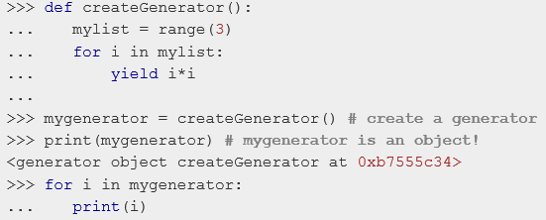
   3. Nothing will happen until list is consumed
   4. No memory allocation
   5. It is called a pointer to an iterator
5. Building an MR Job: Word count with in-memory mapper
   1. 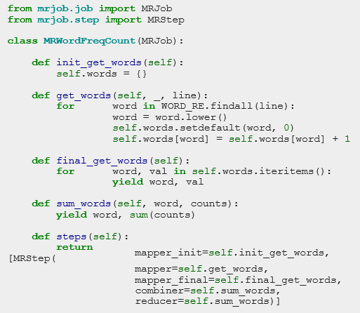
   2. We specify steps which tell us which functions to be used for which step.
   3. Can blend multiple steps here from different objects?
   4. This class inherits from MRJob
6. Other MRJob Methods
   1. Mapper_cmd
   2. Combiner_cmd
   3. Enable unix commands
   4. OO programming
7. Goal:
   1. Create sequences of mrjob steps
   2. Iterative pipelines
8. Functionalities of Python available for MRJob
   1. Define functions
   2. Create loops
   3. Call variety of libraries
9. Fundamentals of MRJob
   1. Python 2.6+ package
   2. Helps write and run Hadoop streaming jobs
   3. Runs on local machine, local cluster, or cloud
   4. Accepts variety of input formats
      1. Text based
      2. Binary (with pickled objects only)

Writing MRJob Code

1. Word Count problem
   1. Mapper function: read data from input, split into words, emit token and count one
   2. Combiner: sum occurrences of each word and emit word and local sum
   3. Reducer: group words and sum counts of each word
2. MRJob code
   1. 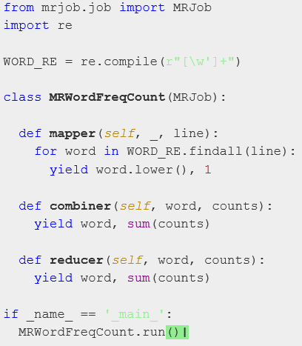
   2. Run with python mr_wc.py
   3. If we have two processors, we might have two mappers and reducers
3. Dev steps
   1. Write mapper and reducer functions for word count.
   2. What does each step (mapper, reducer, combine) do?
   3. Verify mapper, reducer, combine steps.
   4. Check it step by step with two input files.
   5. By the MRJob default setting, two mappers will be a assigned. It is also a good way to debug.
4. Multistep MR Jobs
   1. Not all computations can be done in a single MapReduce step.
   2. Map input: < key, value >
   3. Reducer input: < key, value >
   4. Compose MapReduce steps!
   5. Output as input
   6. The output of one MapReduce job can be used as the input to another.
   7. Examples
      1. PageRank: Multiple steps until solution converges
      2. Multilevel summaries
   8. Pipeline of jobs in sequence
   9. Iterative pipeline
5. Find most-used word
   1. First MapReduce Job: Find most used word.
   2. Mapper
      1. Read data from InputFile.
      2. Split it into words.
      3. Output < word, 1 > tuples
   3. Reducer
      1. Read the results of mapper.
      2. Sum the occurrences of each word to a final count.
      3. Output its results < word, Sum > tuples to …
   4. Second MapReduce Job: Find most frequent word.
   5. Mapper: Nothing to do
   6. Reducer: Select the maximum count tuples
   7. 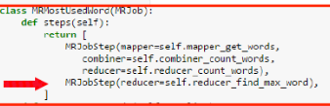
   8. Define two MRJobSteps one after the other.
   9. 
6. Python Driver
   1. 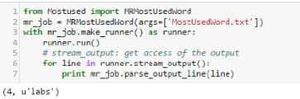

Log File Processing

1. Example log file
   1. 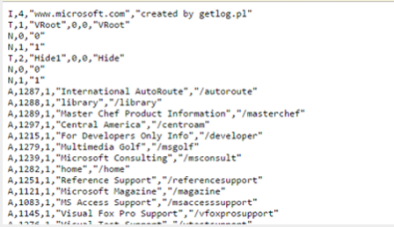
   2. <http://archive.ics.uci.edu/ml/machine-learning-databases/anonymous/anonymous-msweb.data>
   3. each line is a single record
   4. visitor log file for Microsoft.com
   5. 
   6. File tells us information about a "Vroot"
   7. Vroot is just a fancy name for a page with a numeric ID
   8. Each line is different information about the Vroot. Each line begins with a single character.
   9. A: Attributes of a Vroot (ID, title, URL)
   10. V: A visit to a Vroot (id)
   11. C: Customer information, followed by the visits that customer made to the Vroot
   12. Customer 10001 visited 1000, 10001, 10002
   13. 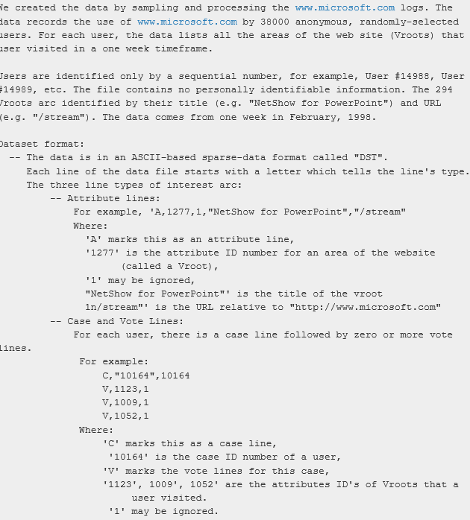
2. Pages with more than 400 visits
   1. Find all pages (vroots) with greater than 400 visits
   2. 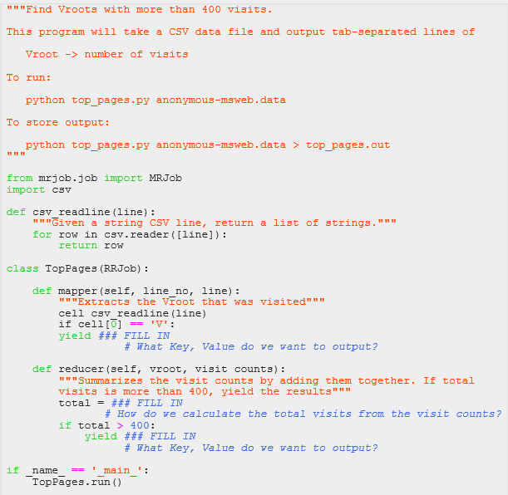
   3. 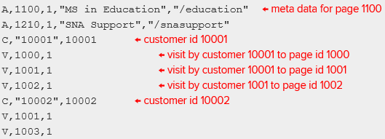
   4. Driver:
   5. 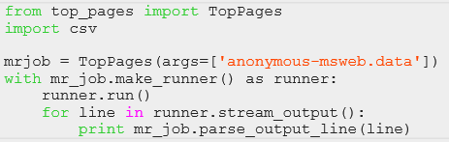
3. Solution:
   1. 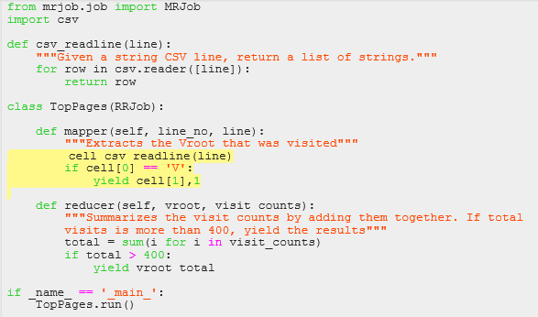

Thought Experiment: Bad Logs

1. Visitor Log File
   1. 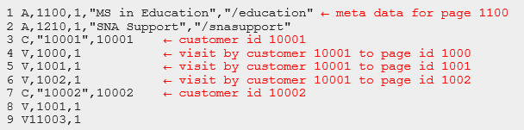
   2. Want to answer some EDA questions: average number of visitors, which are bots, which visit most often
2. Number of visits per user using MR?
   1. No, we cannot: User visit information is spread over multiple lines. As such, there is a sequential dependency difference between lines: e.g., line 3 refers to customer 10001 and the following three lines refer to visits by this customer.
   2. We cannot assume linear or sequential processing of the data by the Hadoop framework. It splits the input file at arbitrary locations; e.g., **lines 1 to 4 could go to one mapper and lines 5 to 9 could go to another mapper**. In this case, it would be impossible to recover lines 5 and 6, which we associated with customer 10001.
   3. We need to transform data on a single machine. Take each visitor record, add a new column, call it customer ID field. Take the context in which visitor records occur and mark up the correct records with the ID.
   4. Using this file, we can find the number of visits per customer.

Serializable JSON

1. Storing of event records is critical, format is important.
2. JSON (JavaScript Object Notation)
   1. JSON (JavaScript Object Notation): An open-standard format that uses human-readable text to transmit data objects
   2. Consists of attribute-value pairs
   3. It is used primarily to transmit data between a server and Web application, as an alternative to XML
   4. 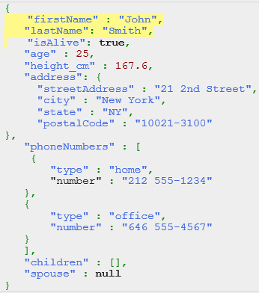
   5. Can have other JSON objects as values, see address above
   6. Hierarchical organization
   7. JSON Schema specifies a JSON-based format to define the structure of JSON data for validation, documentation, and interaction control.
   8. A JSON Schema provides a contract for the JSON data required by a given application and how that data can be modified.
   9. 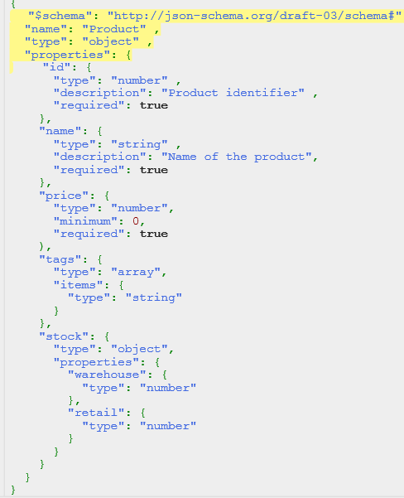
   10. Schema specifies what is required, what he properties are, what type they are, default/minimum values.
   11. Properties can be arrays, specify type of items within them
   12. Can use schema to test validity
   13. 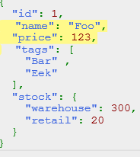
3. Hierarchical JSON Object
   1. Impression record
   2. 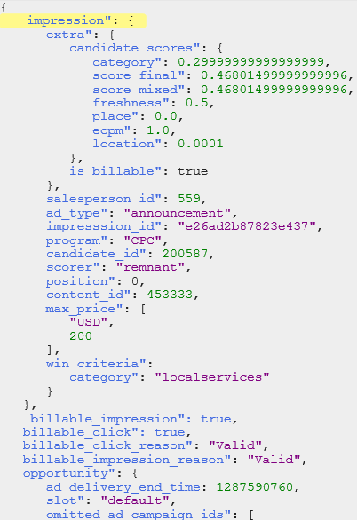
   3. Candidate_scores is hierarchical object
4. Processing JSON
   1. Come in as one file/record in our FS
   2. Can access values of JSON objects in natural way
   3. Think of it as array of attribute-value pairs. We can specify the key as if an array, which will give us the value.
   4. 
5. Input Output format
   1. So far, we focus on stdin/stdout
   2. Within MRJob we can access raw text format, JSON format
   3. Defaults
      1. class MyMRJob(mrjob.job.MRJob):
      2. INPUT_PROTOCOL = mrjob.protocol.RawValueProtocol
      3. INTERNAL_PROTOCOL = mrjob.protocol.JSONProtocol
      4. OUTPUT_PROTOCOL = mrjob.protocol.JSONProtocol
   4. Specify input-internal-output protocols for data format
   5. Available
      1. RawProtocol / RawValueProtocol
      2. JSONProtocol / JSONValueProtocol
      3. PickleProtocol / PickleValueProtocol
      4. ReprProtocol / ReprValueProtocol
   6. Custom protocols can be written.
   7. No current support for binary serialization schemes.
   8. Pickle protocol very useful for serialization of objects to files which can then be recreated in python
6. Input protocol
   1. Previous examples manually parsed line
   2. MRJob provides "protocols" to automatically parse and recover from error
   3. Specify the class desired to parse the lines
   4. Examples:
      1. Open up code/unique_review.py
      2. We're using a JSON object per line; other options include JSON key-values
      3. or writing your own
      4. Instead of raw text, record will now be a Python dict
   5. 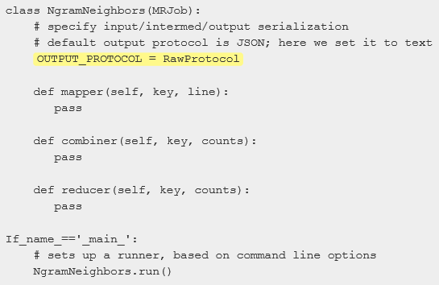
7. Example
   1. 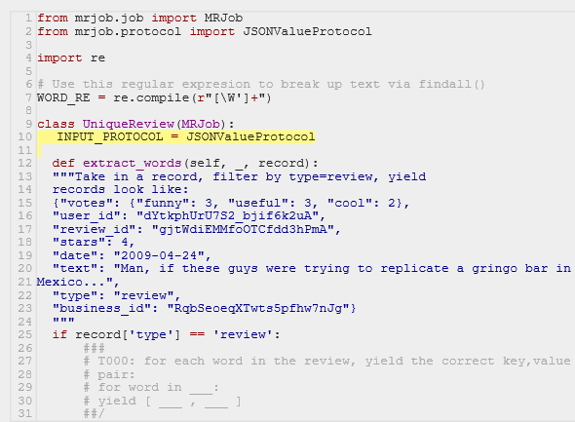
   2. Json value input protocol
   3. Mapper for extract words for a json record
   4. Tells you which types of records you can access. You only care about words in records of type review.
8. Serialization
   1. Making communication and storage of data more efficient
   2. Taking text data and encoding it in a binary format is serialization
   3. Serialization is the process of turning structured objects into a byte stream for transmission over a network or for writing to persistent storage.
   4. Deserialization is the reverse process of turning a byte stream back into a series of structured objects.
   5. Serialization appears in two quite distinct areas of distributed data processing:
      1. For interprocess communication
      2. For persistent storage
9. MRJob Input Text Formats
   1. Cannot use serialization for inputs or outputs
   2. This slows down pipelines quite a bit
   3. When we read in text, we have to encode it in binary, so it takes a lot of time
   4. Process of reading in is time-consuming because we have extra verbose text to read in
   5. MRJob accepts as input text formats raw text and JSON
   6. Binary formats first need to be converted
   7. Text processing is slow, incurs extra storage and network costs (serialization and deserialization for mappers and reducers in Hadoop Streaming)
   8. E.g., Avro
      1. Since Avro is a binary format (by default), you won't be able to use it directly with Hadoop Streaming
      2. You could provide a JVM input/output format that converted the Avro data to lines (e.g., JSON), then use MRJob to process those lines normally
      3. You'd want to do this primarily for compatibility, though, since you'll have an overhead per line
10. How data is read in
    1. 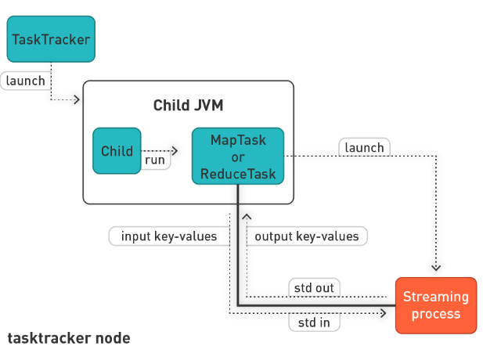
    2. Contact task tracker via job tracker, pass it mapper and reducer code
    3. Framework takes care of passing streaming records to mapper to stdin and reading from reducer from stdout.

MRJob Benchmarks

1. Evaluate Python Frameworks
   1. Evaluate Python frameworks that exist for working with Hadoop on a benchmark data set including:
      1. Hadoop Streaming
      2. MRJob
      3. Dumbo
      4. Hadoopy
      5. Pydoop
      6. And others
   2. We would like to aggregate the data to count the number of times any pair of words are observed near each other, grouped by year. This would allow us to determine if any pair of words are statistically near each other more often than we would expect by chance.
   3. Two words are "near" if they are observed within four words of each other.
   4. Used Google Ngram dataset
2. Example
   1. 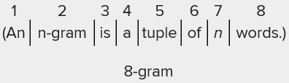
   2. Google scanned a lot of books, extracting sentences and words through OCR
   3. Made available the grams from these books, up to 5gram
   4. Used to test streaming frameworks
   5. Find pairs of words within four words of each other
   6. I.e., a word is near a word if it occurs in 2-gram, 3-gram, 4-gram, or 5-gram
   7. E.g., An can be paired with n-gram, is, a, tuple
   8. 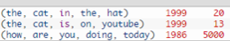
   9. We want to see how often the words the and cat co-occurred in ’99.
   10. Result is 33, as we sum the counts
3. Comparison
   1. 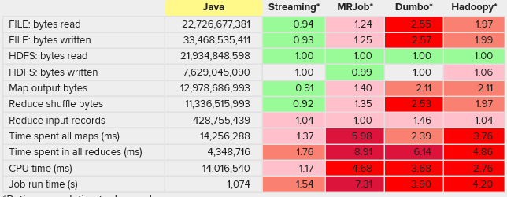
   2. Benchmark all against native Java framework
   3. Streaming has the lowest overhead
   4. Time spent on all maps is six times slower between MRJob and Streaming. This is because of the lack of serialization.
   5. MRJob accepts as input/output text formats raw text and JSON.
   6. Deserialization and serialization of records incurs a lot of CPU, storage, and network overhead.
   7. Not a huge issue as you can easily throw more computers to it. We want to use MRJob as it is very open and easy to use.
   8. All the Python frameworks look like pseudo-code, which is a huge plus.
   9. MRJob seems highly active, easy to use, and mature.
   10. It makes multistep MapReduce flows easy and can easily work with complex objects. It also works seamlessly with Elastic MapReduce (EMR).
   11. But it appears to perform the slowest.
   12. 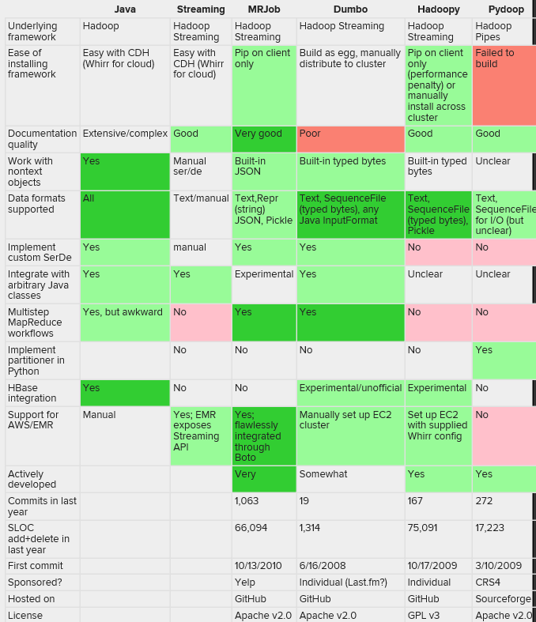

Clustering Overview

1. Clustering
   1. Unsupervised learning activity
   2. Data mining is sorting through data to identify patterns and establish relationships.
   3. Extract useful knowledge from large data sets!
   4. Clustering is a data-mining (machine learning) technique used to place data elements into related groups without advance knowledge of the group definitions.
   5. Great for EDA and source of features for feature engineering
2. Hard vs Soft Clustering
   1. Hard clustering: each document goes to one group
   2. Common and easier to do.
   3. Soft clustering: a document can belong to more than one cluster. Makes more sense for applications like creating browsable hierarchies
   4. You may want to put a pair of sneakers in two clusters: (1) sports apparel and (2) shoes.
   5. You can only do that with a soft-clustering approach.
3. Clustering algorithms
   1. Try to locate homogeneous groups of observations.
   2. Clustering algorithms try to formalize this.
   3. Define the notion of similarity
4. Similarity measure
   1. How close two data points are
   2. Attach a label to each observation or data point in a set.
   3. You can say this is "unsupervised classification."
   4. Intuitively, you would want to assign the same label to data points that are "close" to each other.
   5. Thus, clustering algorithms rely on a distance metric between data points.
   6. Sometimes it is said that, for clustering, the distance metric is more important than the clustering algorithm.
   7. Distance-based similarity measures
      1. 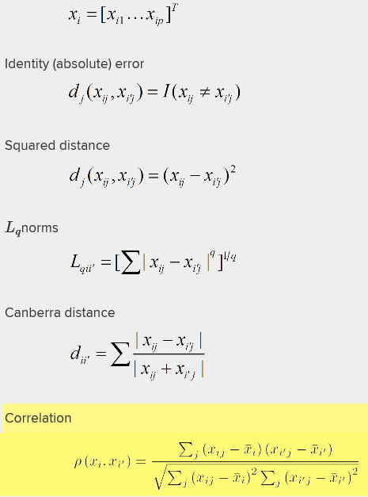
   8. Ordinal and categorical variables:
   9. 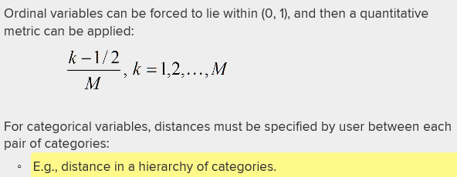
5. Combining distances
   1. 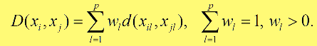
   2. Weighted sum approach
6. Example:
   1. If we ask for four clusters:
   2. 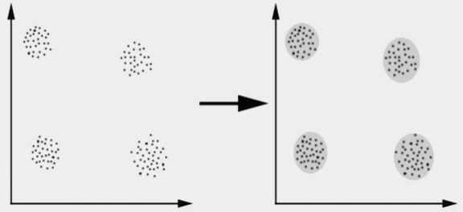
   3. We get very homogenous groups
   4. Use Euclidean distance:
   5. 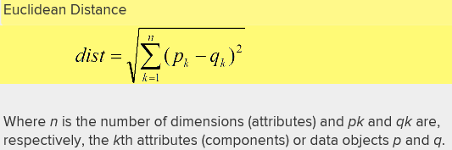
   6. Minkowski distance
   7. 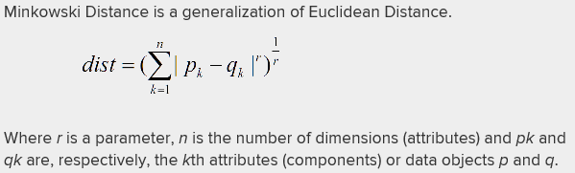
7. Nonhierarchical vs Hierarchical
   1. Non-H: flat approaches to clustering; all clusters are on the same level.
      1. Exclusive clustering (k-means) [in R, cluster package]
      2. Overlapping clustering (fuzzy c means) [in R, e1071]
      3. Probabilistic clustering (mixture of Gaussians)
   2. H: there is hierarchy, many ways to tackle problem
      1. Agglomerative approach (bottom up)
      2. In R: hclust() and agnes()
      3. Divisive approach (top down)
      4. In R: diana()
   3. Agglomerative:
   4. Start with the points as individual clusters.
   5. At each step, merge the closest pair of clusters until only one cluster (or k clusters) is left.
   6. Divisive:
   7. Start with one all-inclusive cluster.
   8. At each step, split a cluster until each cluster contains a point (or there are k clusters).
   9. Can you implement both in Hadoop?
8. Review:
   1. Start with collection of objects
   2. Try to group them in a bottom-up fashion
   3. Get pairs of objects that are most similar
   4. Start with a small cluster and grow it slowly
   5. 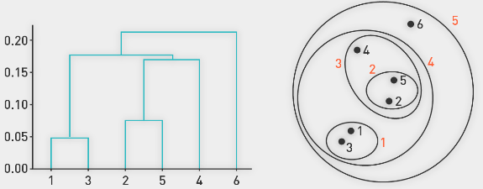
   6. Hierarchical clustering:
   7. Produces a set of nested clusters organized as a hierarchical tree
   8. Can be visualized as a dendrogram
   9. A treelike diagram that records the sequences of merges or splits
   10. No assumptions on the number of clusters
   11. Any desired number of clusters can be obtained by "cutting" the dendrogram at the proper level
   12. Hierarchical clusterings may correspond to meaningful taxonomies
   13. Example in biological sciences (e.g., phylogeny reconstruction), Web (e.g., product catalogs)

K-Means algorithm

1. Clustering Algorithms
   1. Focus on K-Means, non-hierarchical
2. K-Means
   1. K-means clustering aims to partition n observations into k clusters, in which each observation belongs to the cluster with the nearest mean, serving as a prototype of the cluster.
   2. This results in a partitioning of the data space into Voronoi cells.
   3. The problem is computationally difficult (NP-hard); however, there are efficient heuristic algorithms that are commonly employed and converge quickly to a local optimum.
   4. These are usually similar to the expectation-maximization algorithm for mixtures of Gaussian distributions via an iterative refinement approach employed by both algorithms.
3. Partitioning
   1. Partition data so that it minimizes the within group sum of squares over all variables
   2. 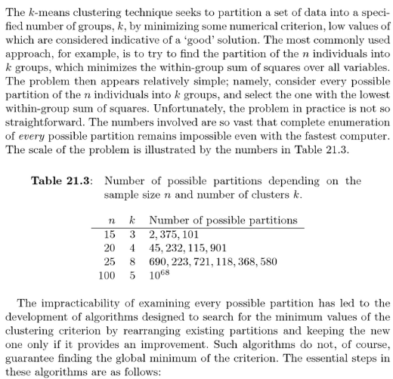
   3. N examples with k clusters: complexity is high, so all possible partitions grow quickly.
4. K-means loop
   1. Init: select random selection of K clusters
   2. E-step: The "assignment" step is also referred to as the expectation step. Take each example and assign it to the nearest cluster.
   3. M-step: The "update step" as maximization step, making this algorithm a variant of the generalized expectation-maximization algorithm. Update centroid of each cluster.
   4. Repeat until we see no changes any more
5. Algorithm
   1. 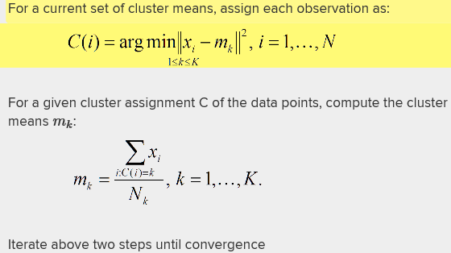
6. Illustration
   1. 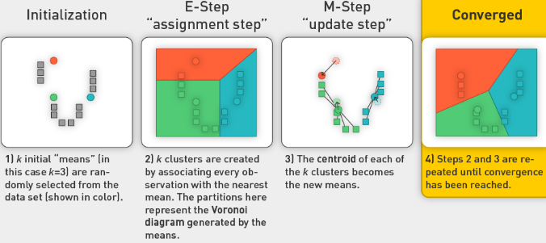
7. Clustering and Hadoop
   1. Can easily do non-hierarchical clustering
   2. Hierarchical is more difficult
   3. Hierarchical clustering is tough to deploy. Distributing a bottom-up algorithm is tricky because each distributed process needs the entire data set to make choices about appropriate clusters. It also needs a list of clusters at its current level so it doesn't add a data point to more than one cluster at the same level.
   4. There are alternative approaches to centroids: model-based approaches that use distribution. They take a different approach to learn centres.
   5. We will use probabilistic approach as well as Maximum likelihood to train
8. Summary:
   1. We have covered the following topics:
      1. MRJob
      2. Installation
      3. Fundamentals and concepts
      4. Writing MRJob code
      5. Logfile processing
      6. Serializable, JSON, and MRJob benchmarks
      7. Clustering algorithms
      8. Clustering overview
      9. k-means algorithm
   2. During our live session for Week 4, we will discuss:
      1. Distributed k-means in MRJob (with a notebook)
      2. Data and distributions
      3. Model-based clustering
      4. EM algorithm for a mixture of Bernoulli distributions
      5. Distributed EM clustering algorithm in MRJob

## Lecture:

* Think about and execute on doing distributed stateless algorithm
* Partial Sort, Total Sort, Secondary Sort
* 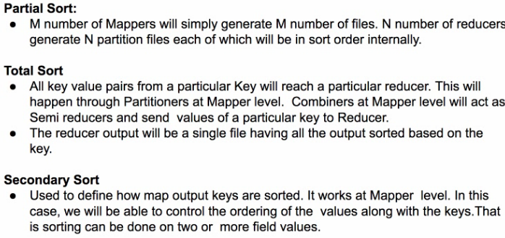
* Vector with 1m digits
  + We want to calculate dot product of this vector X with another vector Y
  + Can have mappers figure out all the partial sums
  + Need to calc numerator or denominator first, so use secondary sort
* MRJob and K-means
  + K-means is iterative
  + Expectation-maximization
  + Perfect for MRJob
  + Can chain different kinds of jobs
* Example
  + 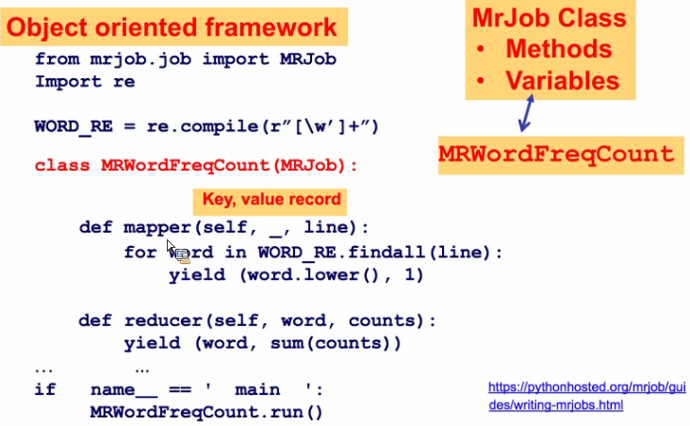
  + Underscore is the key which you don’t have for mapper as you just pass line
  + autoreload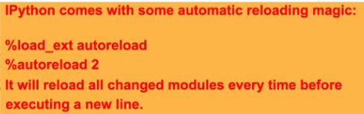
  + allows you to automatically import your script fresh
* Finding most frequent word
  + Need extra reducer
  + Use MRJobStep
  + Second reducer to sort in decreasing order
  + Self.mr is MRJobStep apparently…
  + First reducer has None for the key, as otherwise mapper will split it up by summed count.
  + 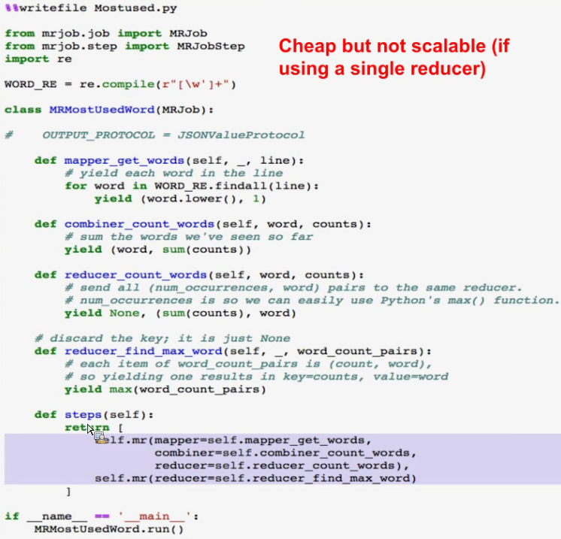
* Different pattern
  + 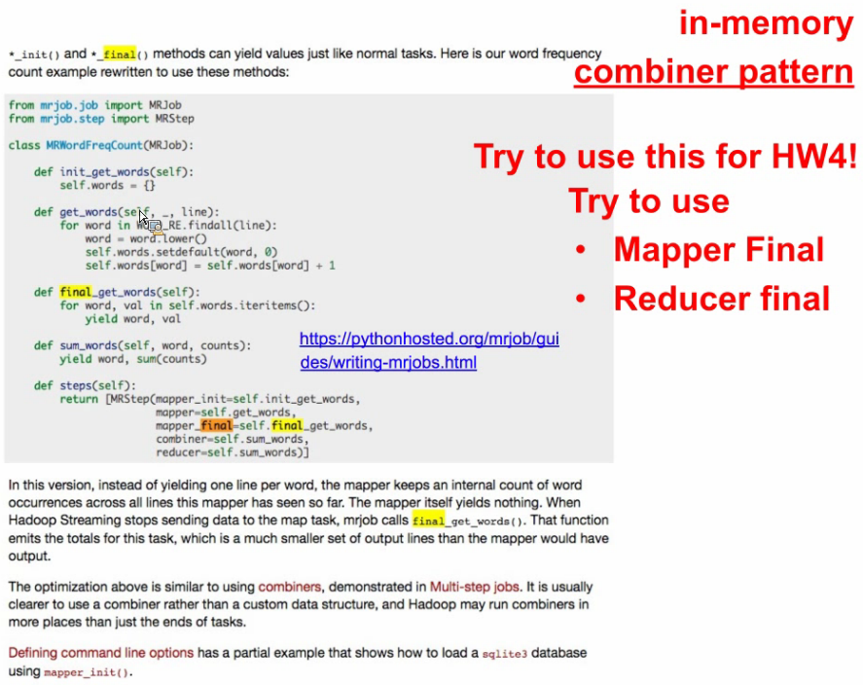
  + You tally everything up in the self.words dictionary in the mapper, then you send it to the reducer
* Counters in MRJob
  + Self.increment_counter(“group”,”num_mapper_calls”, 1)
  + In output we get counters
  + Can access counter in MRJob as a method call: see results in runner.counters().
* K-Means
  + See slides from this class, they had everything
  + <http://nbviewer.jupyter.org/urls/dl.dropbox.com/s/oppgyfqxphlh69g/MrJobKmeans_Corrected.ipynb>
  + the above notebook has Kmeans implemented…
  + see the driver code as well, manages expectation maximization loop

# Unit 5: Big Data Pipelines

## Videos:

Introduction

1. A lot of time in ML is devoted to
   1. EDA
   2. Feature engineering
   3. Data capture
2. Infrastructure and data wrangling
3. Example of ad serving in online context
4. Multiple data pipelines usually
   1. How do I get access to real-time operational data?
   2. Recording transactions is second pipeline
   3. Data pipeline of data analysis
5. Hadoop, MR great for multiple pipelines
6. Apache Cassandra for other types of files
7. Focus on many big-data things
8. Look at secondary sort and inverted indexes

Mobile Advertising Example

1. Mobile Advertising
   1. A prototypical domain
   2. High-level data flow
   3. Data pipelines (both real-time/ops, batch/business intelligence, hybrid pipelines such as predictive analytics)
   4. Data science problems
2. Ads
   1. Big revenue generator
   2. Mobile will overtake desktop advertising
   3. Unit of counting is 1000 displays, impressions or views. CPM is cost of displaying the ad 1000 times
3. Ad serving Data Pipelines
   1. 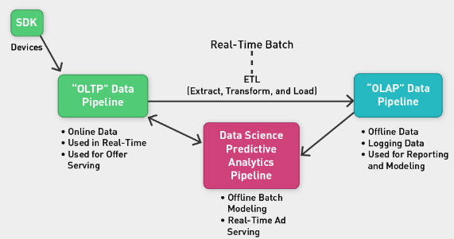
   2. Device on the left with SDK that has library for showing ads
   3. OLTP Data pipeline: record that an ad request comes to show an ad. System has to figure out which ad to show, log the request, look at device, how many ads have been shown already
   4. OLAP Data pipeline: log data and do offline analytics of data to track revenue or report on impressions/costs to advertisers, report. Business analytics pipeline
   5. Data Science Predictive analytics pipeline: offline batch manner of processing, also real-time.
   6. Normally, process terabytes of new data per day. 10k requests per second, response in 200 milliseconds. Could have more data, even lower response time obligation
4. Potential architecture:
   1. 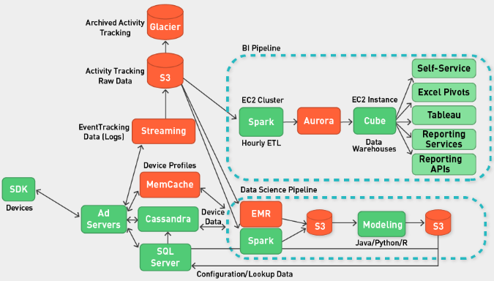
   2. Ad servers: figure out which ad to show, and do some logging. Pass to Cassandra where we can write very quickly. Can push data to S3 for long term storage.
   3. BI and DS Pipelines backed by Hadoop HDFS
5. Focus on which ad we show with respect to device:
   1. Which ad?
   2. How much to charge?
   3. Auction: take all the bids for $ per 1000 impressions. Winner is ad with highest CPM bid. Get the biggest and show the ad.
   4. Consumer may ignore ad, usually don’t show anything.
   5. Usually response is 1% +- 1%.
   6. Conversion Rate:
   7. 
   8. Have auction based on eCMP revenue. Can charge on cost per install or cost per action
   9. 
6. Campaign-Specific models for CTR/CR
   1. 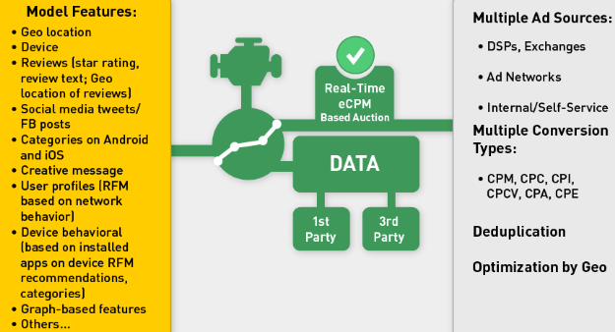
   2. Take into account what device user is using
   3. What is the lifetime value of consumer that installs the app?
7. Data
   1. Revolves around ad campaign itself
   2. Operational issues: Real-time ad serving (frequency capping, budgets, observing constraints)
   3. Accounting (count transactions, billing information)
   4. Ad optimization (ad creative optimization, ad placement)

Data Warehousing OLTP and OLAP

1. Data
   1. Traditionally, storage limited to
      1. OLTP (online transaction processing)
      2. OLAP (online analytical processing)
   2. Data leveraged in new ways now
2. Data Warehouse
   1. Serves as vast repository of data in an enterprise setting
   2. Normally relational, but also
      1. Semi-structured
      2. Unstructured
   3. Foundation for BI and DS
3. Traditional
   1. OLTP is real-time, low latency making of decisions for users. Might have a lot of concurrency
   2. DBs are memory-backed
   3. OLAP is batch-based, used for billing, accounting, analysis, business decisions
   4. 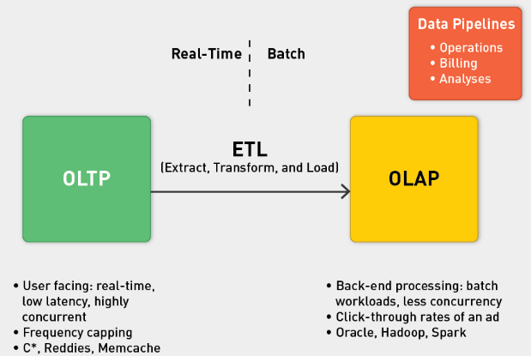
4. Data Warehouse
   1. 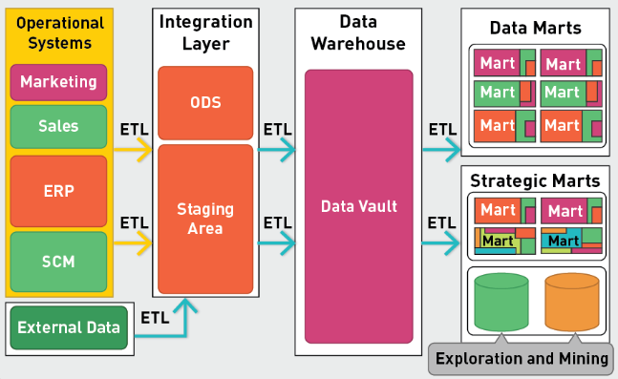
   2. Goal is traditionally to build dashboards
   3. Becoming more interactive now
   4. Allowing drill down, slice and down. Adds extra strain to systems
   5. Pivot Tables, Spreadsheets backed by DW or a data cube with different dimensions and measures.
   6. Dimensions could correspond to discrete variables
   7. Measures: Correspond to real-value number
   8. Bring above in a pivot table
5. Sample BI architecture
   1. 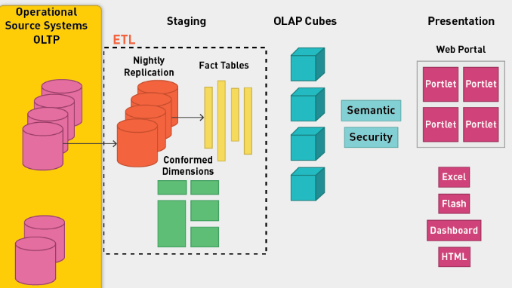
   2. Staging: take data and massage it into measures we need from business perspective
   3. Use this to put data in OLAP cubes, which used for dashboard
6. Star Schemas
   1. 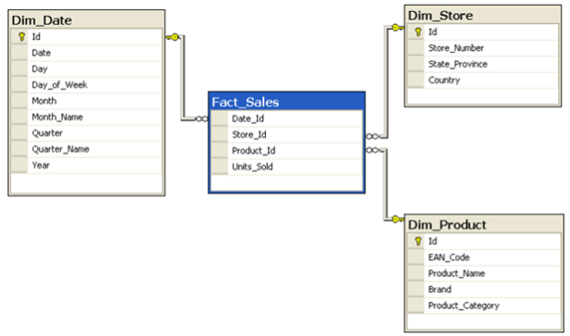

Database relational Joins

1. Data warehousing
   1. Typically, data is relational in nature
   2. Seeing more unstructured data
   3. Huge volumes of data more common
   4. See HDFS-backed data pipelines
2. Comparing
   1. 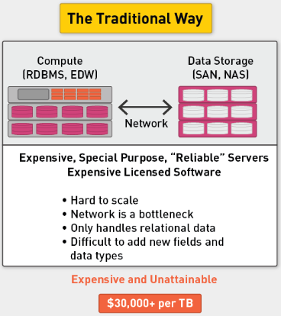
   2. Above is relational and normally very expensive
   3. Make HW more expensive to scale; RDBMS is also expensive.
   4. 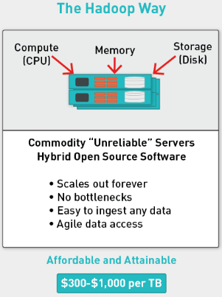
   5. Low cost per TB
   6. Easier to scale
3. Scale is Everything (Almost)
   1. Want to store lots of data
   2. Access it easily
   3. Store variety of data
   4. Do BI and DS
   5. We want linear scale as opposed to vertical scale. This is allowed by HDFS.
   6. DW with Hadoop: Popular
4. Snowplow Data Pipeline
   1. 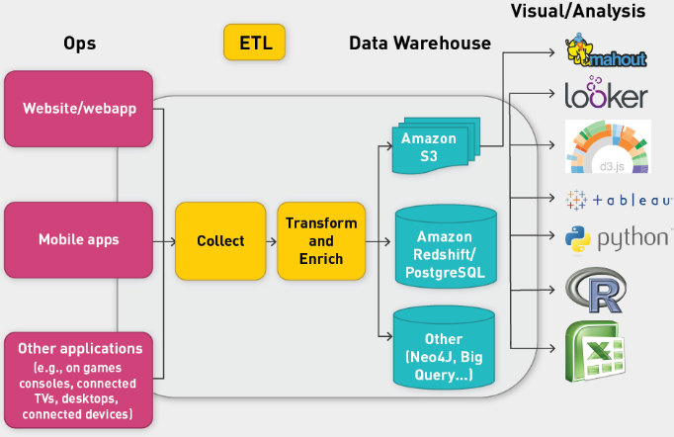
5. HDFS backed data pipeline
   1. 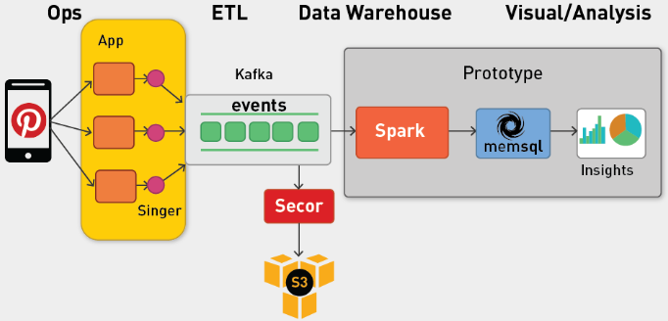
   2. Can use Kafka with Spark to do the ETL
   3. We still want to get dashboards and metrics
6. RDBs vs MR
   1. 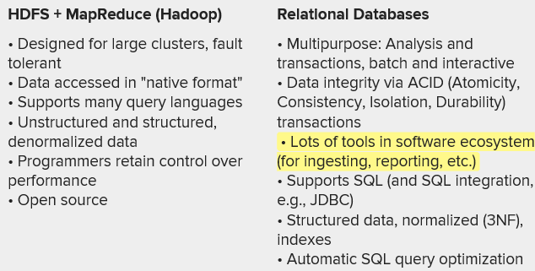
   2. In HDFS programmers have control over performance, as opposed to RDBs where RDBMS controls this
7. Log files
   1. Used in ads
   2. Impressions: someone seeing an ad
   3. 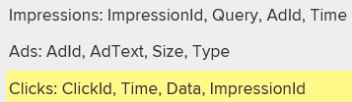
8. Join Example
   1. Join different types of data
   2. Doing it at scale is very difficult
   3. Joins critical to DSs
9. Modern-Day DPs
   1. 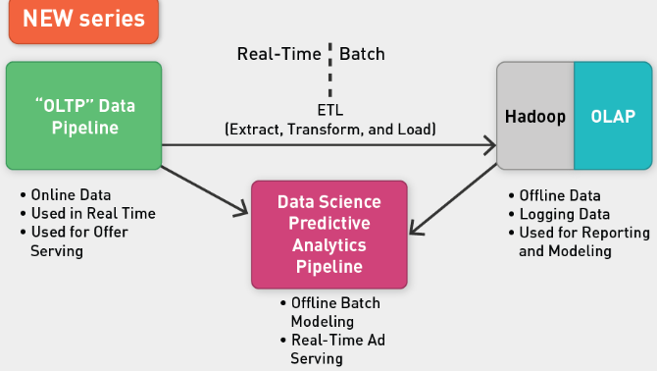

DB Operations in MR

1. Flat Files
   1. Comma or tab separated fields
   2. Used to store and manage data
   3. Very difficult for maintaining data
   4. Example: Customer and transaction data fields
      1. Information repeated with every transaction
      2. If update to one field, have to modify each record
      3. Database rendered unavailable
2. RDBs and Logfiles
   1. 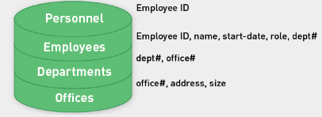
   2. Take big spreadsheet of data and decompose it into smaller tables linked by keys
   3. Save on disk space, no need to repeat data
   4. Easier to make change in one field, only temp lock
   5. Leads to high availability and integrity of data
   6. Normalization process known as 3NF.
   7. To get full pic, sometimes we need to denormalize data
3. Denormalization of Data via Join
   1. Join to see how many employees in department with specific name
   2. 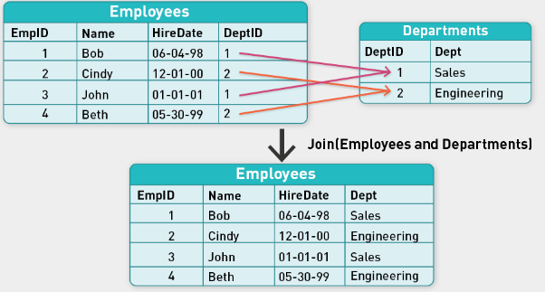
   3. Merge using key: DeptID
4. SQL Join
   1. Combines records from two or more tables in a database
   2. ANSI standard SQL specifies four types of JOINs
      1. INNER
      2. OUTER
      3. LEFT
      4. RIGHT
5. Joins
   1. 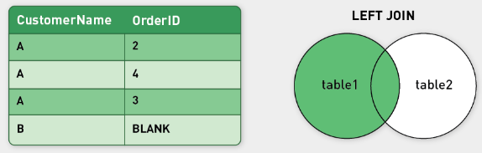
   2. The LEFT JOIN keyword returns all the rows from the left table (Customers), even if there are no matches in the right table (Orders).
   3. The RIGHT JOIN keyword returns all the rows from the right table (Orders), even if there are no matches in the left table (Customers).
   4. 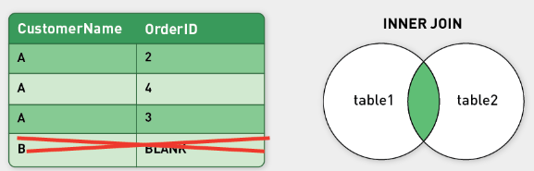
   5. The INNER JOIN keyword selects all rows from both tables as long as there is a match between the columns. Rows in the "Customers" table without matches in "Orders" will not be listed.
6. RDBS
   1. Hard to scale (No shit)
   2. Hadoop based solutions used more now
   3. Column-oriented dbs, such as Cassandra
   4. Real-time DBs such as Arcadia
7. Imagine
   1. Imagine a log file of billions of impressions and millions of clicks stored in separate tables. You need to join them.
   2. HDFS, Hadoop-type system

Relational Joins

1. Relational DB Operations
   1. Using MR at a high level
   2. Group By
   3. Joins
2. Relational Algebra
   1. Primitives
      1. Projection (π)
      2. Selection (σ)
      3. Cartesian product (κ)
      4. Set union (∪)
      5. Set difference (−)
      6. Rename (ρ)
   2. Other operations
      1. Join ⨝
      2. Group by … aggregation
3. Group by
   1. Aggregating data
   2. What is avg time spent per URL?
   3. 
   4. In MapReduce:
      1. Map over tuples, emit time, keyed by URL
      2. Framework automatically groups values by keys
      3. Compute average in reducer
      4. Optimize with combiners
4. Relational Joins
   1. 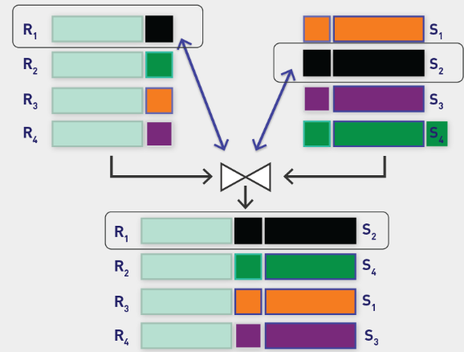
5. Join by MR
   1. Assume two tables (e.g., logfile)
   2. • Each row is a record in the form <Key, Value> (e.g., table R with two attributes, A and B).
   3. • Tables R and S are stored in files.
   4. • Tuples are pairs (a,b) or (b,c).
   5. 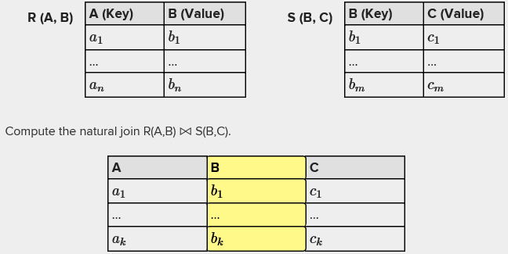
   6. Reduce-side join
   7. Map-side join
   8. In-memory join
      1. Striped
      2. Cached
6. Reduce-side Join
   1. Group by join key
   2. Take both datasets and map over both sets of tuples
   3. Emit tuple as a value when the key is join key as intermediate key
   4. Execution framework brings together tuples sharing the same key
   5. Perform actual join in reducer
   6. This is similar to sort-merge join
   7. Two variants:
      1. One-to-one joins.
      2. One-to-many and many-to-many joins.
7. Map-side join: Parallel Scans
   1. If data sets are sorted by join key, join can be accomplished by a scan over both data sets.
   2. How can we accomplish this in parallel?
   3. Partition and sort both data sets in the same manner.
   4. In MapReduce:
   5. Map over one data set, read from other corresponding partition.
   6. No reducers are necessary (unless to repartition or re-sort).
   7. Consistently partitioned data sets: Realistic to expect?
8. In-memory Join (Hash Join)
   1. Load one dataset into memory; stream over the other
   2. Only works if smaller table fits in memory
   3. MapReduce implementation:
   4. Distribute R (smaller table) to all nodes (broadcast).
   5. Map over S; each mapper loads R in memory, hashed by join key.
   6. No reducers required unless for regrouping or resorting
9. In-memory Join (Striped Variants)
   1. 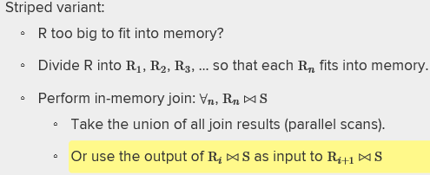
10. In memory Join (Memcached Join)
    1. Memcached join
    2. Load R into memcached cluster.
    3. Replace in-memory hash look-up with memcached look-up.
    4. Pro: Scales out with cluster.
    5. Con: Latency costs.
11. Which Join?
    1. In-memory join, map-side join, or reduce-side join
    2. Limitations
    3. In-memory: Fast memory but with constraints
    4. Map-side: Data must be sort ordered and partitioned
    5. Reduce-side: General purpose and more scalable but slower

Reduce-Side Join

1. Reduce Side Join
   1. Mapper syncs up records in data stream using merge or join key.
   2. Mapper iterates over each record in tables, emitting:
      1. The join key as the intermediate key.
      2. The tuple itself as the intermediate value.
   3. Since MapReduce guarantees that all values with same key are brought together, all tuples will be grouped by join key.
   4. Join happens in reduce side, where data is synced up.
2. Variations: One-to-One Join
   1. One record from L table, one from R table
   2. No guarantee about ordering of these two records in reducer input stream
   3. Solution: Tag each record as L or R
   4. Can proceed to join two tuples and perform additional computations
   5. E.g., filter by some other attribute, compute aggregates (maximum, minimum, average), etc.
   6. Inner join: If only one value associated with a key, no tuple in other data set shares join key. So reducer does nothing
3. One-to-Many Join
   1. Assume L is the one table, R is the many table.
   2. Buffer all values in memory.
   3. Pick out the tuple from L and cross it with every tuple from R.
   4. Issue: Memory scalability bottleneck.
   5. Solution: Use a secondary sort, so single record from the one table shows up first in reducer stream.
4. Many-to-Many Join
   1. Challenging if both tables are big
   2. Can put the smaller table in memory and then iterate over larger table
5. Join Mapper: Tagging source of record
   1. MapReduce calls for processing each record one at a time in a stateless manner.
   2. For state information to persist, we have to tag the record with such state.
   3. For example, given two files, record may appear to mapper as:
   4. 
   5. •Tag each record as coming from the customer or the order database.
   6. Example:
   7. 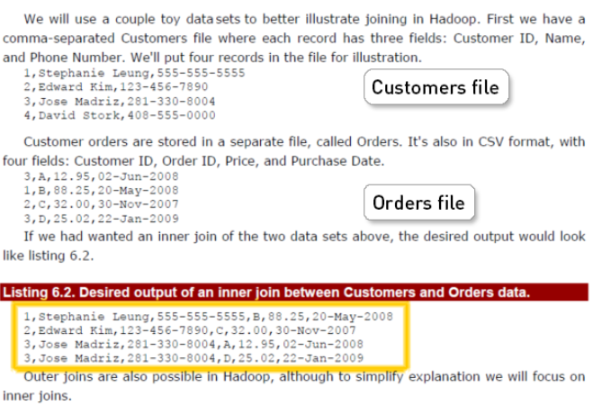
   8. Flow:
   9. Separate records in join key in mapper
   10. Tag each record with the database it is coming from
   11. Shuffle done by Hadoop
   12. 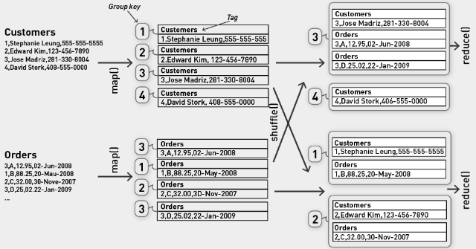
   13. Customer 3 has two orders
   14. 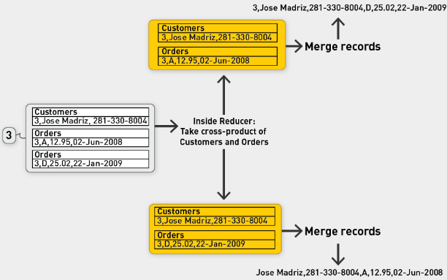
   15. Filter outputs based on the type of join
6. Abstract representation
   1. 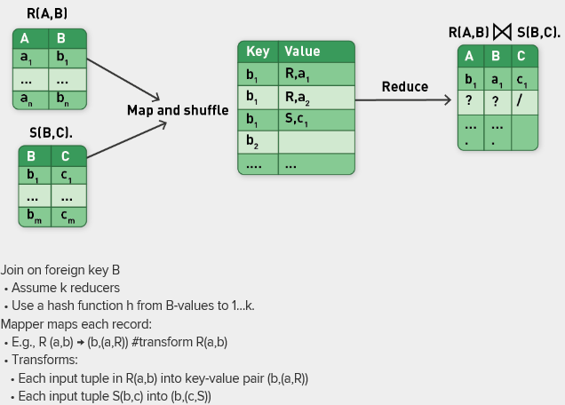
   2. 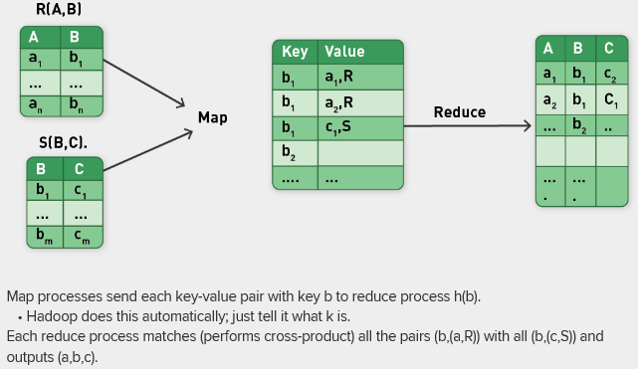
   3. Problem: memory constraints

Reduce-Side Join Example

1. Tables of customers and orders
   1. 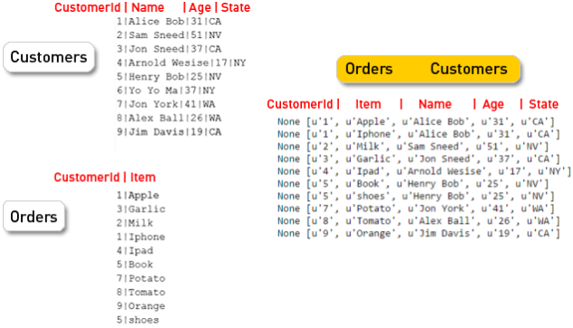
2. The code
   1. 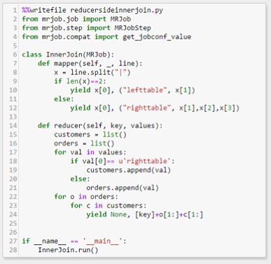
   2. Tag each record based on the length of the record
   3. Yield None for the reducer key.
   4. We do in-memory accumulation of left and right records
   5. Once all values are processed, we can process orders
3. Driver code
   1. 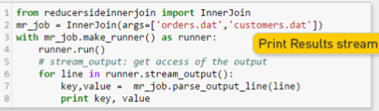
4. Weakness
   1. On reducer side, needing to store records with the same key from the left and right tables in memory
   2. Solution: Secondary sort: Partition based on the join key but sort based on the whole key (the new key)

Memory-Backed Map-Side Join

1. Reduce side joins
   1. Easy to implement
   2. Drawbacks:
   3. All data are sent across the network to reducers.
   4. Many-to-many joins can cause reducer to run out of memory as it buffers records from one side of join.
   5. Map-side joins can overcome these limitations.
2. Map-side join
   1. Memory-backed join: The data sets to be joined do not need to be sorted by the join key
   2. Merge-sort join
   3. Partitioned memory-backed join
3. Memory-backed Join
   1. 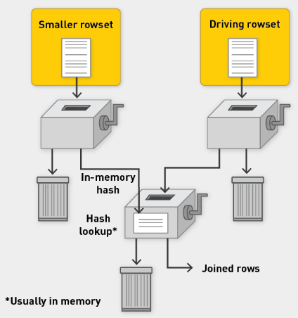
   2. Very simple hash join

Map-Side Merge Join

1. Sort-Merge Join or Merge Join
   1. 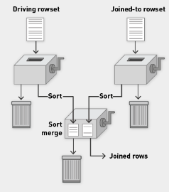
   2. Both tables presorted on join key, partitioned in same way
   3. At its simplest, imagine listing rowsets side by side, sorted by join keys
   4. Alternately walks down the two lists (single pass down each)
   5. Compares top rows, discards rows falling earlier in sort order than top of other list, returns matching rows
2. Example of Sort-Merge Join
   1. 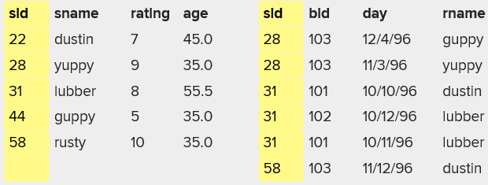
   2. First record doesn’t have corresponding on right, (counter is smaller than smaller on other side)
   3. SID has corresponding, so we join them
   4. Figure out how to write the code for this.
   5. Map-side joins scale beautifully
   6. Data needs to be sorted and partitioned in the same way
   7. Hadoop comes with pre-enabled features allowing us to do that
   8. Can use composite input format.
   9. 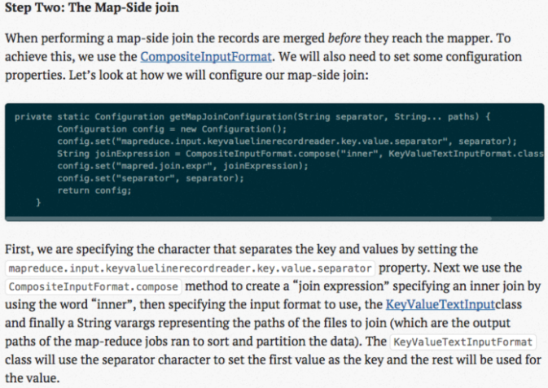
3. Outer Join example using streaming three-way join
   1. 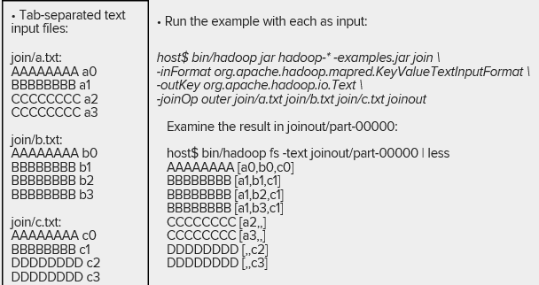
4. Summary
   1. Hash join great if you can squeeze your data into memory
   2. Map-side join also attractive
   3. Overall, joining not only for databases, also for machine learning

## Lecture:

* Altiscale server:
  + 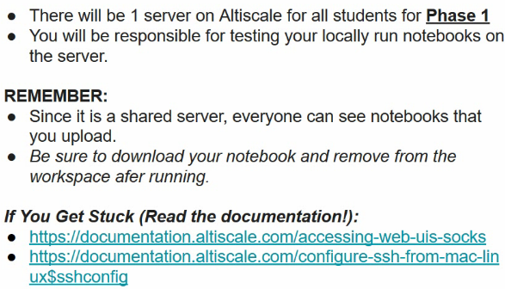
  + See James’ session on getting altiscale up and running, this will be next week
  + HW 5.1 due next week.
  + HW 5.2 due afterwards
  + Do more work on your own for Altiscale before the class
  + Running a notebook on Altiscale:
  + 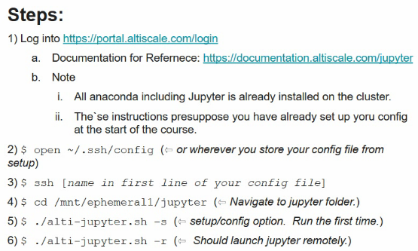
  + See slides for more information and installation
  + 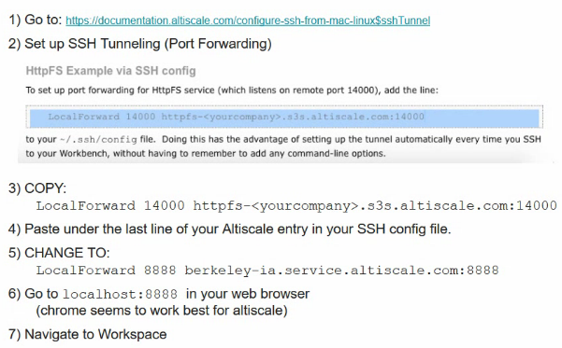
  + HW 5.2 might be group work
* MRJob
* Normal Forms
  + First: no cells have multiple values; Each row has primary key
  + Second: first + primary key contains multiple columns (secondary key); Non-key columns depend on the whole key
  + Third: second + each non-key attribute in a row does not depend on the entry in another non-key column.
  + 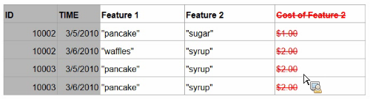
* Vector Space Models
  + Representing documents
  + VSM is algebraic model for representing text documents as vectors of identifiers
  + Used in info retrieval, filtering, indexing, relevancy ranking
  + Term by doc:
  + 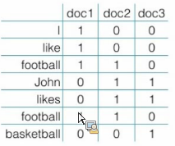
  + Represent both documents and words with vectors or points in a multidimensional space
  + Build a matrix of term x documents
  + 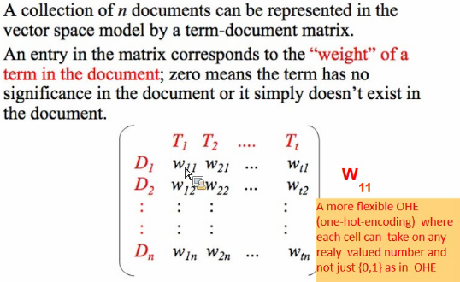
  + First index should be row index, second index should be column index, above is wrong.
* TF-IDF
  + Term frequency inverse document frequency reflect how important a word is to a document in a collection or corpus
  + It is often weighting factor in info retrieval and text mining
  + Terms that are least frequent might be most discriminating
  + We reward terms that are used frequently in this document, but punish them if they are used a lot in a lot of other documents
  + 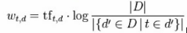
  + 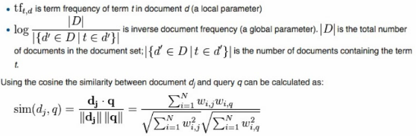
  + Above, take normalized projection of each of the documents.
  + Dot product of two vectors: multiply them together term by term, we then add all the results together. So dj is a vector and q is a vector and we multiply them above.
  + Similarity: <https://en.wikipedia.org/wiki/Cosine_similarity>
* Sparse document matrix
  + How do you represent it effectively?
  + Sparsity makes it difficult to make calculations
  + For high dimensions everything is very far from everything else
* Word2Vec creates smaller VSM from original VSM
  + Axis denote latent concepts rather than words
  + The thing Ievgen mentioned :O
* Distance metric vs similarity measure
  + So distance is 1 – similarity
  + Similarity is like the angle between them
  + Distance is the distance between them
* Index vs inverse index
  + The index in a book (at the end) is actually known as an inverse index (on which page each of the words are)
* Using MR to construct indexes
  + 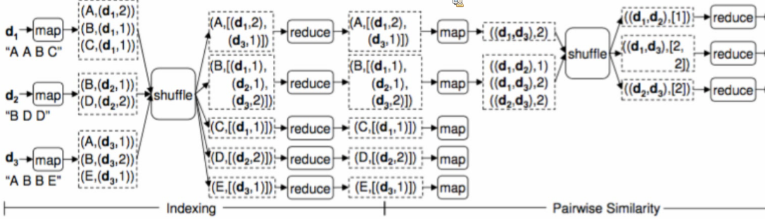
  + First reducer doesn’t do much in this case, but it might be doing.
  + After first reducer, we can calculate similarities between documents. Look at A and B and compare documents they have.
  + After second mapper, you get product between each pair of documents (goal is cosine similarity).
  + After second shuffle d1 and d3 appears once in A and once in B, so we get two 2s
  + After last reduce, we just sum or multiply them…
* Stripes

# Unit 6: Distributed Supervised ML Part 1

## Videos:

Introduction:

1. Matrices and matrix multiplication, the distributed way
2. Optimization theory
3. Gradient Descent
4. Convex optimization
5. Linear Regression (convex optimization gives closed form solution)

Supervised Machine Learning Parametric vs. Nonsupervised

1. Types of learning
   1. Unsupervised: K means, principal component analysis
   2. Supervised learning: generates a function that maps inputs to desired outputs. For example, in a classification problem, the learner approximates a function mapping a vector into classes by looking at input-output examples of the function.
   3. Semisupervised learning: using labelled and unlabelled data.
   4. Reinforcement learning: one-shot decision-making vs lifetime-value modelling. Learns how to act given an observation of the world. Every action has some impact in the environment, and the environment provides feedback in the form of rewards that guide the learning algorithm. Transduction tries to predict new outputs based on training inputs, training outputs, and test inputs.
   5. Not that easy to distribute as it is sequential
2. ML Background
   1. Machine learning (ML): "a computer program that improves its performance at some task through experience" (Mitchell, 1997).
   2. Given: Input data are a table of attribute values and associated class values (in the case of supervised learning).
   3. 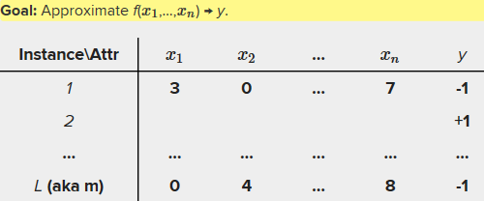
   4. Do this using a linear model
3. Families of SL
   1. 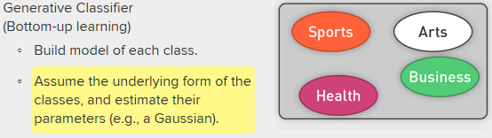
   2. We work from the class prototype out, let the class define itself
   3. 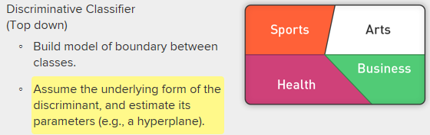
   4. Trying to find boundaries between classifiers. Think SVM
4. Generative vs Discriminative
   1. Generative learning (e.g., Bayesian networks, HMM, naïve Bayes) typically more flexible
      1. More complex problems
      2. More flexible predictions
   2. Discriminative learning (e.g., linear regression, ANN, SVM) typically more accurate
      1. Better with small datasets
      2. Faster to train
5. Parametric vs Nonparametric ML
   1. Parametric ML algorithms (e.g., OLS, decision trees; SVMs, NNs): Model-based methods, such as neural networks and the mixture of Gaussians, use the data to build a parameterized model. After training, the model is used for predictions, and the data are generally discarded. Should be easy to optimize for MR
   2. Nonparametric (lowess(); knn; some flavors SVMs):
      1. In contrast, "memory-based'' methods are nonparametric approaches that explicitly retain the training data and use it each time a prediction needs to be made.
      2. The term "nonparametric" (roughly) refers to the fact that the amount of stuff we need to keep in order to represent the hypothesis/model grows linearly with the size of the training set.
      3. Very little learning; some hyperparameter tuning.
      4. Just store the data usually.
      5. Hard to optimize for MR

Core Supporting Concepts: Matrices, Applications of Matrices

1. Overview
   1. Glene Golub
   2. Charles van Loun
   3. 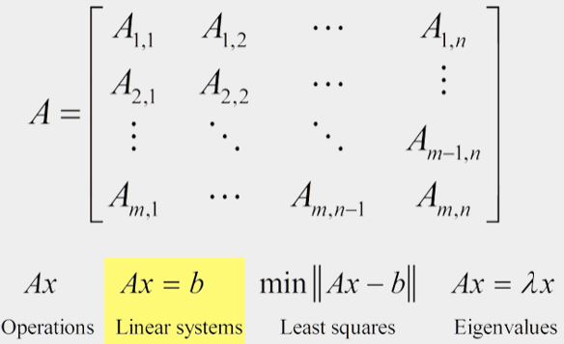
   4. Can come in the shapes of SQL queries
   5. Linear regression in closed form
   6. PCA
   7. PageRank for graph problems.
   8. Graphics.
   9. Navigation: shortest path.
   10. Robotics and automation: Matrices are the base elements for the robot movements.
   11. And many others.
2. Example: Nonlinear operation with matrices
   1. 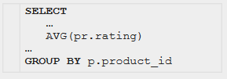
   2. 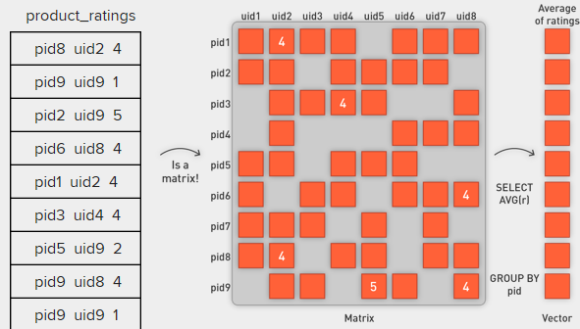
   3. Above is represented as below matrix operation
   4. 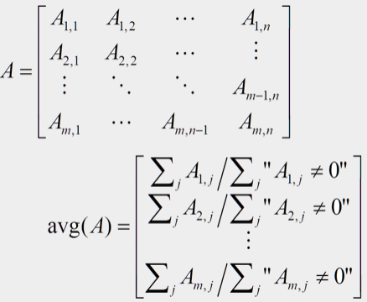
3. More matrix computations
   1. Doc by term matrix: each cell entry corresponds to how often a term occurs in a document
   2. 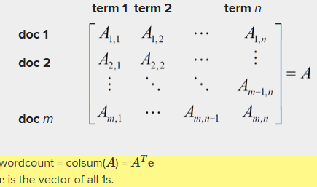
   3. Transposed matrix:
   4. 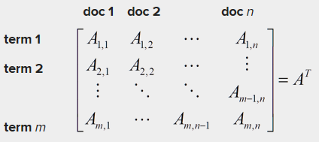
   5. Gives us an inverted index
4. Recommender systems
   1. User-item matrix
   2. Matrix structure of a bipartite graph
   3. 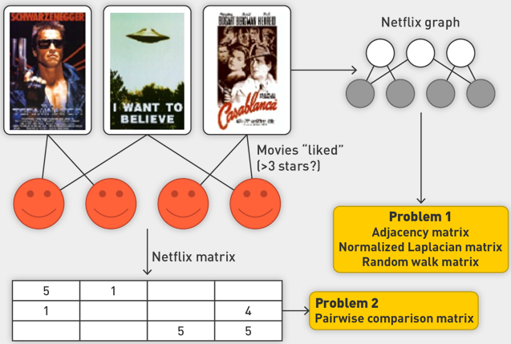
5. The web as a graph
   1. 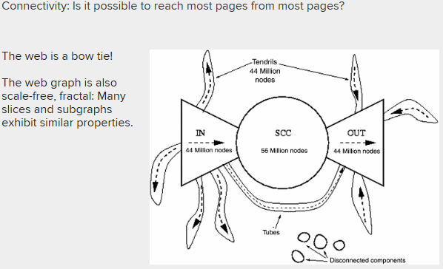
6. Closed form of linear regression
   1. 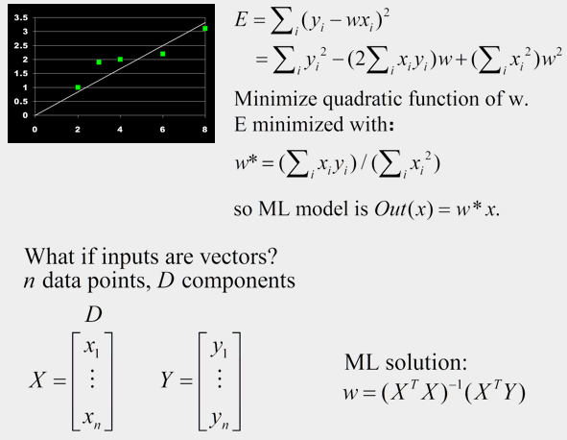

Matrices: Vector by Vector Multiplication

1. Composite keys
   1. Natural key + secondary key
   2. To make MR framework do the heavy lifting
   3. 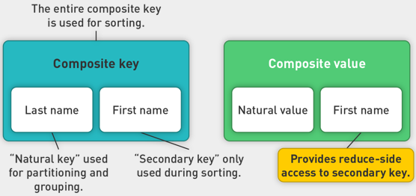
   4. What if we want to sort by last name and first name
   5. Taking composition of the two is a lot of values in the universe of names
   6. We can do something around last names, we can count how many first names to a last name.
2. Composite key: partition and Sort
   1. Look at historical data of Amazon, want to calculate change in stock price per day for last 30 days
   2. First gather all stock prices for Amazon in the same reducer, then sort those by timestamp.
   3. In MR requires construction of composite key. First part is stock ticker price (Amazon), second part is timestamp
   4. We partition on stock symbol, sort based on actual timestamp
   5. 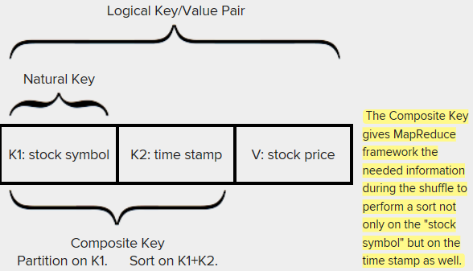
   6. Do a secondary sort over the timestamp
   7. 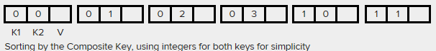
   8. The Composite Key gives MapReduce framework the needed information during the shuffle to perform a sort not only on the "stock symbol" but on the time stamp as well.
   9. 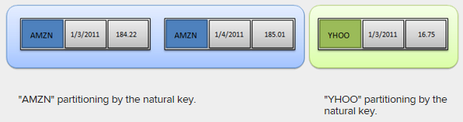
3. Vector by Vector multiplication: Dense input
   1. 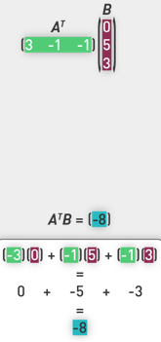
   2. In MR:
   3. Encode matrix in a dense format
   4. 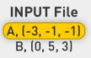
   5. Above are key, value records, A and B being keys. We explicitly record zero fields
   6. What are units of parallelism?
   7. Treat as routing problem, put an address on each item.
   8. Doing component level multiplication and reduce by summing
   9. Take each element, attach target address, such that they are synced up to reduce side and further aggregated. Natural address is position in the output vector ( so -3 and 0 will be at position zero). Tag each input value with a key telling us how it will be consumed on reduce side. Take each k,v pair so that:
   10. 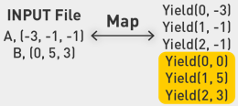
   11. Keys are positions in the vector, values are values at position. Shuffle brings them together by key.
   12. 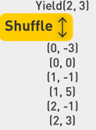
   13. 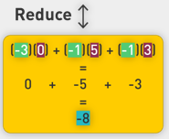
   14. Finish with multiplication and in-memory combiner to get the final sum.
   15. We can also get by with sparse multiplications
   16. 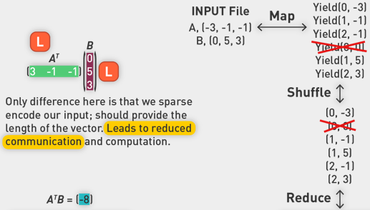
   17. We don’t have to send the zeroes, becoming a more efficient operation across the board.

Matrix by Matrix multiplication V1

1. Notation
   1. 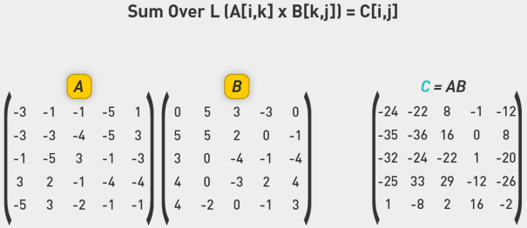
   2. 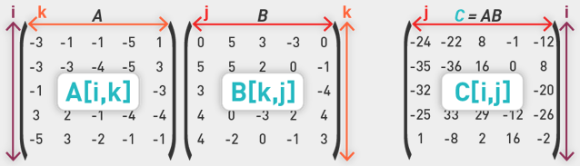
2. Distribute Matrix multiplication
   1. Look at the output matrix and its elements Cij, each of the elements is independent of each other, ripe for serialization
3. One Job: Matrix-Vector Multiplication
   1. MR framework needs to know k, columns in A and rows in B
   2. Best to know I, K, and J:
      1. I number of rows in A
      2. K number of columns in A (number of rows in B)
      3. J number of columns in B
   3. Emits a lot of superfluous data into the mapper-to-reducer stream, i.e., a dense emit
      1. If value exists, then emit a value for each k (the number of columns in matrix A) and targets that could potentially involve that cell, i.e., all cells in row k in matrix B
      2. In short B[k,*]
4. Input data: dense vs sparse
   1. MapReduce needs to divide and aggregate data (matrix) by key-value pairs.
   2. It is easier to represent data as (rowIndex, columnIndex, value).
   3. Regardless of the input data format, we can derive input value (rowIndex, columnIndex, value) from matrix.
      1. Dense matrix in array format can be easily scanned to be transformed to (rowIndex, columnIndex, value).
      2. Sparse format will be in this format already or can be transformed to this format easily.
5. V1 One-Step MR
   1. 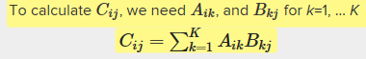
   2. 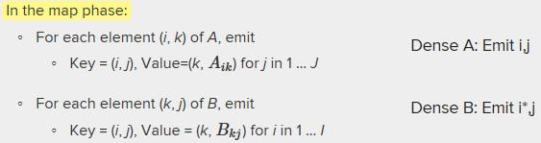
   3. 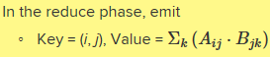
6. Schematic look
   1. 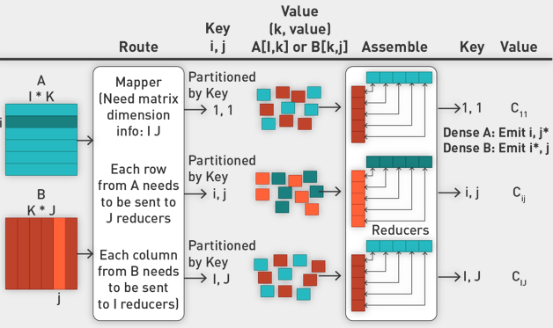
7. Split and Route elements
   1. 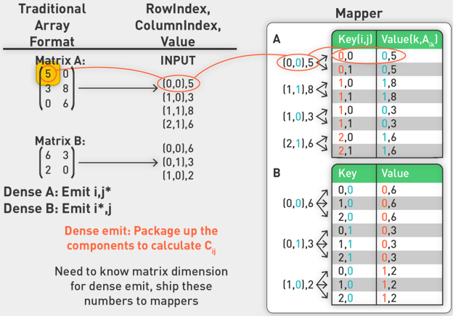
   2. For A, I know what i is for this cell, but I don’t know which js this value belongs to.
   3. We emit value 5 and address it to index i, as well as a dense emit over all values of j. All values of j here refers to 0 and 1, because B has only two columns.
   4. Send column corresponding to the first element.
   5. For B, we emit for all values of i. We tell the system where this element may participate.
   6. We split A and B, telling system where data is supposed to go.
8. Reducer: assembling components for Cji
   1. 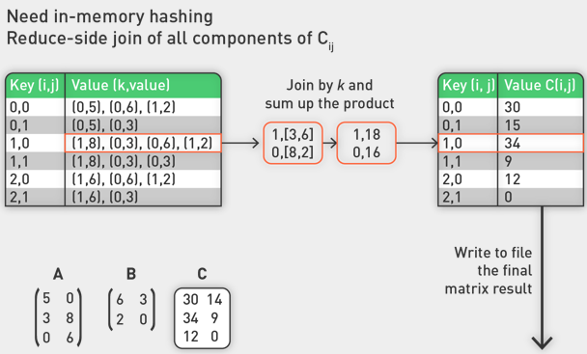
   2. Works with keys
   3. Take all components for particular Cij and will organize them in memory.
   4. I will sort them and match indices of A matrix by B matrix. Like multiplying a vector for A and vector for B, summing up in the end.
   5. In the above example, [3 8] is multiplied by [6 2] and the indices in the value (the first number in the parentheses) are what we use to match them.
   6. Reducer limited by the memory hashing.
   7. Reducer is a big join.
   8. Write to file in the end. In this case, this is just part of a matrix.
9. Pros and Cons of V1
   1. Pros:
      1. Straightforward
      2. The same as manual calculation
      3. Only need MapReduce step
   2. Cons:
      1. Reducer-side join of Cij in memory
      2. Component when K is too big, in reducer method 1 cannot load all data into memory to join and sum up the product (the hash table to hold the component for Cij)
      3. If matrices dimensions are unknown, method does not work
      4. Network communication is heavy: Dense emits of individual elements of matrix Aik and Bkj

Distributed MxV V1.1

1. Drawbacks of 1.0
   1. When M is too big, in reducer, method1.0 cannot load all data into memory to join and sum up the product.
   2. If the dimensions of two matrices are unknown, the method does not work.
   3. Network communication is heavy: dense emits of individual elements of matrix Aik and Bkj.
   4. Lets use secondary sorts and more complex keys
2. Solution
   1. Secondary sort of k values:
   2. If we sort the output values of mapper by k, we don't need to join values by k in memory, just scan values by on pass to get the sum of product without loading all data into memory.
   3. 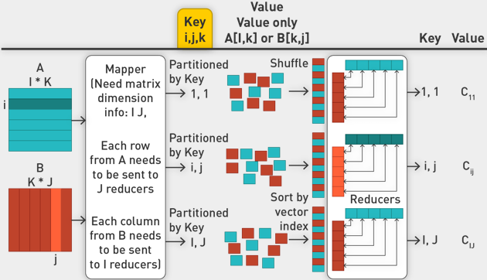
   4. Have key in the form of I,j,k, where I,j is primary part which we use to partition and sync around them in the reducer. K is used for sorting, it is the vector index.
   5. 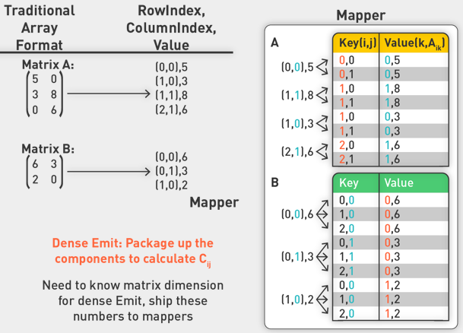
   6. Reducer will get a list of sorted pair values.
3. Example
   1. 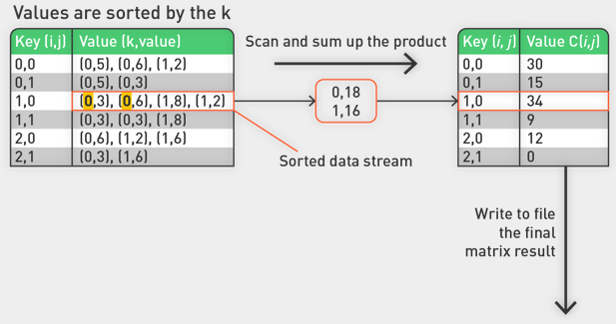
   2. There is no change apart from the mapper output values. Increased key and made value smaller.
4. Limitations
   1. Solution:
      1. Secondary sort of k values:
      2. If we sort the output values of mapper by k, we don't need to join values by k in memory, just scan values by on pass to get the sum of product without loading all data into memory.
   2. Only limitations:
      1. Need to provide matrix dimension.
      2. Network communication is heavy: dense emits of individual elements of matrix AikAik and BkjBkj.
   3. Solution is a 2-step MR job: (NOT INCLUDED IN CLASS)
      1. Two-step MapReduce:
      2. Intermediate products are calculated in first reducers.
      3. Sum these products up at second reducers.
      4. Click [here](https://www.dropbox.com/s/crh2rcii3l6ihfg/Lecture-06-Matrix-by-Matrix-Mult-2job-approach.pdf?dl=0) for a detailed description of the [Two-Step MapReduce Approach to Matrix-by-Matrix-Multiplication](https://www.dropbox.com/s/crh2rcii3l6ihfg/Lecture-06-Matrix-by-Matrix-Mult-2job-approach.pdf?dl=0)

Distributed Matrix Summary

1. Methods
   1. One-step with dense emit
   2. Two-step with a heavy in-memory sync around k-based components
   3. 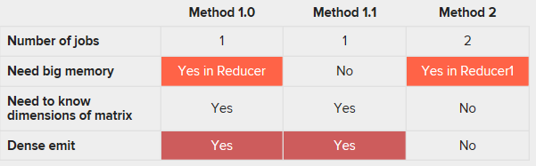
   4. Other: Tile-Based Matrix Multiplication
   5. "MadLINQ: Large-Scale Distributed Matrix Computation for the Cloud," Qian et al, EuroSys 2012.

Core Concepts: Optimization Theory – Gradient Descent

1. Optimization
   1. Mathematical optimization is the selection of a best element (with regard to some criteria) from some set of available alternatives.
   2. In the simplest case, an optimization problem consists of maximizing or minimizing a real function by systematically choosing input values from within an allowed set and computing the value of the function.
2. Mathematical Optimization
   1. 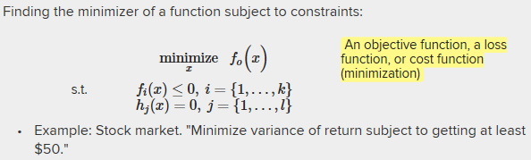
   2. Such a formulation is called an optimization problem or a mathematical programming problem.
   3. Many real-world and theoretical problems may be modeled in this general framework.
   4. The function f0f0 is called, variously, an objective function, a loss function or cost function (minimization), a utility function or fitness function (maximization), or, in certain fields, an energy function or energy functional.
   5. A feasible solution that minimizes (or maximizes, if that is the goal) the objective function is called an optimal solution.
   6. Very important for ML
3. Linear Regression
   1. 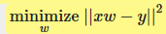
   2. Logistic regression or SVM
   3. 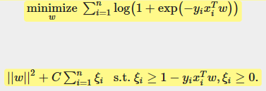
4. Others
   1. 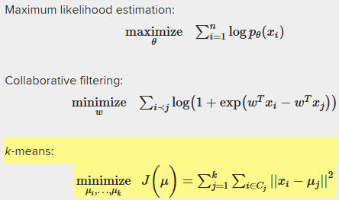
5. Maximum vs Minimum
   1. Univariate objective function
   2. 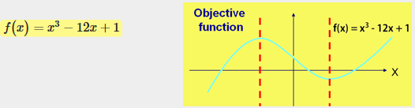
   3. This one has multiple maxima and minima points. Can we find it in specific area?
   4. Take first derivative with respect to x
   5. 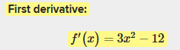
   6. 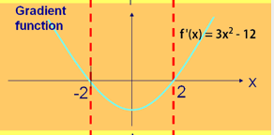
   7. 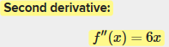
   8. 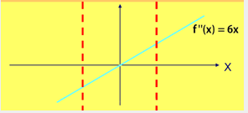
   9. All three derivatives:
   10. 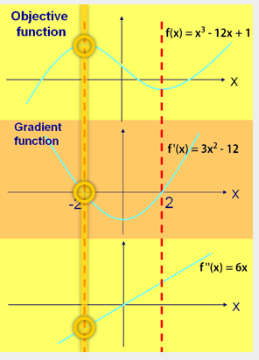
   11. All candidate extreme points will have zero crossing of the gradient function.
   12. At a maximum point, the second derivative function is negative. It is positive in minimum point.
   13. First and second order conditions for a minimum and maximum
   14. 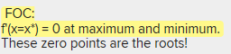
   15. For a point to be min or max, we need it to cross at zero in gradient function.
   16. 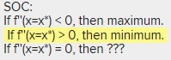
6. Finding the optimum
   1. Finding roots of gradient function
   2. Closed form exists for some functions
   3. Gradient descent
   4. Newton-Raphson
7. Newton-Raphson Method: Root finding of derivative/Gradient Function f’(x)
   1. 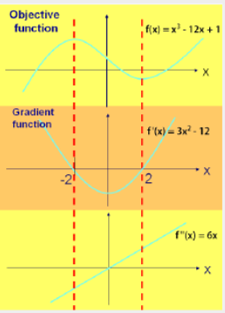
   2. Focus on gradient, right side
   3. Try to estimate using tangents.
   4. 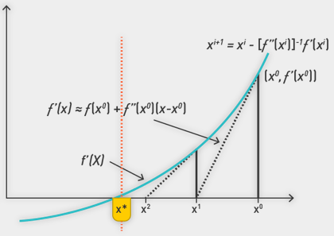
   5. 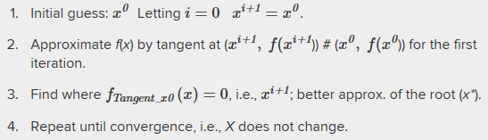
   6. Iteratively refine where crossover point is.
8. Deriving Newton-Raphson Method (no need to cover below in detail, but understand the method)
   1. 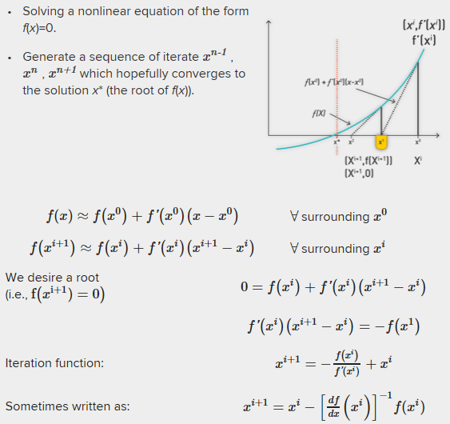
   2. Question: do we need to know this in details?
9. Some bullshit, but NR is complicated for multiple dimensions. We need to take inverse of hessian matrix.
10. Gradient Descent
    1. Replace Hessian matrix by factor alpha
    2. Learning rate approximates very well.
    3. Update step is taking current value and weighted portion of gradient vector
    4. 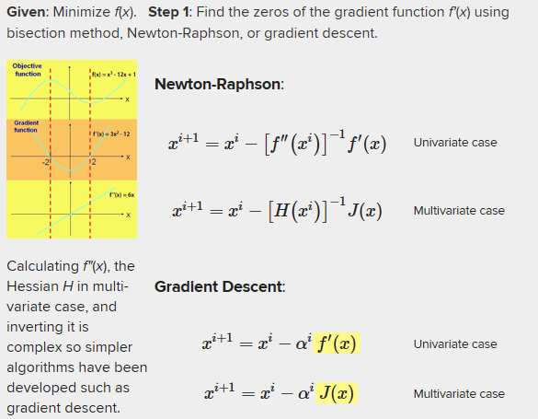
11. Learning Rate
    1. Can be fixed
    2. Can decay over time
    3. Linesearch
12. Characterizing Extrema in multiple dimensions
    1. First order condition: Gradient function is zero (i.e., the objective function is at an extremum).
    2. 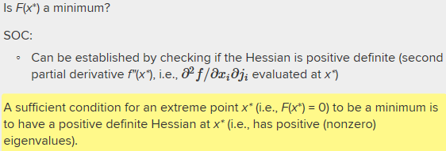
    3. 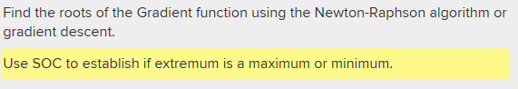
13. General Approach to finding extrema
    1. Well behaved version spaces: convex or concave function.
    2. Algorithms seek a local extrema knowing that it will be global.
       1. If f( ) is a concave function, then local maximum is a global maximum.
       2. If f( ) is a convex function, then local minimum is a global minimum.
       3. Newton-Raphson, gradient descent, conjugate gradient descent.

Optimization Theory: Convex optimization

1. Convex minimization
   1. Convex minimization, a subfield of optimization, studies the problem of minimizing convex functions over convex sets.
   2. Convexity can make optimization in some sense "easier" than the general case; e.g., any local minimum must be a global minimum.
   3. We don’t need to look at SOC
   4. 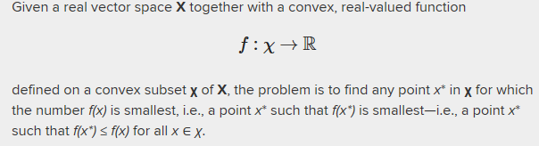
2. Convex minimization over convex sets
   1. In Euclidean space, an object is convex if for every pair of points within the object, every point on the straight line segment that joins them is also within the object.
   2. Intuitively, this means that the set is connected (so that you can pass between any two points without leaving the set) and has no dents in its perimeter.
   3. For example, a solid cube is convex, but anything that is hollow or has a dent in it, for example, a crescent shape, is not convex.
   4. 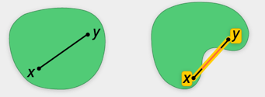
3. Minimization: Convex Functions in 1D
   1. 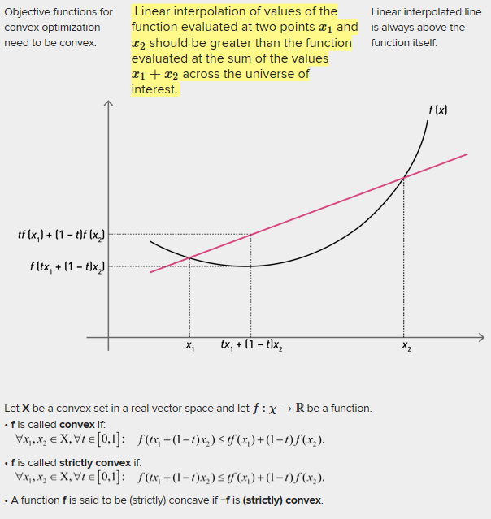
   2. Zero order conditions for convex minimization
   3. 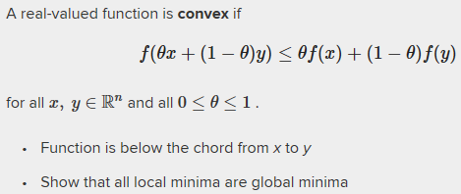
4. First order condition for convexity
   1. 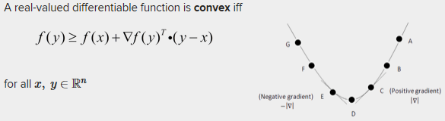
   2. 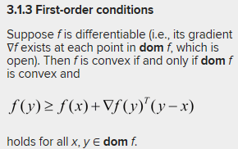
   3. 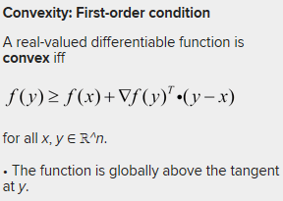
5. Convex optimization problems
   1. 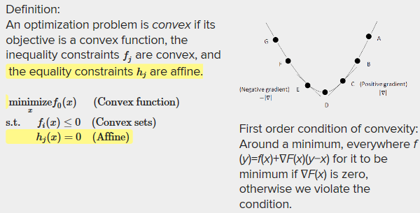
6. CO in ML
   1. Many methods in machine learning are based on finding parameters that minimize some objective function. Very often, the objective function is a weighted sum of two terms:
   2. A cost function and regularization term. If these are convex, their sum is convex.
   3. This arises in ML in many cases
   4. In statistics terms, these are the (log-)likelihood and (log-)prior. If both of these components are convex, then their sum is also convex.
   5. Loss functions are summed over examples so the sum of a convex functions is a convex function.
7. ML Objective Function: Regression Loss Function
   1. 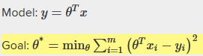
   2. Leads to following loss function
   3. 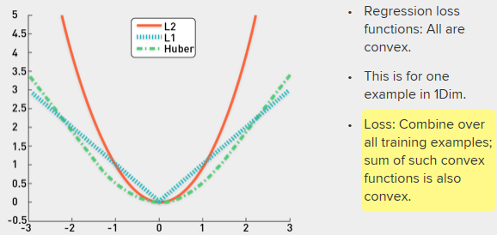
8. Classification loss function
   1. 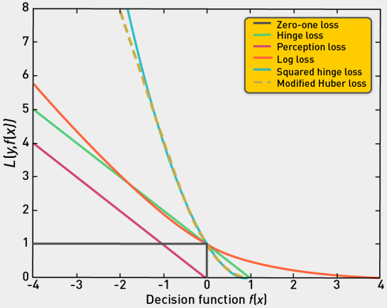
9. Gradient Descent for LR Price and Size
   1. Iteration 0
   2. 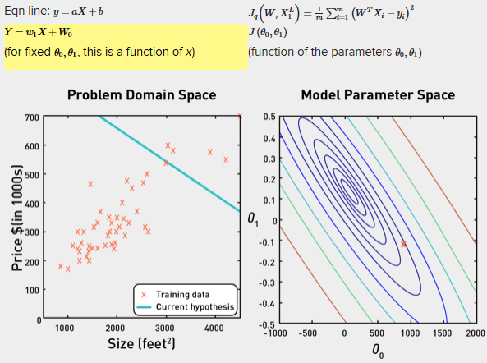
   3. Iteration 7
   4. Combo of theta 0 and theta 1 is minimum for this objective function. If this problem is convex, then minimum is global minimum
   5. 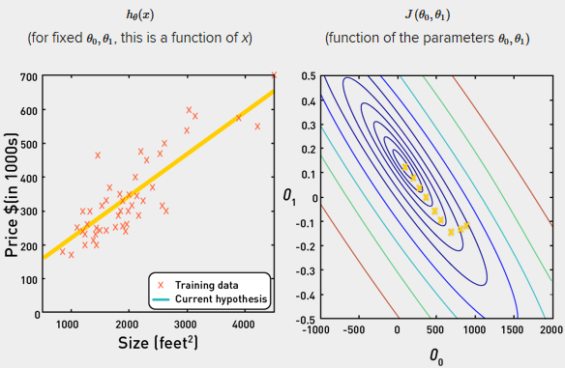
10. In 3D
    1. 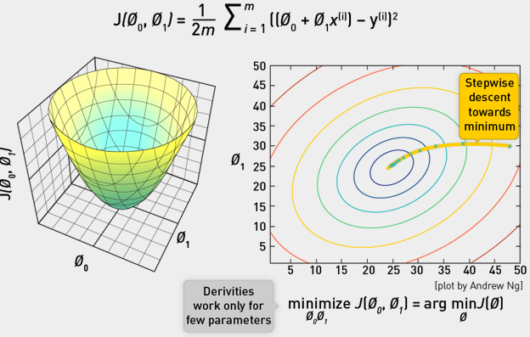
11. OLS
    1. Is a convex optimization problem
    2. 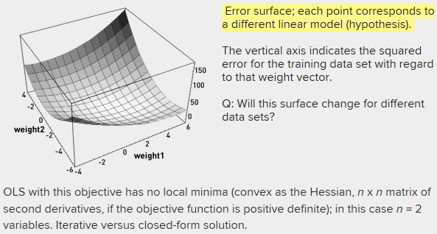
12. Summary
    1. Having a convex objective function in machine learning is very attractive, as we can leverage the FOC to determine a minimum—a minimum that will be a global minimum.
    2. We can use techniques such as gradient descent or Newton-Raphson to get us there.
    3. Let's leverage this to build some learning algorithms and run them on MapReduce frameworks.

Distributed Closed-Form Linear Regression

1. Overview
   1. Next we look at a data-modeling approach that has a convex objective function, that of linear regression.
   2. We will exploit this fact to develop two learning algorithms and also show how these algorithms can be scaled up through parallelization in a MapReduce framework.
   3. Closed form
   4. Gradient Descent version
2. Equation of a line
   1. 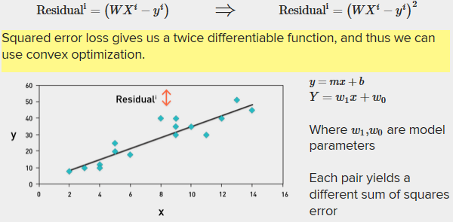
   2. 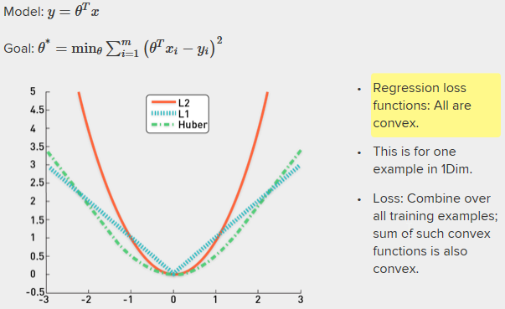
3. Convex Operation, FOC
   1. Convex optimization tells us that the first-order condition ∇F(X) = 0 at the global minimum.
   2. We are going to exploit that here to get a closed-form solution for linear regression.
   3. 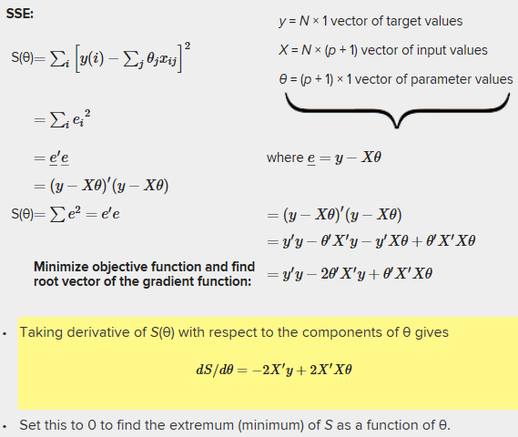
   4. 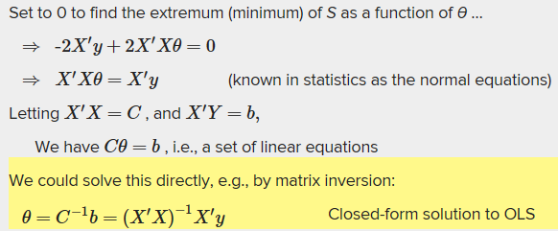
4. OLS on a single computer in R
   1. 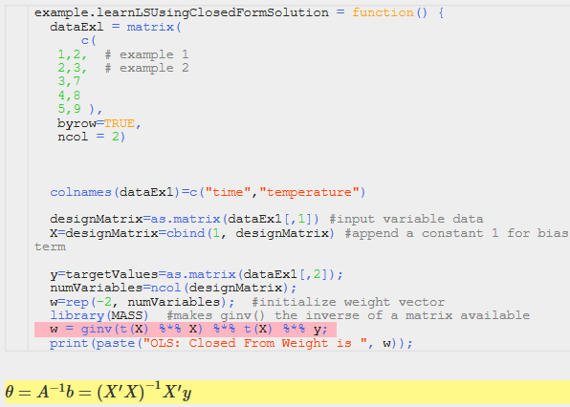
   2. How do we distribute this in MR
   3. See matrix multiplication from earlier and use it to solve this problem
5. OLS on multiple computers
   1. Four MR jobs, two for Xtrans*X, two for Xtrans*y plus local comp.
   2. 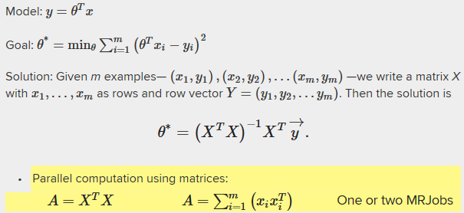
   3. 
   4. Then ship A and b back to the master node that launched this cluster
   5. Calculate the inverse of the covariance matrix.
   6. 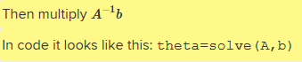
6. Schematic
   1. 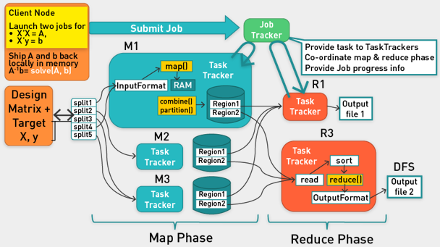
   2. Start job to multiply design matrix by design matrix and design matrix by y.
   3. Get results, solve in memory for final part.
7. Conclusion
   1. That is our first version of a linear regression.
   2. I hope you are excited about being able to distribute one of the workhorse algorithms of machine learning that forms the basis of many fields such as statistics, social sciences, and econometrics.
   3. But wait—there is more!
   4. This is just one way to distribute linear regression. We will address that next.

Complexity of Algorithms

1. Algorithm time complexity analysis
   1. Two core operations in single core
   2. Calculation of covariate matrix A and the inverse of it
   3. First takes mn^2 where m is training examples and n is input variables
   4. The matrix must be inverted for n^3
   5. For Multi core, we divide by P which is number of nodes. We add extra complexity for communication
   6. 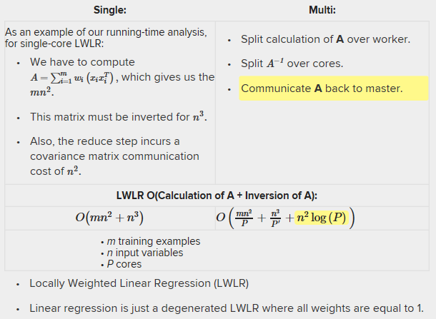
2. Evaluation Data Sets
   1. Conducted an extensive series of experiments to compare the speed-up on data sets of various sizes (Table 2)
   2. On eight commonly used machine learning data sets from the UCI Machine Learning repository
   3. Two other ones from an anonymous research group (helicopter control and sensor data)
   4. Note that not all the experiments make sense from an output view—regression on categorical data—but our purpose was to test speed-up, so we ran every algorithm over all the data
   5. 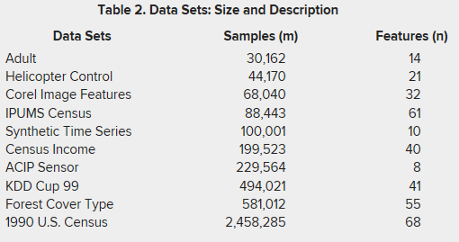
   6. 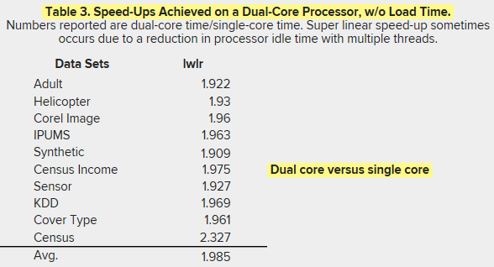
   7. 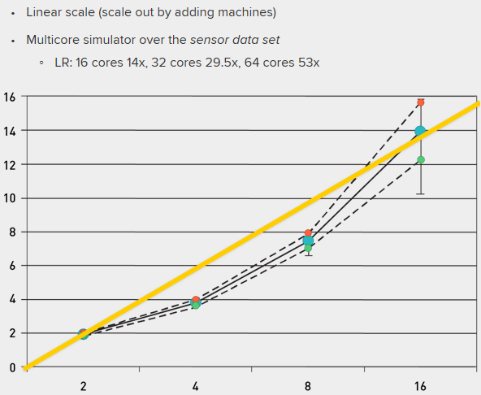
   8. Distributed is almost linear.
3. Conclusion
   1. You have just seen how one of the workhorse algorithms of machine learning, linear regression, scales out.
   2. We will discuss shortly one of the limitations of this approach.
   3. In addition, I will present an alternative approach to distributing linear regression that overcomes these limitations.

Distributed-Gradient-Descent Approach to Linear Regression

1. Overview
   1. Previously we have seen how to learn a linear regression model using distributed closed-form solution.
   2. This distribution solution runs into minor issues when we try to scale.
2. Limitation of Closed form OLS: Solving for the thetas
   1. Problem is equivalent to inverting X′X matrix.
   2. Inverse does not exist if matrix is not of full rank.
      1. E.g., if one column is a linear combination of another (collinearity).
      2. Note that X′X is closely related to the covariance of the X data.
   3. So we are in trouble if two or more variables are perfectly correlated.
   4. Numerical problems can also occur if variables are almost collinear.
   5. Equivalent to solving a system of p linear equations.
   6. Many good numerical methods for doing this, e.g., Gaussian elimination, LU decomposition, etc.
   7. These are numerically more stable than direct inversion.
   8. Matrix inversion is not easily parallelized.
3. Linear Regression via Gradient Descent
   1. Take objective
   2. Calculate gradient
   3. Use GD to hone in to a local minimum that will turn out to be a global minimum
   4. 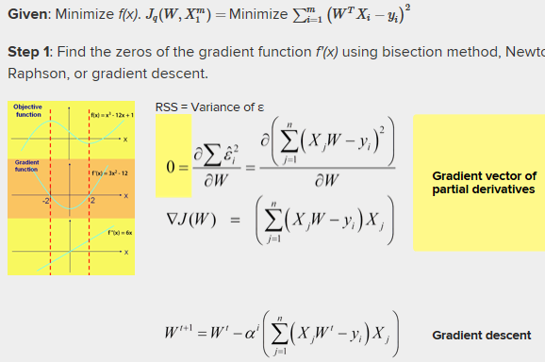
   5. Pulling model closer to examples with biggest residuals
   6. Iteratively apply GD
   7. At some point we converge, so updates are very small
4. OLS using GD
   1. 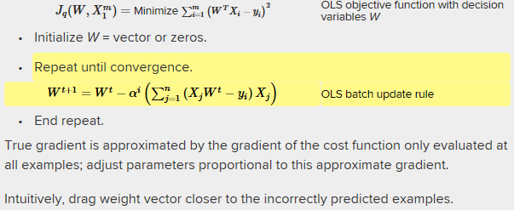
   2. Stochastic vs Batch GD
   3. Stochastic: instead of updating after we look at all of training data, we pick each example, calculate gradient and update
   4. 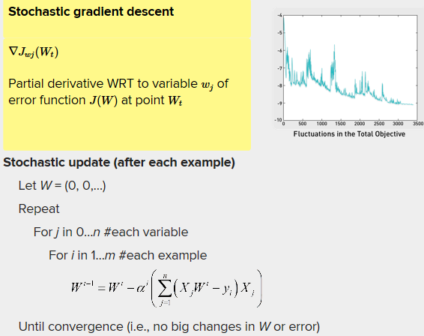
   5. Stochastic gradient descent can start making progress right away and continues to make progress with each example it looks at.
   6. Often, stochastic gradient descent gets W "close" to the minimum much faster than batch gradient descent.
   7. Note, however, that it may never "converge" to the minimum, and the parameters W will keep oscillating around the minimum of J(W); but in practice most of the values near the minimum will be reasonably good approximations to the true minimum.
   8. For these reasons, particularly when the training set is large, stochastic gradient descent is often preferred over batch gradient descent.
5. Stochastic GD in MR:
   1. Cannot update weight vector after visiting each example. Too much communication overhead
   2. Stochastic gradient descent requires the weight vector to be updated after each example (or minibatch of examples).
   3. "Some implementations of machine-learning algorithms, such as ICA, are commonly done with stochastic gradient ascent, which poses a challenge to parallelization. The problem is that in every step of gradient ascent, the algorithm updates a common set of parameters."
   4. Batch much better for MR
6. OLS via distributed GD
   1. 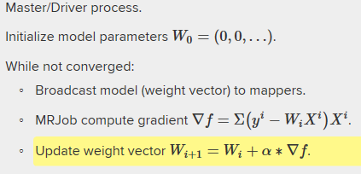
   2. Master updates the weight vector in this case, after gradient is computed using MR.
   3. 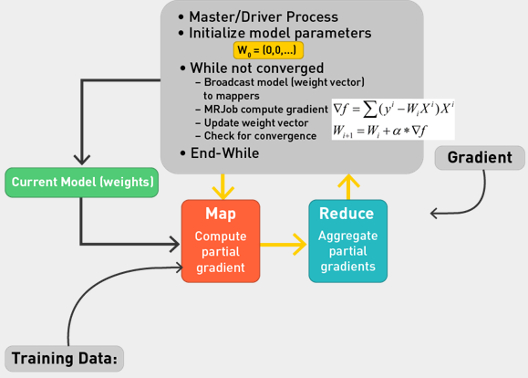
7. Mapper and Reducer
   1. 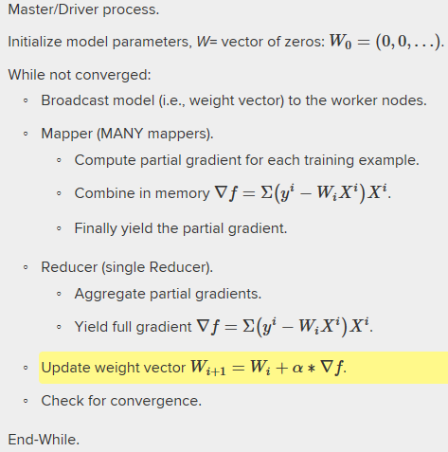
8. Divide and conquer
   1. Combiner
   2. Use in-memory combiner
   3. So use mapper final.
   4. How many reducers?
      1. We can have one (should be sufficient).
      2. Or many (in the case of many, the master has to aggregate the partial reducer aggregates).
   5. 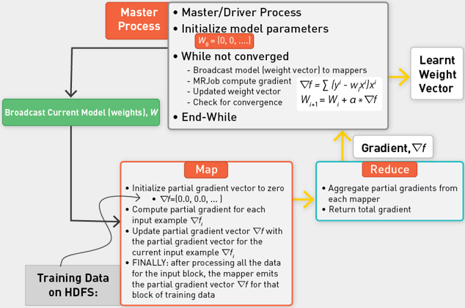
   6. From Quiz: The mapper loads all its data into memory. If the block of data is bigger than the available memory, then the mapper will crash. This is a terrible practice. To make this implementation work as is, one could make the block sizes (chunk sizes) of data smaller than the memory available to each mapper.

Summary of Linear Regression

1. Summary
   1. Derived closed form
   2. Can parallelize
   3. Gradient descent for learning linear regression model
   4. Two different approaches
   5. Distributed closed form solution is not that scalable after all, as we need to compute the inverse of the covariance matrix XTXXTX.
   6. Gradient descent approach to linear regression is more scalable.
2. Gradient Descent Pattern
   1. Other machine-learning algorithms follow this pattern for distributed gradient descent.
      1. Support vector machines
      2. Logistic regression
   2. Not surprisingly, many learning algorithms do not follow this pattern.
      1. E.g., stochastic gradient descent.
      2. Nonconvex problems.
      3. Perceptron learning is a sequential learner, but we will see how to get around this over the course of this lecture series.

## Lecture:

* Picking words for index: you get the words between 9000 and 10000, which are popular but not too popular
* Curse of Dimensionality: if we have a lot of dimensions, we cannot get good data density easily. This means our data isn’t representing the general world and the model we train will not generalize well.
* Data density is important for generalization.
* 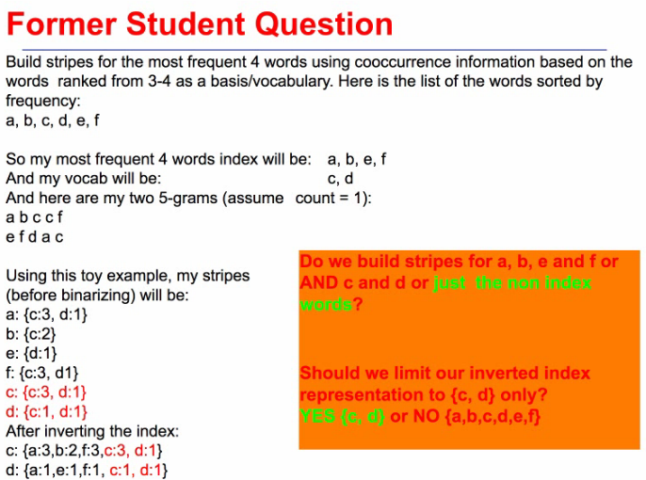
* Because of curse of dimensionality, we want to get small number of dimensions. The small number dimensions are achieved by using the index words.
* You want to represent every word as a 1000d vector, so you pick the 9000 to 10000 words.
* HW5.1 is used to build a synonym detector.
* Dot product similarity: multiply vectors together. Take the count for each word in index of a word, multiply it by the count for the same word in the index of another word.

# Unit 7: Intro to Graph Algorithms at Scale

## Videos:

Introduction

1. Background on Graphs and Networks
2. Definitions
3. Shortest Path algorithm
4. Variations
5. How can we distribute it?

Networks and Motivation

1. Data mining
   1. Bags of features usually
   2. What about relations and dependencies?
2. Networks are useful
   1. Allow for modelling dependencies
   2. A general language for describing real-world problems
   3. Recently became first-class citizen in ML world
   4. Train stations
   5. Economy
   6. Biology
   7. Social stuff
   8. Transforming society
   9. High utility
   10. Change how we compute
3. Mining Network Data
   1. It is inherently messy
   2. Computational challenge
   3. Need new algorithms to tackle it
   4. Great source of features
   5. Can help solve ML problems
      1. Bayesian networks
      2. Bipartite problems
   6. Synergies between graph processing and machine are manyfold.
      1. Hybrid of graph traversal (random walks) + classification
      2. Filling in missing data in networked data

Applications of Graphs

1. Networks mathematically
   1. Represent networks as graphs of nodes and edges
   2. Graph algorithms in MR
   3. Read book!
2. Problems
   1. Graph search and path planning
   2. Routing Internet traffic and UPS delivery trucks
   3. Finding experts, friend recommendations
   4. Finding minimum spanning trees
   5. Telco laying down fiber
   6. Finding max flow
   7. Airline scheduling
   8. Identify "special" nodes and communities.
   9. Breaking up terrorist cells, spread of avian flu
   10. Bipartite matching.
   11. Monster.com (employer-applicant), Match.com (person-person), Netflix (viewer-movie), recommender systems, finding restaurants
   12. Text summarization, concept extraction (TextRank).
   13. Find popular web pages: PageRank, Hits.
3. Scale
   1. A common feature of these problems is the scale of the datasets on which the algorithms must operate, for example, the hyperlink structure of the web, which contains billions of pages, or social networks that contain hundreds of millions of individuals. Clearly, algorithms that run on a single machine and depend on the entire graph residing in memory are not scalable. We'd like to put MapReduce to work on these challenges.
   2. Dijkstra assumes sequential properties
4. Shortest path
   1. Hard
   2. Seasonality
      1. Rush hour
      2. Game night
   3. Page rank
   4. 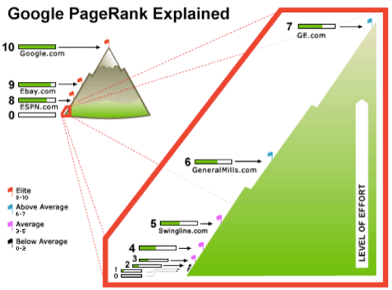
   5. Finding Friends
   6. Growing body of research captures dynamics of social network graphs.
   7. [Latanzi, Sivakumar '08][Zheleva, Sharara, Getoor '09][Kumar, Novak, Tomkins '06][Kossinets, Watts '06][L., Kleinberg, Faloutsos '05]
   8. What links will occur next? [LibenNowell, Kleinberg '03]
   9. Networks + many other features:
   10. Location, school, job, hobbies, interests, etc.
   11. Text rank
   12. Connect words in a document by simple cooccurrence. Can generate a graph and do graph analysis to find list of keywords to summarize document.

Graph Definitions

1. Graphs
   1. A graph is a representation of a set of objects where objects that are related are connected by links.
   2. Vertices (nodes) and edges (links).
   3. The interconnected objects are represented by mathematical abstractions called vertices, and the links that connect some pairs of vertices are called edges.
   4. Typically, a graph is depicted in diagrammatic form as a set of dots for the vertices, joined by lines or curves for the edges.
   5. Types:
      1. Directed
      2. Undirected
      3. Cycles
   6. G= (V,E)
   7. Both vertices and edges may contain additional information
   8. Can represent as an adjacency matrix
   9. 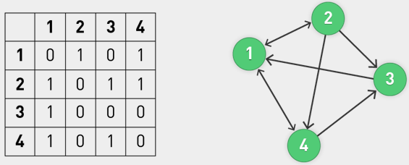
   10. Can convert to adjacency list
   11. 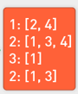
2. Adjacency List
   1. Adjacency list is usually preferred, because it provides a compact way to represent sparse graphs: those for which |E| is much less than |V|.
   2. Adjacency matrix may be preferred when the graph is dense, or when we need to be able to tell quickly if there is an edge connecting two given vertices.
   3. Adjacency list is preferred in the following:
   4. In a social network of n individuals, there are n(n − 1) possible friendships (where n may be on the order of billions). However, even the most gregarious will have relatively few friends compared to the size of the network (thousands, perhaps, but still far smaller than hundreds of millions).
   5. The same is true for the hyperlink structure of the web: Each individual web page links to a minuscule portion of all the pages on the web.
3. Graph Paths and Traversals
   1. In graph theory, a path in a graph is a finite or infinite sequence of edges that connect a sequence of vertices, which, by most definitions, are all distinct from one another.
   2. Directed path: In a directed graph, a directed path (sometimes called dipath) is again a sequence of edges (or arcs) that connect a sequence of vertices but with the added restriction that the edges all be directed in the same direction.
4. Graph Traversal
   1. 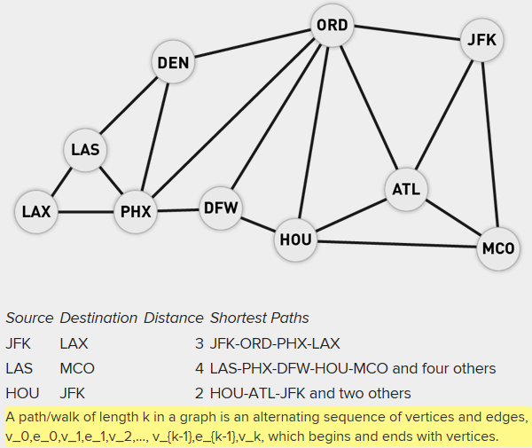
5. Properties:
   1. <http://en.wikipedia.org/wiki/Graph_property>
   2. 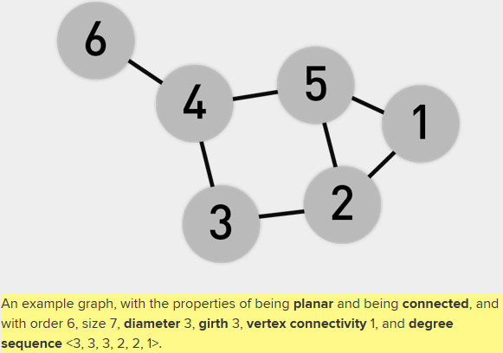
   3. Connected component: A connected component (or just component) of an undirected graph is a subgraph in which any two vertices are connected to each other by paths, and which is connected to no additional vertices in the supergraph.
6. Study graphs using Triads
   1. Groups of three
   2. 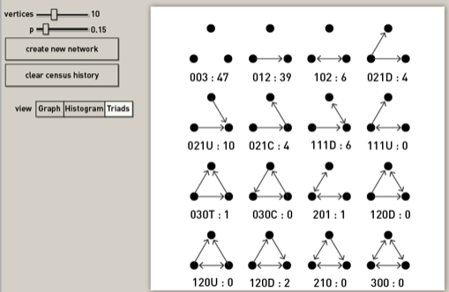

Shortest Path Introduction

1. Shortest Path
   1. Commonly done on a single machine with Dijkstra's algorithm.
   2. Can we use BFS to find the shortest path via MapReduce?
   3. Single source shortest path: A common graph-search application is finding the shortest path from a start node to one or more target nodes.
   4. A path through the graph is a sequence (v1,…, vn) such that the graph contains an edge e1 going from v1 to v2, an edge e2 going from v2 to v3, and so on.
   5. That is, all the edges must be traversed in the forward direction. The length of a path is the sum of the weights along these edges: e1,…, en−1.
   6. We call this property "length" even though for some graphs it may represent some other quantity: for example, money or time.
   7. To implement Google Maps, we need to solve the following shortest-path problem:
   8. Given two vertices v and v', what is the shortest path through the graph that goes from v to v', that is, the path for which summing up the weights along all the edges from v to v' results in the smallest sum possible?
   9. It turns out that we can solve this problem efficiently by solving a more general problem, the **single-source shortest-path problem**.
   10. Given a vertex v, what is the length of the shortest path from v to every vertex v' in the graph?
2. Single source
   1. From a single source reach all other nodes in shortest way possible (unweighted graph).
   2. Let's consider a simpler problem: solving the single-source shortest-path problem for an unweighted directed graph.
   3. In this case we are trying to find the smallest number of edges that must be traversed in order to get to every vertex in the graph.
   4. This is the same problem as solving the weighted version where all the weights happen to be 1.

Single Source SP Unweighted Graphs

1. Single source
   1. Single source: smallest number of edges that must be traversed in order to get to every vertex
   2. Unweighted graphs
   3. Challenge 1: Shortest path to all nodes from a source
   4. Sometimes we want to reach all nodes in a graph from a single starting node. How can we do this in the shortest way possible?
   5. Challenge 2: Shortest path to a single destination
   6. Sometimes we just have one target destination in mind.
   7. Do we know an algorithm for determining this? Yes: breadth-first search.
2. Overview
   1. Unweighted: each edge has weight of 1
   2. BFS and DFS algorithms
3. BFS and DFS
   1. 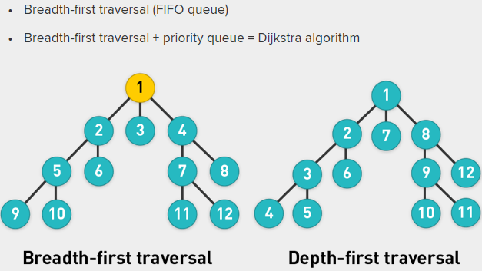
   2. For BFS, 12 is furthest (like 11 or 10 or 9) from source 1
   3. The numbers also tell you how they get added in the queue
   4. BFS is FIFO
   5. DFS is LIFO
   6. They accomplish the same thing
4. BFS complexity
   1. The running time of that algorithm is O(V+E), where V is the number of vertices and E is the number of edges.
   2. Because it pushes each reachable vertex onto the queue and considers each outgoing edge from it once
   3. There can't be any faster algorithm for solving this problem, because in general the algorithm must at least look at the entire graph, which has size O(V+E).
5. BF Traversal
   1. Is roughly analogous to level-by-level traversal of an ordered tree.
   2. Start the traversal from an arbitrary vertex.
   3. Visit all of its adjacent vertices.
   4. Then, visit all unvisited adjacent vertices of those visited vertices in last level.
   5. Continue this process, until all vertices have been visited.
   6. 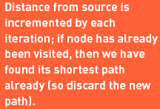
   7. 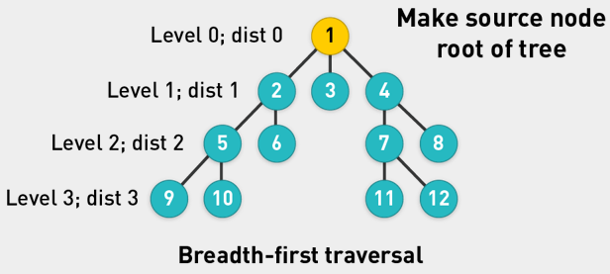
   8. 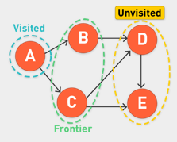
   9. The completed vertices: visited vertices that have already been removed from the queue
   10. The frontier: visited vertices on the queue
   11. The unvisited vertices: everything else
   12. Except for the initial vertex v0, the vertices in set 2 are always neighbors of vertices in set 1.
   13. Thus, the queued vertices form a frontier in the graph, separating sets 1 and 3.
   14. The expand function moves a frontier vertex (selected via FIFO/LIFO) into the completed (visited) set and then expands the frontier to include any previously unseen neighbours of the new frontier vertex.
   15. Once queue is empty, we have finished algorithm
   16. 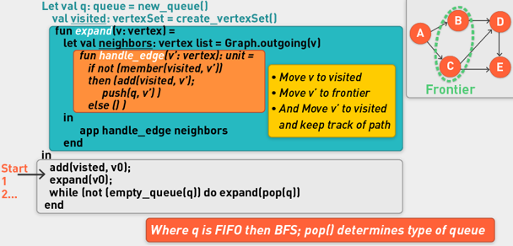
   17. 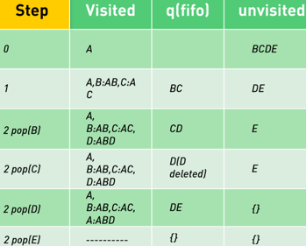
   18. In visited, you record Node:PathToNode
   19. Check if node is in visited set before adding it with its path. Add edge of B to D to path for B.
6. Tracking path lengths
   1. The only modification needed is in expand, which adds to the frontier a newly found vertex at a distance one greater than that of its neighbor already in the frontier.
   2. 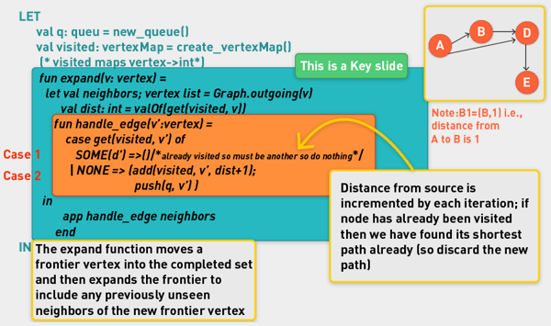
   3. 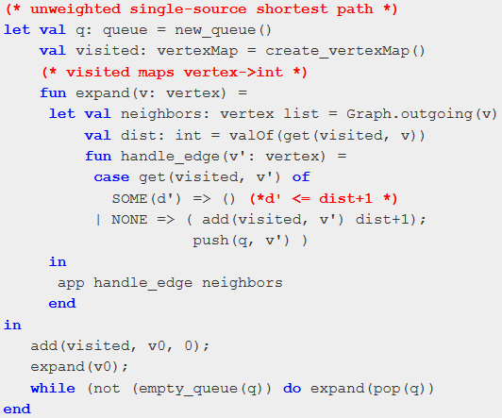

BFS for Unweighted Graphs: Directed and Animations

1. 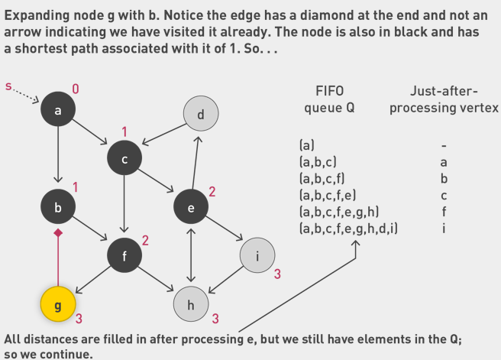

Can see other animation in video 7.9

SSSP for Weighted Graphs

1. Unweighted to Weighted
   1. Now we can generalize to the problem of computing the shortest path between two vertices in a weighted graph.
   2. For the BFS algorithm, we can keep a visited hashmap that maps vertices to their distances from the source vertex v0.
   3. Previously, when traversing an edge in our node expansion, we added 1 to the distance.
   4. We change expand so that instead of adding 1 to the distance, its adds the weight of the edge just traversed.
   5. 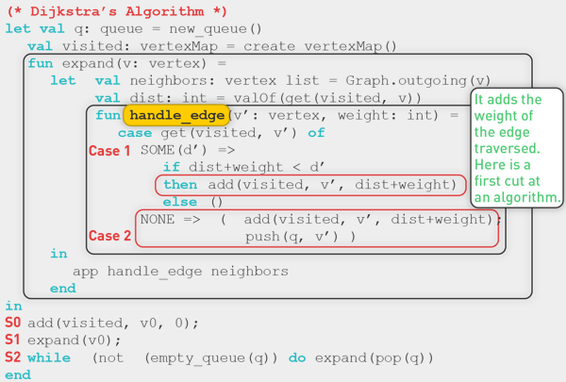
   6. Will not give shortest path to all nodes in weighted context.
   7. 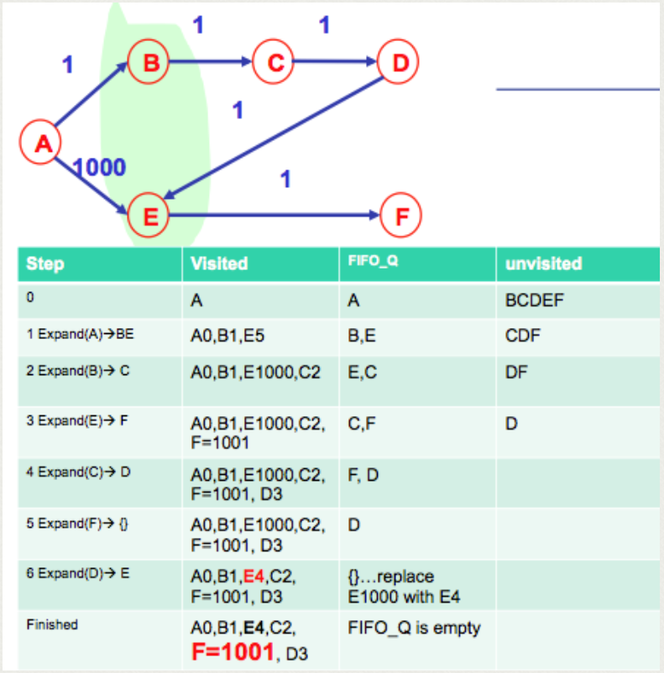

Dijkstra’s Algorithm

1. Current problem
   1. 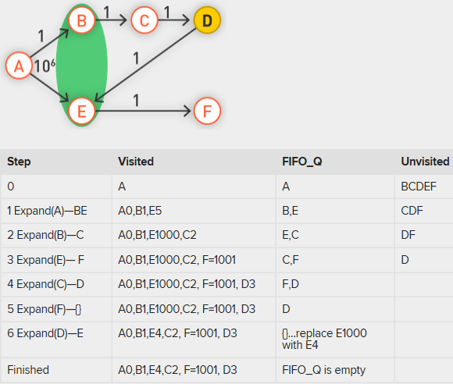
   2. E1000 is replaced by E4 at step 6, but F=1001 isn’t replaced after E is updated
2. Two Fixes
   1. If new path is improvement, update that path
   2. The queue q should not be a FIFO queue.
   3. Instead, it should be a priority queue where the priorities of the vertices in the queue are their distances recorded in visited.
   4. Keep priority queue sorted in increasing order of distance from source node
3. Dijkstra’s Algorithm
   1. 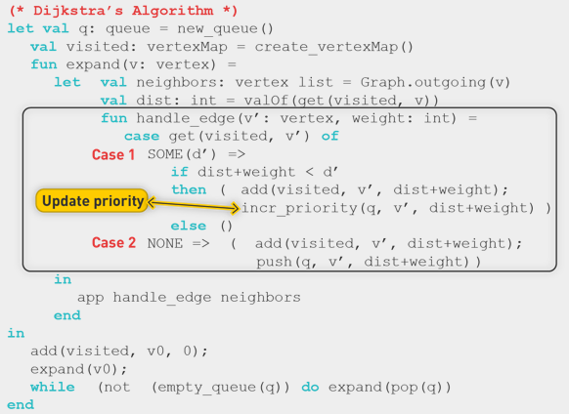
   2. Single source to all destinations
   3. Single source and single destination
4. Walkthrough
   1. Each node associated with distance of positive infinity
   2. Edges have positive weight
   3. Always take one with highest priority (lowest distance)
   4. 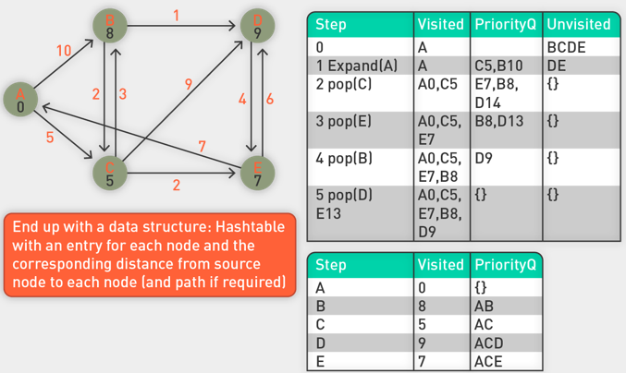
5. Sundry items on SSP
   1. Short answer is that Dijkstra is a greedy algorithm, meaning we assume that we have made the best choice possible in every step of the algorithm.
   2. With negative edges, this is no longer possible, and thus a greedy algorithm will not suffice.
   3. Because of this, there are no overlapping subproblems and therefore no need for memoization of already calculated values.

Distributed SSP: Unweighted Graphs

1. Single node computer
   1. Priority queue is key
   2. On a single-node computer Dijkstra's algorithm proceeds slowly down the tree one level at a time.
   3. Once you are past the first level, there will be many nodes whose edges need to be examined, and in the code above this happens sequentially.
   4. The key to Dijkstra's algorithm is the global priority queue that maintains a globally sorted list of nodes by current distance.
2. Parallel MR is stateless
   1. This is not possible in MapReduce, as the programming model does not provide a mechanism for exchanging global data (it is stateless).
   2. How can we modify this to work for a huge graph and run the algorithm in parallel?
   3. Instead, we adopt a brute-force approach known as parallel breadth-first search.
   4. 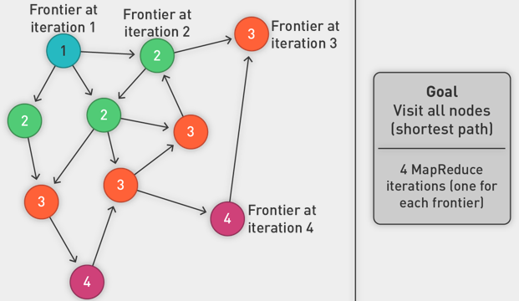
   5. Encode graph in adjacency list
   6. Start at node 1, expand to first frontier in first iteration
3. Multiple iterations needed
   1. This MapReduce task advances the "known frontier" by one hop.
   2. Subsequent iterations include more reachable nodes as the frontier advances.
   3. Multiple iterations are needed to explore entire graph.
   4. Feed output back into the same MapReduce task.
   5. Preserving graph structure (in stateless MR):
   6. Problem: Where did the edges (points-to) list go?
   7. Solution: Mapper emits (n, edges list) as well.
4. Represent Graph as adjacency list
   1. 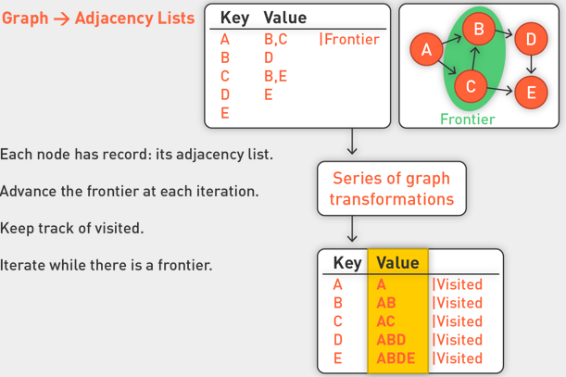
   2. Structure like this adjacency list will be constantly in our stream, from iteration to iteration
   3. For each iteration in MR, we advance of frontier one step at a time
5. Algorithm
   1. 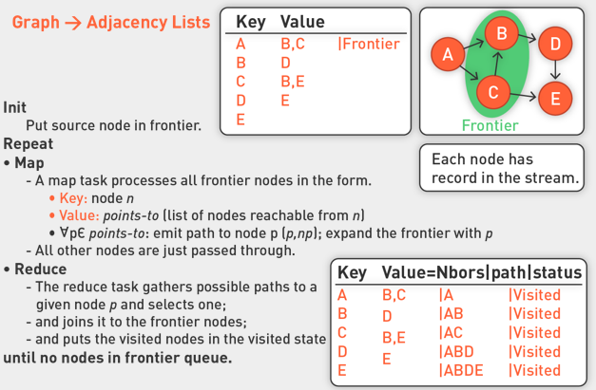
   2. Put source in frontier status
   3. Mappers process all nodes in stream. If node is in frontier, expand node to its neighbours. Take each node, look at the value (in adjacency list), and expand each of those nodes by emitting to the stream a key value pair.
   4. All other nodes are passed through
   5. Reducer syncs around each node: if there are updates in terms of distances, we pick the minimum one.
   6. For all other records, we just pass those through. WE ensure having each node represented in each stage of MR.
   7. Do this until no nodes in the frontier
   8. Output:
   9. 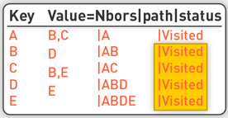
6. Distributed SSSP
   1. In BFS using a FIFO queue, you would expand each node in the front sequentially.
   2. Here take that notion one step further and expand all nodes in the frontier in parallel.
   3. Reduction ensures each node is associated with shortest path to that node.
7. SSSP Map Reduce
   1. Algorithm is based upon BFS tables that we have seen already.
   2. The completed vertices: **visited** vertices that have already been removed from the queue
   3. The **frontier**: visited vertices on the queue
   4. The **unvisited** vertices: everything else
   5. And multiple calls to the same mapper and reducer.
8. SSSP in MR: Key-value pair
   1. Single-source shortest path (SSSP)
   2. Represent a node in key-value format:
   3. 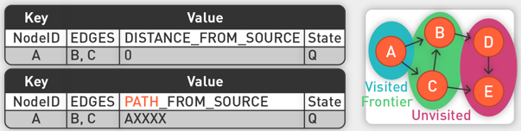
   4. Where ID is the node id.
   5. Where EDGES is a comma-delimited list of the ids of the nodes that are connected to this node.
   6. In the beginning, we do not know the distance and will use Integer.MAX_VALUE for marking "unknown."
   7. The state tells us whether or not we've seen the node before, so this starts off as unvisited. (visited|frontier|unvisited).
9. Finding Shortest path
   1. First, consider equal edge weights.
   2. Solution to the problem can be defined inductively.
   3. Here's the intuition:
   4. DistanceTo(startNode) = 0
   5. For all nodes n directly reachable from startNode,  DistanceTo(n) = 1
   6. For all nodes n reachable from some other set of nodes S, DistanceTo(n) = 1 + min(DistanceTo(m), m ∈ S)
10. SSSP MR steps
    1. Mapper
    2. Every map iteration expands the frontier.
    3. Reducer
    4. Every reduce iteration compresses the paths to frontier nodes to the ones that are minimum for a node in the frontier.
11. Example
    1. Suppose we start with the following input graph, in which we've stated that node 1 is the source (starting point) for the search.
    2. Marked this one special node with distance 0 and frontier queue.
    3. All other nodes are in the unvisited state U.
    4. 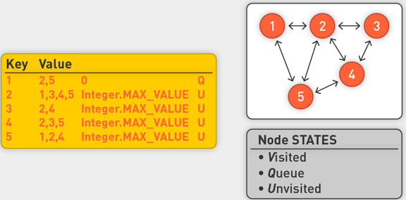
    5. Mappers are responsible for expanding the frontier nodes.
    6. Similar in spirit to expand(), which adds to the frontier a newly found vertex at a distance one greater than that of its neighbor already in the frontier.
    7. For each frontier node, expand(); the mappers emit a new frontier node, which is with distance = distance + 1.
    8. They also then emit each old frontier node with a new status; updated to visited. (Once a node has been expanded, we're done with it.)
    9. Mappers also emit all unvisited nodes, with no change.
    10. Note that when the mappers expand the frontier nodes and create a new node for each edge, they do not know what to write for the edges of this new node, so they leave it blank.
    11. 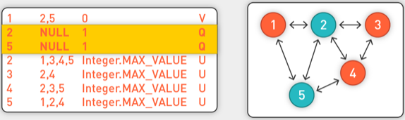
    12. If mapper sees a node in state Q, it tries to expand them.
    13. 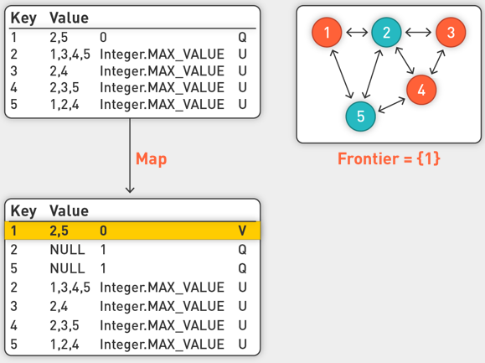
    14. All other nodes are passed through. The second and third row are from expansion.
    15. 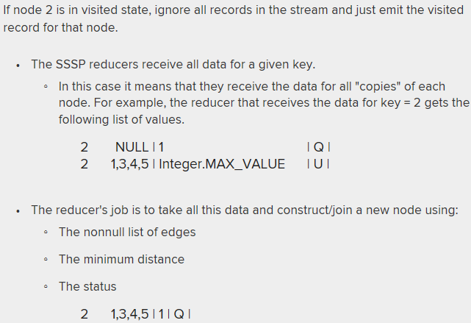
12. First few iterations
    1. 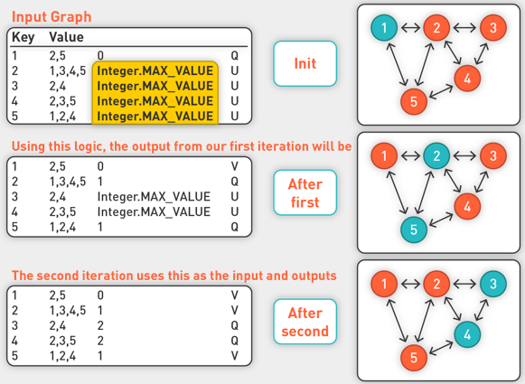
    2. Between each iteration both Map and Reduce have been run. That is why Q and U states for the same node have been combined.
    3. 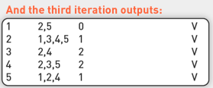
    4. When all nodes are visited, we stop
13. SSSP Termination
    1. Does the algorithm ever terminate?
    2. Eventually, all nodes will be discovered and all edges will be considered (in a connected graph).
    3. Subsequent iterations will continue to print out the same output.
    4. We are done when there are no output nodes that are frontier (i.e., in Q state).
    5. Note: If not all nodes in your input are actually connected to your source, you may have final output nodes that are still unvisited.

Distributed SSSP: Weighted Graph

1. Weighted Graph
   1. 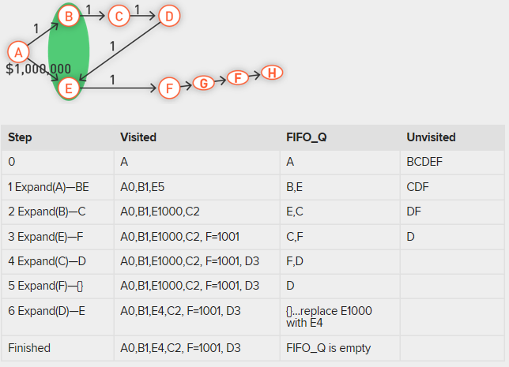
   2. Current implementation doesn’t work
   3. First frontier node is A, we go through MR steps to get B and E
   4. Next iteration gives us C and F, next D and G, Next F2, Next H and we will not be finished.
   5. All nodes on the path from E onwards having million-dollar distances, even though we know there are shorter ones
2. Map Reduce SSSP
   1. 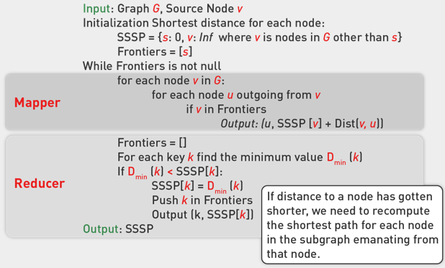
   2. Mapper is same, process each record in stream, expanding queued nodes
   3. On reducer side, if we are re-visiting node that has been visited, check to see if length of new path is shorter than existing path. If it is, then re-set status of that node and put it back in frontier queue.
   4. Sent back to mappers on next iteration. The mapper will re-visit anything downstream from current node.
3. Example
   1. 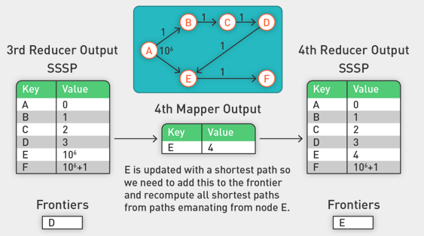
   2. On fourth iteration, we put E back in as queued, so that anything after E is re-visited.
   3. Once frontier is empty, we finish
4. Compare to Dijkstra
   1. Dijkstra’s algorithm is more efficient.
   2. MapReduce explores all paths in parallel.
   3. Throw more hardware at the problem.
5. General Approach for Large Graphs
   1. MapReduce is adept at manipulating graphs.
   2. Store graphs as adjacency lists.
   3. Graph algorithms for MapReduce:
   4. Each map task receives a node and its outlines.
   5. Map task computes some function of the link structure, emits value with target as the key.
   6. Reduce task collects keys (target nodes) and aggregates.
   7. Iterate multiple MapReduce cycles until some termination condition.
   8. Remember to "pass" graph structure from one iteration to next.
   9. Special distributed graph libraries like Giraph, Spark Graphx are purpose-built for graph processing.